U.S Economic Growth Projection Downgraded
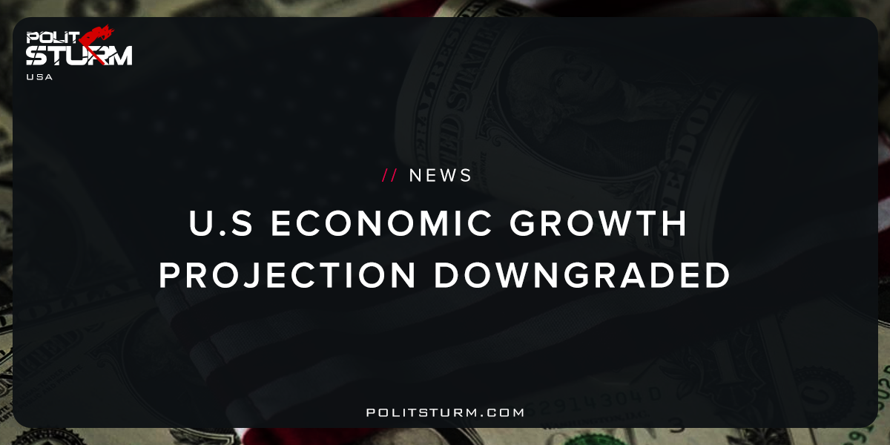

Original article
2017-10-11
2 min read

The International Monetary Fund is dialing back its expectations for the U.S. economy, according to a report out Tuesday.
The IMF no longer expects President Trump’s proposed tax cuts to happen, causing the international organization to cut its forecast for U.S. economic growth this year and next.
The U.S. economy will still expand, the IMF predicts, just not as quickly as some had hoped. The IMF forecasts 2.2 percent growth in 2017 and 2.3 percent in 2018, a decline from April when the IMF projected 2.3 percent growth this year and 2.5 percent in 2018.
“The downward revision relative to April forecasts reflects a major correction in U.S. fiscal policy assumptions,” the IMF wrote in its latest World Economic Outlook report. Because of “significant policy uncertainty,” the IMF economists felt they should not count on Congress and the president passing lower taxes.
Politsturm: A recent study released by the International Monetary Fund suggests that global growth will accelerate at a slower rate than what was predicted earlier this year. The justification for this downward revision is the political uncertainty that surrounds tax reform in the United States. This reflects the standards which modern bourgeois economists use to evaluate the health of the U.S economy. The implied logic is that by lowering corporate taxes, there will eb a subsequent increase investment which will stimulate employment, consumer demand, and growth. It also reflects the mistaken belief that the politicians and economists have a major role in determining the trajectory for the U.S economy.
The fact of the matter is that during the late stages of the industrial cycle politicians and economists try and take credit for the increased economic activity. During the subsequent economic depression they will look for external factors to misdirect the blame for the poor performance of the economy. The capitalist economy is regulated by the law of value which keeps prices in line with values over the long run. The crisis is the period in which commodities are overproduced relative to the money commodity, gold, which is required to circulate them. The replacement of gold by fiat currency in no way invalidates this fact. This crisis superficially appears to be a credit crisis, but in actuality the cause is the overproduction of commodities. The law of value is the regulating force of capitalist political economy, not tax reform as the bourgeois economists suspect. The strict adherence to dogmatic neo-classical economics blinds them to this fact. The law of value will soon assert itself in the global economy in the same way that gravity asserts itself in everyday life and modern economists will not see it coming.
Sources: 1, 2

Original article

