U.S. COVID-19 Deaths Exceed 300,000
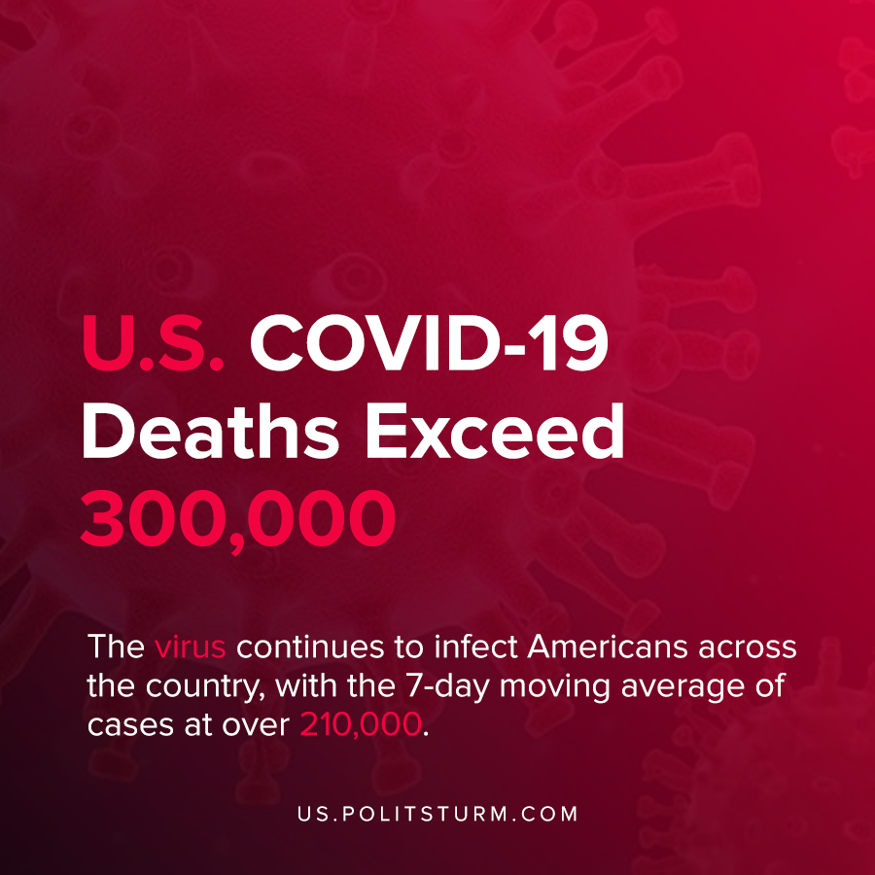

Original article
2020-12-15
1 min read

The U.S. passed a grim milestone as over 300,000 Americans have died as a result of the coronavirus. The distribution of the COVID-19 vaccine to health care workers and long-term care facilities is beginning.
The virus continues to infect Americans across the country, with the 7-day moving average of cases at over 210,000. The average infections have been rising steadily over the last several months.
According to data by Johns Hopkins, U.S. COVID deaths make up approximately 19% of the global total.
The U.S. bourgeois government failed to contain and respond to the coronavirus as the death toll climbed. The accumulation of corporate profits and the inability to coordinate a centralized response to the virus strongly contributed to the current state of affairs. Economic and political forces precluded the U.S. from conducting an effective response to the pandemic.
While the oligarchs continue to reap profits, the coronavirus pandemic continues to infect and cause the death of countless Americans.
Sources: 1 , 2 , 3

Original article

