U.S. Coronavirus Infections Surpass 2,000,000
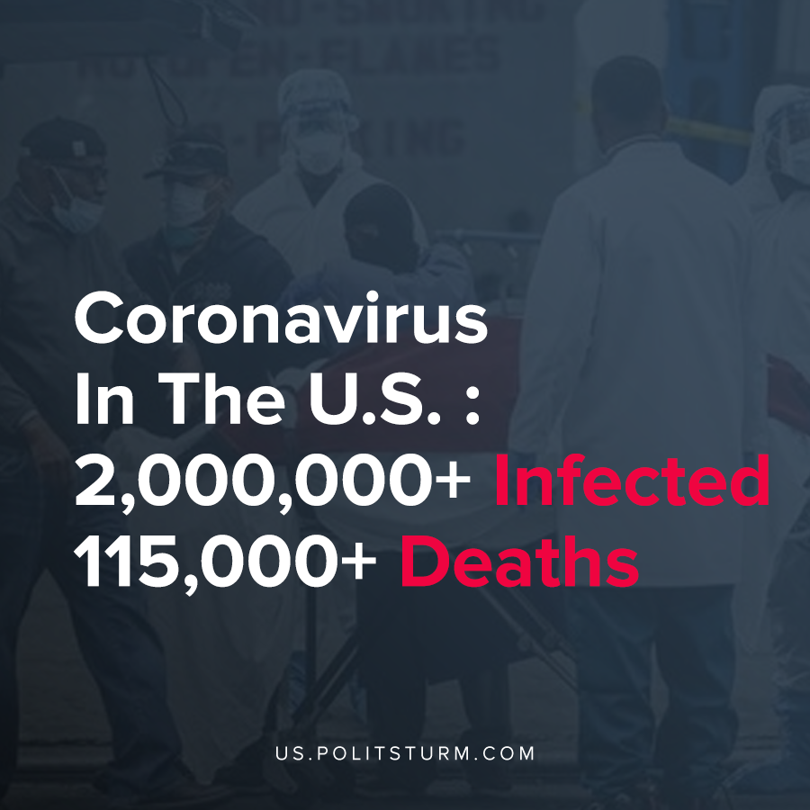

Original article
2020-06-11

U.S. Coronavirus Infections Surpass 2,000,000

Original article

