More U.S. Companies Charging Employees for Job Training
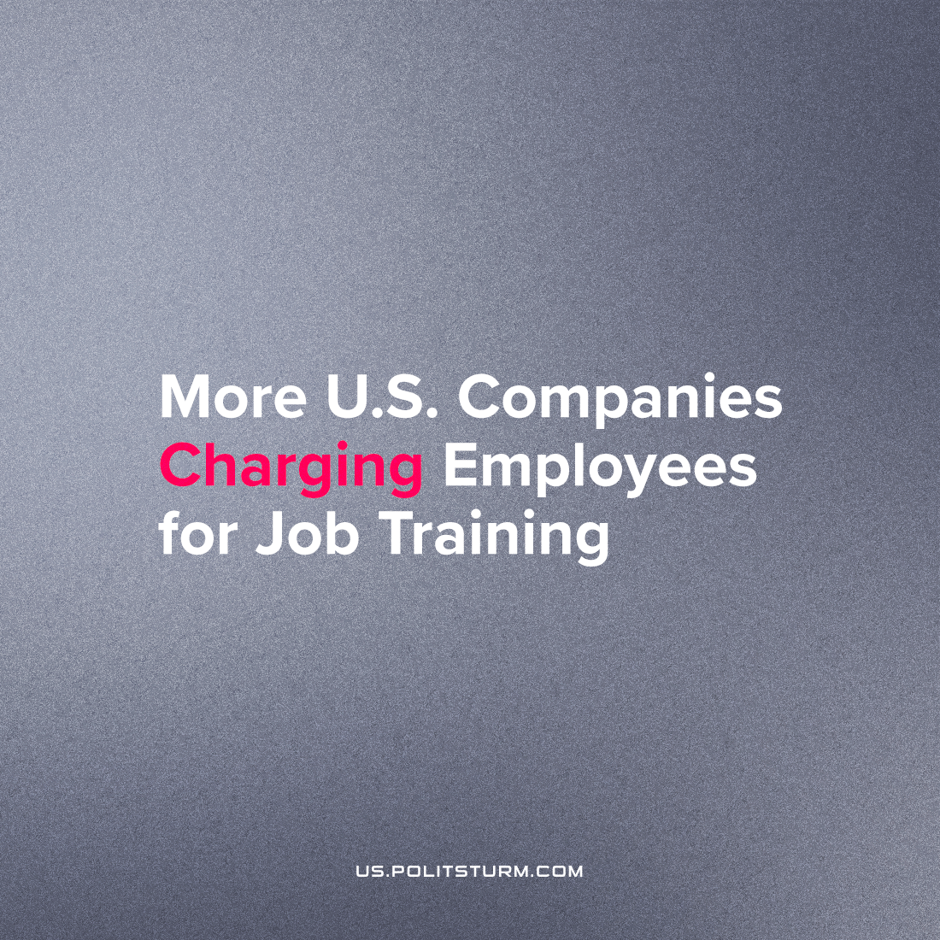

Original article
2022-11-09
1 min read

With the ever-increasing exploitation of America’s working class, more workers are seeing companies attempting to implement training repayment agreements prior to employment.
The Consumer Financial Protection Bureau (CFPB) is beginning to investigate US companies charging employees for job training. The practice is being called Training Repayment Agreement Provisions; fittingly abbreviated, TRAPs. It is being shown that companies are looking to use this practice to keep employees from leaving their positions once they experience actual workplace conditions, without having to raise wages or other employee benefits to attract recruits.
These TRAPs are largely used in nursing and the trucking industry, as training in these areas can be costly. In a survey of 1700 people, 35% of nurses were required to take part in training programs and 19% were required to pay the training costs back. The American Trucking Association being in favor of these employee-driven reimbursement contracts asking the CFPB to not refer to it as “employee driven dept.”
A widespread implementation of this training repayment practices would undeniably affect the working class the most. This would cause lower class workers to stay at low paying jobs unless they had the adequate funds to afford the training bill sent to them after quitting. This is an attempt to keep workers at low paying jobs without having to raise the working conditions in terms of pay, insurance coverage, paid time off, or even college reimbursement.
As operating costs rise for capitalists increase, they seek to push off their expenses onto their own workers who they already exploit for profit. As the crisis deepens, it is necessary for the capitalist to deepen exploitation to maintain the system of exploitation itself.

Original article

