U.S. Commits $3 Billion Security Assistance to Ukraine
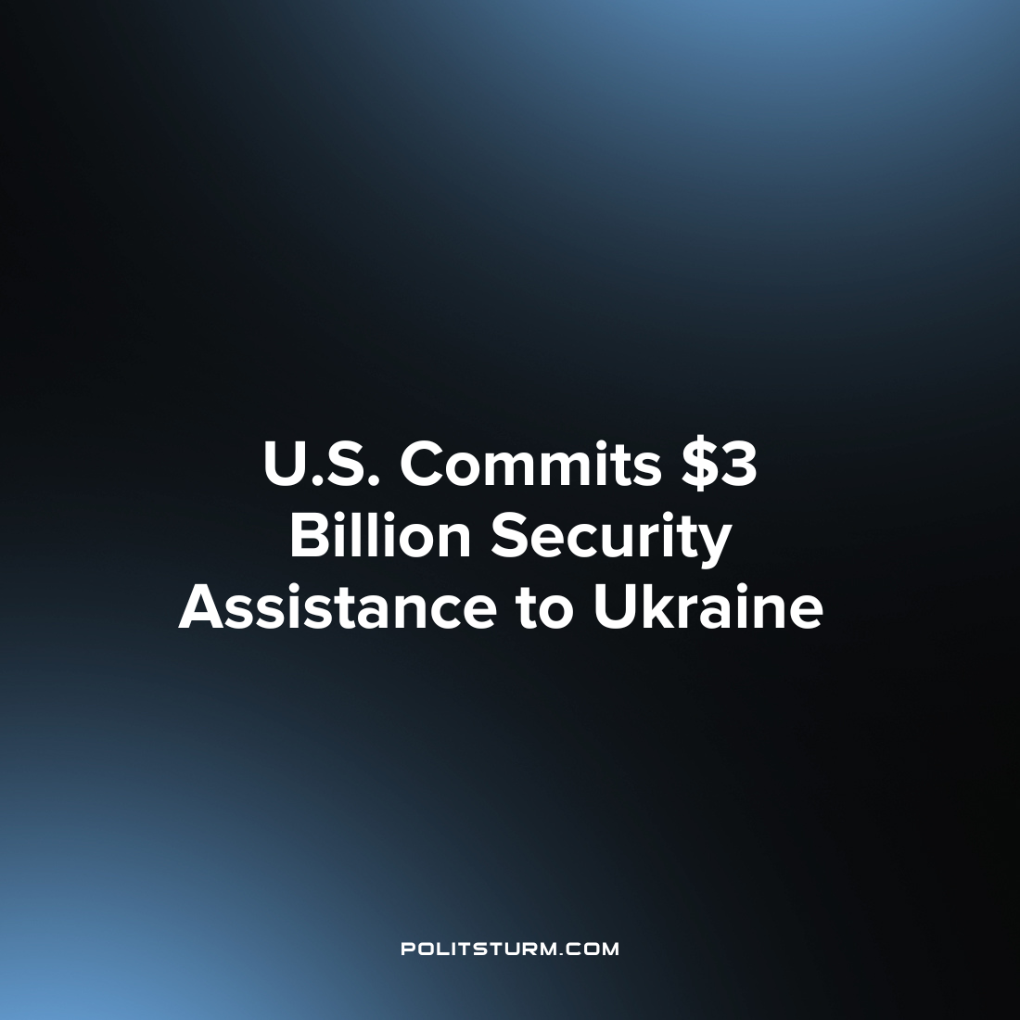

Original article
2022-08-23
1 min read

The U.S. Defense Department announced that it will be providing an additional $3 billion in security assistance to Ukraine under the Ukraine Security Assistance Initiative. This is the single largest security assistance package that has been sent to Ukraine to date.
“This package is about building enduring strength for Ukraine as it continues to defend its sovereignty in the face of Russian aggression. Vladimir Putin seems to believe that Russia can win the long game—outlasting the Ukrainians in their will to fight, and the international community’s will to continue to support Ukraine. This USAI package is a tangible demonstration that this is yet another Russian miscalculation.”, said undersecretary for defense policy Colin Kahl.
The package includes six National Advanced Surface to Air Missile Systems and munitions, 245,000 rounds of 155-mm artillery ammunition, 65,000 rounds of 120 mm mortar ammunition and 24 counter artillery radars.
Deliveries of the military defense package will commence in the coming months and are expected to continue over the coming years. Kall stated that this was a long-term package intended to “form the backbone of a robust future Ukrainian force, capable of defending Ukraine for years to come”.
This package will be obtained from the private sector and will greatly increase the sales of the manufacturers of these munitions and military equipment. The U.S. Defense department is merely serving the interests of the domestic capitalist class and their imperialist aims in the “special military operation” in Ukraine. While the ordinary citizens suffer from the wars of imperialist aggression, the capitalist class line their pockets and continue to profit regardless of the conditions.

Source: 1

Original article

