U.S. Capitalists Spend $500 Million Dollars On Local Propaganda
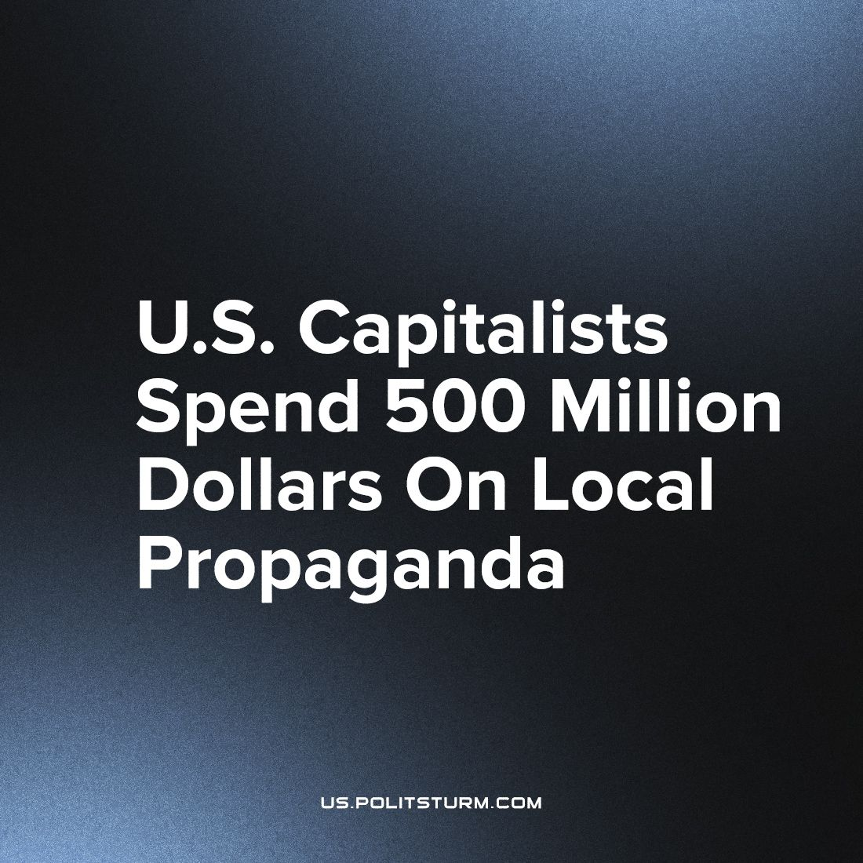

Original article
2023-09-30
2 min read

Some of the biggest names in American capitalist philanthropy have joined forces to spend at least $500 million over five years to revitalize the coverage of local news in places where it has waned.
The industry has been dominated by a trio of challenges: the consolidations of major advertisers; the massive shift in audiences' reading habits from paper to digital a comparative unwillingness to pay for news online; and key owners' relentless drive for profits.
Many major newspaper groups — including Gannett, McClatchy, and the old Tribune and Media News publications — are now controlled by investment funds which have embarked on severe rounds of repeated cuts.
According to NPR, a “middle ground” news organization, "The chance that we would support a hedge fund-supported newspaper is very, very low". Palfrey, the president of the MacArthur Philanthropy Fund: "One of the reasons we're in this predicament is greed. And one of the reasons we're in this predicament is capitalism run amok. And I think that we're not going to be propping up organizations that may or may not have made good choices in that corporate setting".
He continues, "What is exciting about this moment – against the backdrop of genuine crisis – is the innovation that's occurring … And we want to support those social entrepreneurs, those journalists, those editors who are figuring out new ways to provide local news to every community in America".
These statements contradict similar projects of philanthropists who donated to local news. The Knight Foundation previously devoted $300 million in grants over five years. Google and Meta (formerly Facebook) each launched their own million-dollar investments in news.
The two digital giants have often been blamed for scooping up content from news outlets and siphoning off advertising that previously helped pay for that original journalism. The tech companies' money subsidized some well-regarded initiatives, but has not notably altered the landscape.
"We've failed 1,000 times. We've failed in all kinds of ways," says Alberto Ibargüen, the president and CEO of the Knight Foundation.
The Investments by capitalists into the “local” news agencies have been deliberate to make so that they can have an outlet for their own “local” propaganda. Although this investment is made to be “local”, the contradictions of capitalism. The centralization of capitalism causes these “local” news to fail and get bought up by bigger capitalists. The “local” propaganda of the capitalists is being stopped, ironically by the system they set up.
Source: https://www.npr.org/2023/09/07/1198029284/macarthur-knight-journalism-news-press-forward

Original article

