U.S. Billionaires Contributed $675 Million for Midterm Elections
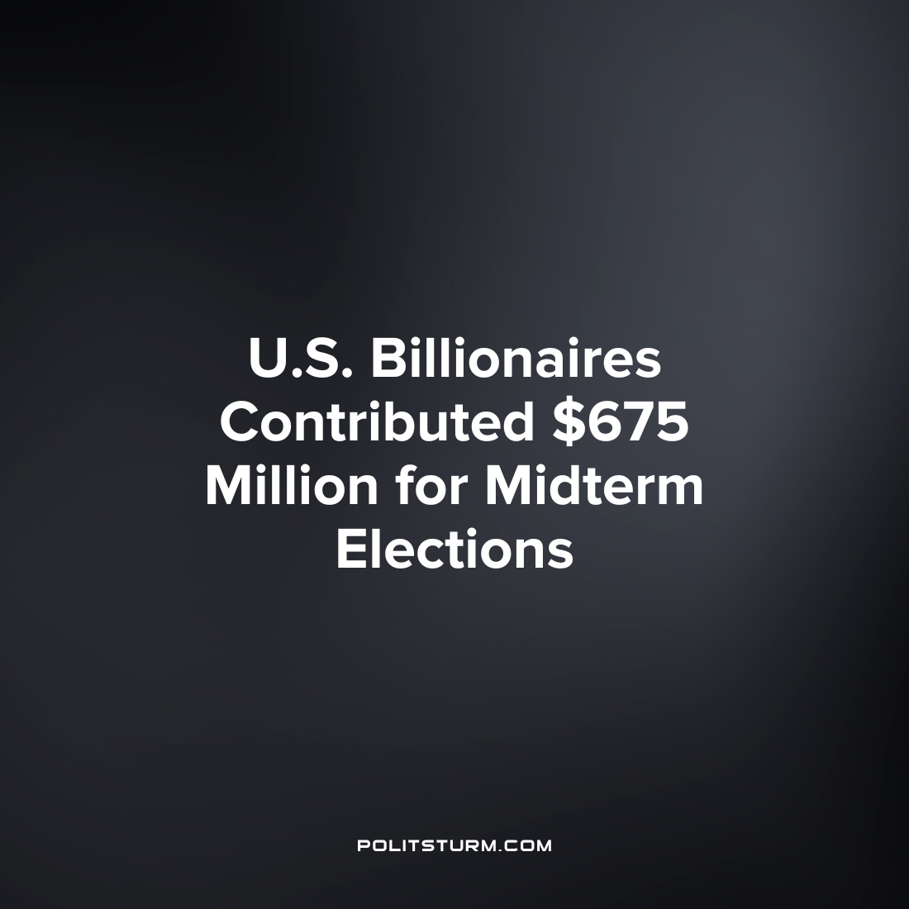

Original article
2022-10-06
1 min read

An analysis done by USA Today shows that billionaires have funneled $675 million dollars to U.S. politicians in the upcoming midterm elections. Almost all of this money was donated by 50 ultra-wealthy individuals which was determined by the data obtained from OpenSecrets.
Billionaires spend a disproportionate amount of money in the U.S political system compared to the rest of the population. The $675 million in contributions represents approximately 10% of the total political contributions while there are only approximately 724 billionaires in the United States.
Of the $675 million in contributions, there was $360 million contributed to Republican candidates while $300 million was contributed to Democratic candidates.
The U.S. political system is an oligarchy which serves the interest of the ruling class, namely, the capitalists. While the political, economic, and legal foundations of any capitalist country already support the interests of the capitalist class, billionaires still funnel money into the political system. The workers in the United States only have the choice of which servant of the capitalist class will be elected to serve the interest of the capitalist imperialists, which is defined as a ‘democracy’. It is imperative that workers study Marxism-Leninism and fight against the political dictatorship of the capitalist class.

Source: 1

Original article

