U.S. Approval of Labor Unions At Highest Level Since 1965
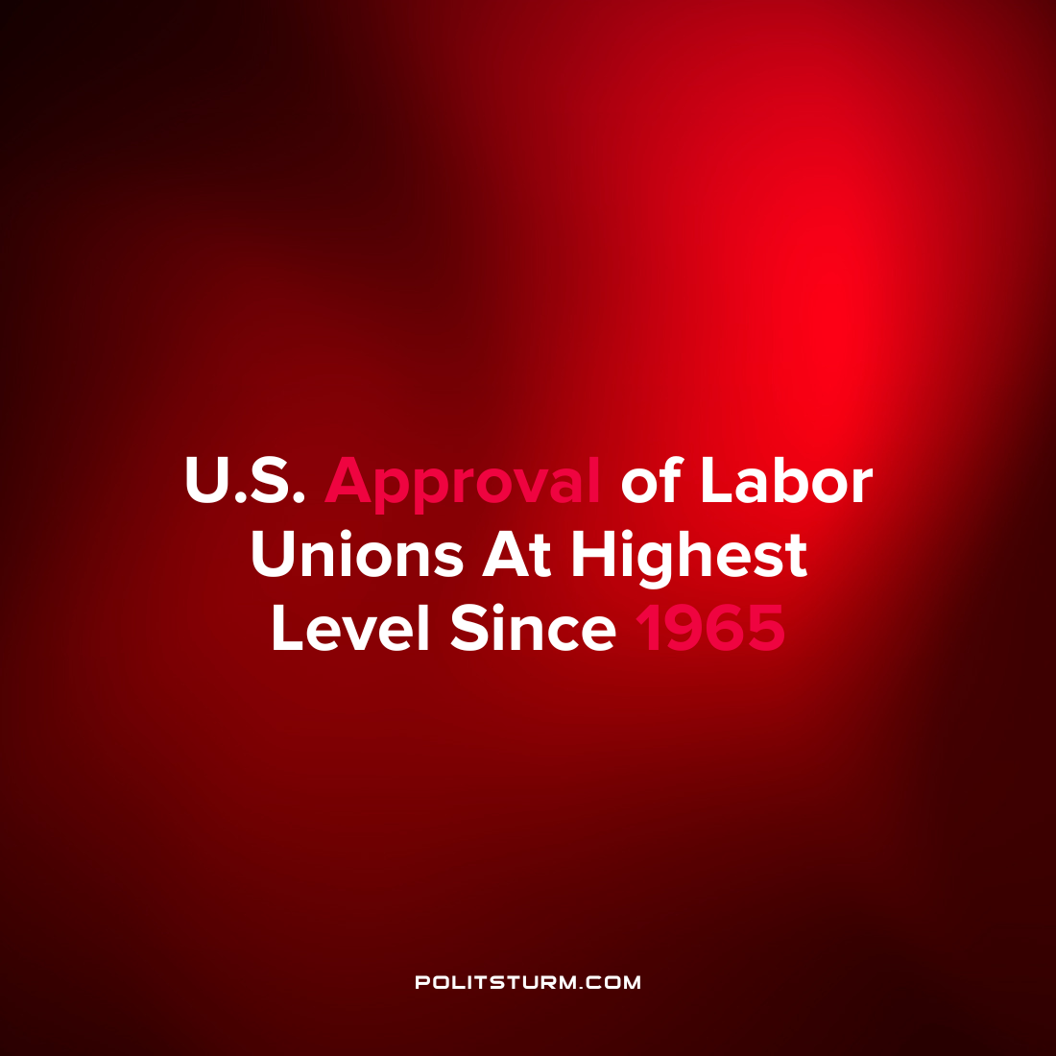

Original article
2022-09-01
1 min read

New polling from Gallup suggests that American public support for labor unions is at the highest point since 1965. Seventy-one percent of Americans now approve of labor unions which is up from 64% before the start of the pandemic.
The increase in public support for unions is happening concurrently with an increase in unionization efforts across the United States. According to data from the National Labor Relations Board, the number of petitions to form a union has increased 58% in fiscal year 2022.
Despite the increasing popularity of labor unions among the wider population, U.S. participation in labor unions is still relatively low. When polled as to whether the respondent or anyone in their household was in a union, 84% of those polled stated they are not in a union nor is anyone in their household.
While the public perception of labor unions is generally favorable and is on a positive trend, this has not yet translated to increased union participation. Also, unionization in itself is not sufficient to increase the gains of the working class in the struggle against the capitalists unless it is militant and rooted in Marxist-Leninist theory and practice.
Source : 1 2

Original article

