U.S. Annual Heating Costs Expected to Rise By 17.8%
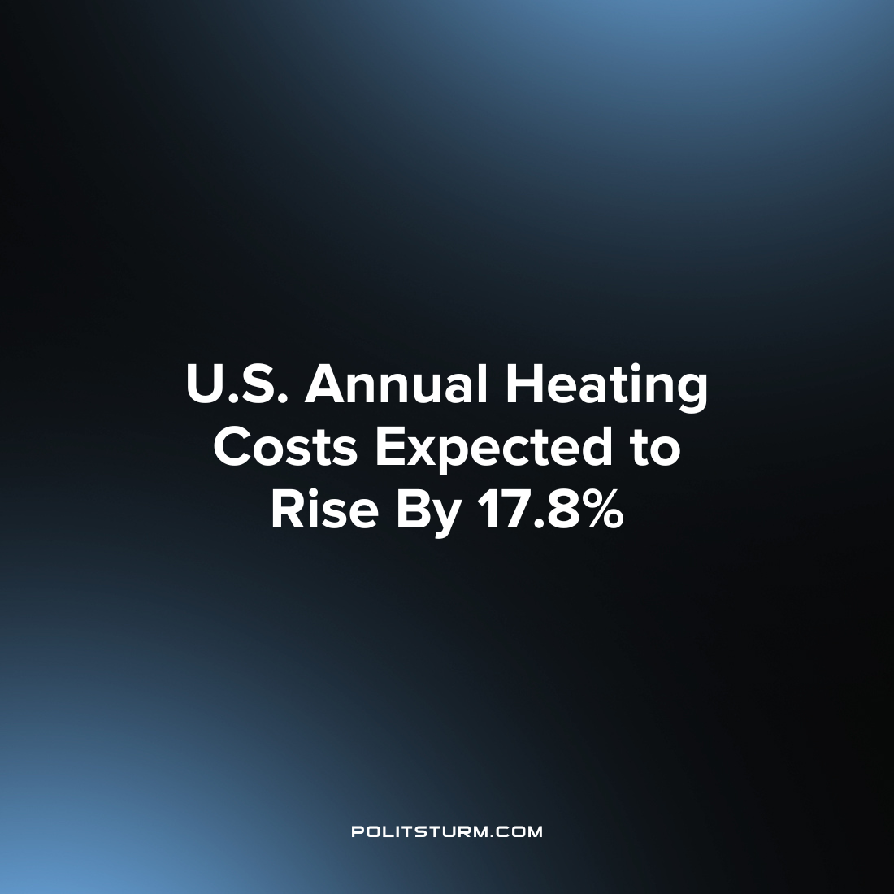

Original article
2022-11-02
1 min read

Rising energy prices in the United States are making utility costs unaffordable for millions of Americans, and the situation appears to be worsening as Winter approaches. 1 in 6 American households were already behind on their utility bills as of this Summer and energy price projections are only higher for this Winter.
The National Energy Assistance Directors’ Association (NEADA) is projecting that home heating costs will reach the highest levels in 10 years. Families can expect to pay 17.8% more in home heating costs this Winter as compared to last Winter.
This increase follows the increase from the preceding year in which there was also a substantial increase in energy prices. According to the NEADA between the 2020-2021 and 2022-2023 Winter heating seasons, energy prices increased 36%. At the national level, home heating costs are projected to increase from $127.9 billion to an estimated $151.6 billion. The burden of such an increase will fall hardest on low income households who are “at risk of falling behind on their energy bills and having no choice but to make difficult decisions between paying for food, medicine and rent.”
Under the capitalist economic system the burden of inflation falls hardest on the low-income workers and the unemployed. While millions struggle to adapt to the rising prices, billionaire oligarchs continue to reap massive profits regardless of the conditions. As long as capitalism continues to exist, the working class will struggle to survive and will always face the brunt of political and economic conditions while the class of oligarchs will profit and exploit without bounds.
Source: 1

Original article

