U.S. Announces $400 Million Security Package to Ukraine
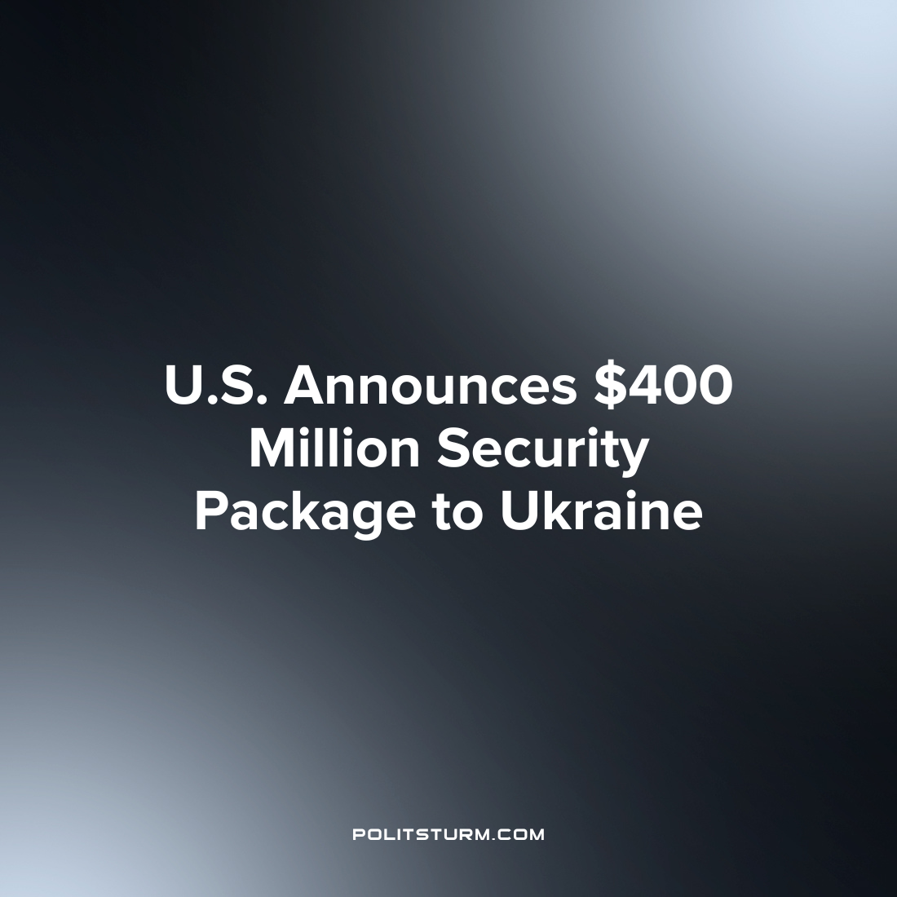

Original article
2022-11-04
1 min read

On November 4th, 2022 the U.S. Department of Defense (DoD) announced an additional $400 million in security assistance to Ukraine under the Ukraine Security Assistance Initiative. As opposed to the Presidential Drawdown Authority which has drawn down the equipment reserves of the department, the Ukraine Security Assistance Initiative procures equipment directly from private manufacturers.
The package includes funding to refurbish HAWK air defense missiles, 45 T-72B tanks, 1,100 Phoenix Ghost Tactical Unmanned Aerial Systems, and more. The T-72B tanks provided were part of a trilateral effort between the U.S., the Netherlands, and the Czech Republic. The Department confirmed that it has provided more than $18.9 billion in security assistance to Ukraine under the Biden administration and the DoD release implied that there will be future funding to Ukraine through the Presidential Drawdown Authority.
As the so-called ‘Special Military Operation’ continues in Ukraine, the U.S. continues to spend billions with the stated intention to “help Ukraine preserve its territorial integrity, secure its borders, and improve interoperability with NATO”. The U.S. defense companies such as Raytheon and Lockheed Martin have benefitted tremendously from acts such as the Ukraine Security Assistance Initiative. For example, the U.S. army awarded a $182 million contract to Raytheon on August, 26th, 2022 for the “delivery of two NASAMS batteries, training and logistical support to Ukraine’s military and security forces”. This is but one example, however, it illustrates the general condition where capitalist enterprise actively profits from war. The workers, however, suffer needlessly at the behest of the capitalists while the capitalists continue to profit as long as they retain power.
Source: 1 2 3

Original article

