Two Years of War in Gaza
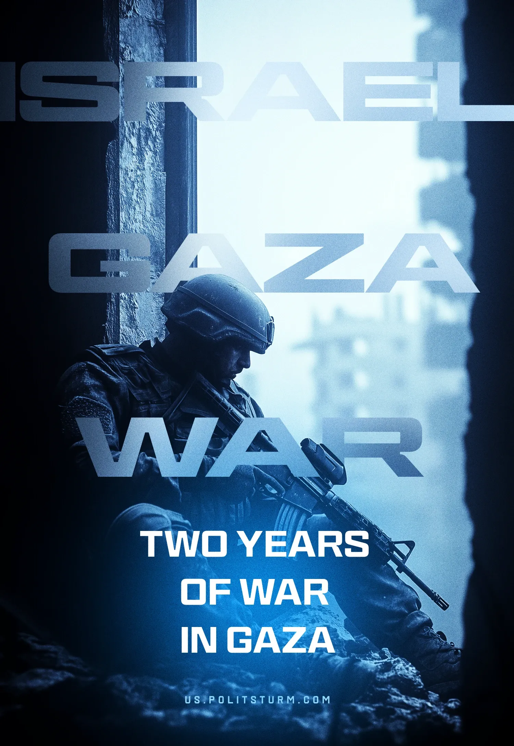

Original article
2025-10-07
13 min read

October 7, 2023, marked a turning point for the entire Middle East. The armed invasion by reactionary Hamas forces became the pretext for a large-scale military operation by the Israeli authorities. The IDF's actions were subsequently recognized as genocide by a UN international commission.
Two years later, the Gaza Strip lies in ruins. Tens of thousands of Palestinians have died, millions have been left homeless, and the Israeli government continues its military campaign, turning the enclave into a humanitarian disaster zone. Who really benefited from this war, and what are its results?

I. Gaza: The Illusion of Liberation
1. Two years of hostilities resulted in a humanitarian catastrophe of unprecedented proportions. Tens of thousands of civilians died, thousands were wounded, and millions became refugees. Urban infrastructure was destroyed, water and sewage systems were destroyed, and hospitals are no longer functioning. Hunger and epidemics became a daily reality for those who survived the bombings.
This is the outcome of a war that, according to its initiators, was supposed to bring liberation to the Palestinian people.
2. Hamas played the role of provocateur and exposed millions of Palestinians to the attacks of the nationalist Netanyahu regime. Created with the support of Israel, this reactionary Islamist organization acted as a puppet force of the imperialists of Iran and Turkey.
The raid by Hamas militants and forces under its command on October 7 was a deliberate provocation. The raid, including the massacre at the Nova music festival in the Reima district, led to the death of 1,200 people – approximately 780 civilians, including workers, students, and children. More than 250 people were taken hostage. These actions were calculated to provoke inevitable retaliatory strikes from Israel, whose leadership is supported by the Western bloc and protects its interests in the Middle East.
The result was exactly what Hamas leaders had hoped for: an all-out war with the Israeli army, in which Gaza's civilian population became a human shield for Islamists.
3. Hamas has never been a genuine liberation movement, and the events of the past two years clearly illustrate this. When a "liberation struggle" is led by a reactionary bourgeois movement and a puppet of the imperialist powers, the result is the deaths of tens of thousands of Palestinians and the destruction of much of Gaza's urban infrastructure, turning it into rubble.
The West Bank is heavily militarized and suppressed by the army of the nationalist Israeli regime. Hamas' actions have provided Israeli imperialism with a convenient pretext for attacking and annexing territory.
Moreover, the Islamists gave Israeli imperialism moral cover for its aggression, allowing the Netanyahu government to consolidate power. Hamas and its allies, including the pseudo-communist “Popular Front for the Liberation of Palestine” and the “Democratic Front for the Liberation of Palestine” dealt a severe blow to the prospects of organizing Palestinian workers against national and class oppression. Palestinians in Gaza itself, daring to protest against Hamas rule, are being suppressed by force and subjected to repression. Islamist forces disperse demonstrations, arrest and execute activists. This is what "liberation" under the leadership of reactionaries looks like.
4. Numerous rallies and protests in solidarity with Palestine swept across the world. Hundreds of thousands of people took to the streets demanding a ceasefire. But these protests failed to fundamentally influence the course of military operations or stop them. They had no significant impact on either the Israeli leadership or the governments of Western bloc countries.
On the contrary, instead of calls for class solidarity of the workers of Palestine and Israel against “their” bourgeois governments, nationalist and petty-bourgeois pacifist slogans dominated, ultimately creating only the illusion of activity and contribution to ending the war.
Nevertheless, these rallies demonstrated the enormous anti-war potential of the masses. The communists' task was to lead this protest and channel it into the mainstream of class struggle. Instead, communist organizations dissolved into the petty-bourgeois strife, becoming mere extras for bourgeois forces.

II. Israel: Militarization and Right-Wing Policy
1. The war in Gaza significantly strengthened the Netanyahu regime's position domestically. Before the events of October 7, 2023, the Israeli government was in crisis and weakened by mass protests. The Hamas attack gave Netanyahu the opportunity to unleash a nationalist and chauvinist media campaign under the slogan of "national unity" and to denounce the opposition as "supporters of terrorism".
2. The Israeli hostages were not fully freed; many were killed or still remain in captivity. One of Israel's stated main goals of the war – hostage release – has been almost completely thwarted. After two years of fighting, intense shelling, and destruction in Gaza, the Netanyahu government has failed to return the majority of the hostages. Only a small number were freed during military operations; the rest either returned as part of temporary deals or died.
Relatives of hostages regularly accuse the government of using the hostages as a pretext to continue the war without making any real efforts to rescue them. This has led to a new wave of discontent with the Netanyahu government among Israelis whose relatives remain in captivity. However, the authorities are attempting to silence this criticism by further intensifying chauvinistic hysteria and escalating military action in Gaza and throughout the Middle East.
3. Israel's militarization policy intensified. Immediately after the events of October 7, Israel began its largest mobilization, and the IDF called upon more than 350 thousand reservists.
For two years of war, Israel received tens of billions of dollars and tens of thousands of tons of military equipment and materiel from its main ally – the United States of America. American military aid included precision-guided bombs, artillery shells, components for the Iron Dome air defense system, and spare parts for military aircraft, which increased Israeli capital's dependence on aid from the American bourgeoisie.Nevertheless, hundreds of Israeli soldiers died during the ground operation in Gaza, marking the highest casualties for the IDF since the Second Lebanon War in 2006.
The most reactionary circles of Israeli capitalists have strengthened their pro-fascist course, suppressing the opposition and intensifying chauvinistic propaganda.
4. The war in Gaza was only the beginning of a large-scale regional military campaign. For two years, Netanyahu's nationalist regime has consistently launched systematic attacks against Iranian-allied regional proxy forces – the Houthis in Yemen, Hezbollah in Lebanon, and pro-Iranian forces in Iraq – effectively waging a war on multiple fronts simultaneously.
In early 2025, taking advantage of the weakening of Bashar al-Assad's regime in Syria, the Israeli government expanded its control over Syrian territories, in particular the southern provinces of Quneitra and Daraa, effectively annexing strategically important areas under the pretext of creating a "security buffer zone".
This escalation culminated in the summer of 2025, when Israel launched a direct strike on nuclear and military facilities in Iran with the full support of the United States, putting the entire region on the brink of a major war. Hundreds of Iranian civilians and dozens of Israeli civilians were killed in the exchange of fire, and thousands were wounded.
Thus, the war in Gaza became not just a local conflict, but a trigger for a large-scale restructuring of the balance of capitalist power throughout the Middle East.

III. The Palestinian People – Hostages of The Imperialist Conflict
1. The Gaza conflict has been exploited by Middle Eastern imperialists to advance their interests. The Palestinian people have become hostage to the contradictions between Iran, Turkey, Israel, and Saudi Arabia – regional powers representing the interests of various imperialist blocs. Turkey, Qatar, Saudi Arabia, and other Islamic and Arab countries are exploiting the Palestinian tragedy to strengthen nationalism and chauvinism at home.
2. A direct consequence of the conflict was a shift in the political balance in the region in favor of Israel and the Euro-Atlantic bloc behind it. The reactionary regime in Iran supported various governments and groups in the region in order to increase pressure on Israel. Two years after the events of October 7, the position of Iranian capitalists and their proxy forces was seriously weakened.
3. International attention to Palestine is being used by the bourgeoisie of various countries and populists of all kinds to build up their political capital. The recognition of Palestine by a number of European Union members is a manifestation of divisions within the Euro-Atlantic bloc. This measure has had no practical impact on their relations with Israel. It is intended to demonstrate the EU's independence and put pressure on the US on more pressing issues for them, primarily the Ukrainian crisis.
4. The UN and international law have shown their helplessness. Even the recognition of Israel's actions in Gaza as genocide by the UN commission did not lead to any sanctions or isolation of the perpetrators. In the context of the global crisis of capitalism and the arms race, the United Nations proved powerless.
In our article on the strikes against Iran, we pointed out that Israel's actions would serve as an example for other countries. The war in Gaza has become yet another example for imperialists everywhere: international problems in the modern day can be successfully resolved by force of arms.

IV. The Crisis in the Communist Movement and the Palestinian Question
1. The international communist movement failed to influence the conflict and direct political activity of the masses. Two years of war in Gaza have tested the international communist movement's ability to take the right position and act effectively. They failed this test.
The overwhelming majority of the communist movement failed to take the correct position. The "Marxist-Leninist pole" of the Communist Party of Greece and its allies rightly pointed to the more than 50-year history of the conflict in Palestine and the hypocrisy of Western bloc leaders. They rightly emphasized that the Hamas attack and the civilian casualties in Israel were merely a pretext for the Israeli government to continue its expansionist policies.
However, the interests of other blocs, primarily regional imperialists and the Chinese bloc, were not taken into account. Because of this, the role of Hamas as a reactionary Islamist organization was overlooked and hushed up. The significance of the events of October 7 as a deliberate provocation was downplayed. Moreover, in some cases, arguments were put forward in defense of this organization. This argumentation was analyzed in detail by our organization in a major material about Palestine.
2. The position of unconditional support for forces representing Palestine is outdated and irrelevant to the current situation. During the Cold War and the first decade after the collapse of the socialist bloc, Palestine was associated with the Palestine Liberation Organization. Many forces within the PLO were oriented toward the USSR and the socialist countries and received material support from them. In the 21st century, their place was taken by the Islamists of Hamas. This organization was supported by Israel in order to squeeze out communists and other progressive forces. This calculation proved successful: the Hamas attack provided the perfect pretext for aggression. The Palestinian people were identified with the movement that was suppressing them.
3. The "Marxist-Leninist pole" lagged behind its opponents. It was unable to pursue actions and slogans distinct from the many structures of anarchist, Trotskyist, social-chauvinist, social-democratic, or Islamist persuasions.
Instead of promoting an independent communist position on this conflict in the interests of the working class, opposing both Israel and Hamas, various communist organizations and movements have moved to positions of unconditional support for pro-Islamist forces.
These organizations failed to lead the movement in defense of the Palestinian people and direct it in the right direction of class struggle. They failed to conduct proper outreach to Palestinians and sympathetic workers, explaining the true causes of the conflict and the means to resolve it.
Instead, they followed behind, becoming pawns for various political adventurers and allowing bourgeois propaganda to label communists as "defenders of Hamas terrorism". Capitalists successfully exploited the communists' participation in pro-Palestinian protests to fuel anti-communist, nationalist, and chauvinistic sentiments. A direct consequence of this was the strengthening of right-wing, fascist forces, which are playing the card of "defense against the Islamic threat" and "left-wing extremism".
4. The Palestinian question revealed all the problems of the international communist movement: the lack of a unified theory, organizational fragmentation and general weakness.

V. What To Do?
1. The Gaza war and the communists' stance on it became a clear manifestation of the crisis of the communist movement. It demonstrated that without Marxism-Leninism, class analysis, and consistent internationalism, communists are doomed to remain passive observers, following in the wake of more organized forces.
2. Now, when the bourgeoisie of several great powers openly advocates for the recognition of Palestine and is prepared to support it with "international forces", communists must clearly distinguish themselves from all reactionary forces. They must correct their mistakes and focus on explaining the nature of Hamas and other bourgeois forces that will be promoted as an alternative to the Islamists.
3. All communist organizations involved in the protests must critically evaluate their tactics and completely reconsider their position in relation to inter-imperialist conflicts and social chauvinists.
Communists' work strategy must be based on Marxist-Leninist theory without any distortions or deviations. An independent class policy must be pursued, which must under no circumstances be confused with the actions of bourgeois forces and propaganda.Communists must consistently expose the inter-imperialist nature of the conflict, showing that the struggle between imperialists is waged at the expense of the blood of workers on both sides.
4. In their work, communists must constantly emphasize that only socialism can end wars. In this spirit, they must clearly and unambiguously implement the principle of internationalism in practice: the unity of workers of all countries in the struggle against capitalism and its manifestations. No concessions or deviations that declare workers of one side or the other "more important" or "more prioritized" are permissible.
The only path to genuine liberation for the Palestinian people lies through a joint struggle of Jewish and Arab workers against their capitalists, for the socialist reconstruction of the entire Middle East.
Would you like to get in touch with us? Contact us: politsturm.inter@gmail.com.

Original article

