Two-Thirds of Kroger Workers Cannot Afford Basic Expenses
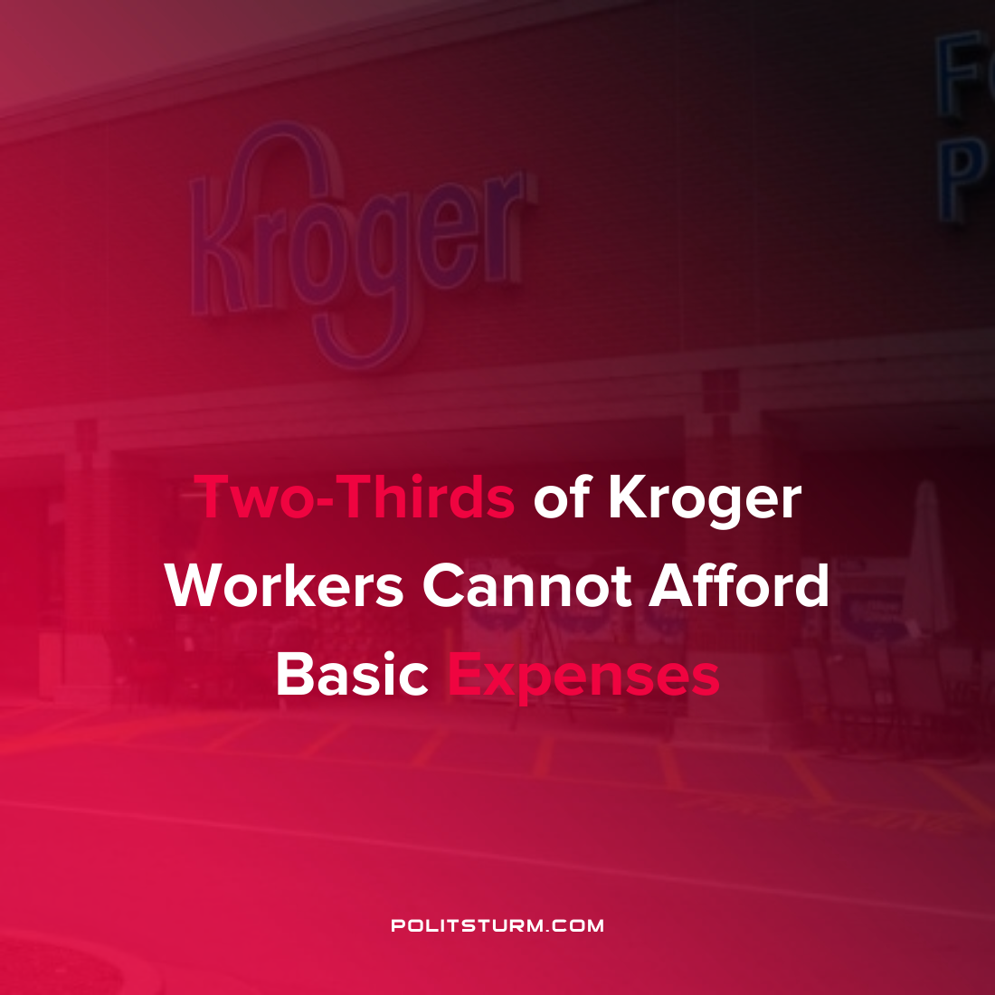

Original article
2022-01-18
1 min read

A new white paper underwritten by the United Food and Commercial Workers union surveyed workers from Kroger grocery stores in the United States. The survey responses showed that even though these grocery store workers are surrounded by food on a daily basis, nearly three-quarters of these workers are food insecure. These workers struggle to eat balanced diets and often run out of food for themselves while struggling to provide for their children.
More than two-thirds of Kroger workers surveyed say that they struggle for survival due to low wages and only being able to work part-time hours. 90% of Kroger workers report that their wages have not risen at the same rate as basic expenses such as food and housing.
“Since 1990, wages for the most experienced Kroger food clerks have declined from 11 to 22 percent
(adjusted for inflation) across the three regions surveyed. Across the entire grocery industry, 29 percent of the labor force is below or near the federal poverty threshold.”
While the workers struggled, the shareholders and corporate executives of Kroger’s have done very well. According to their most recent annual report the company posted an operating profit of $2.8 billion and returned $1.9 billion to shareholders through share repurchases and dividend distributions. This is the clearest manifestation of the class struggle where the workers are struggling to survive while the private owners reap massive profits from their investments.
Source: 1 2

Original article

