Twitter Lays Off Thousands of Workers
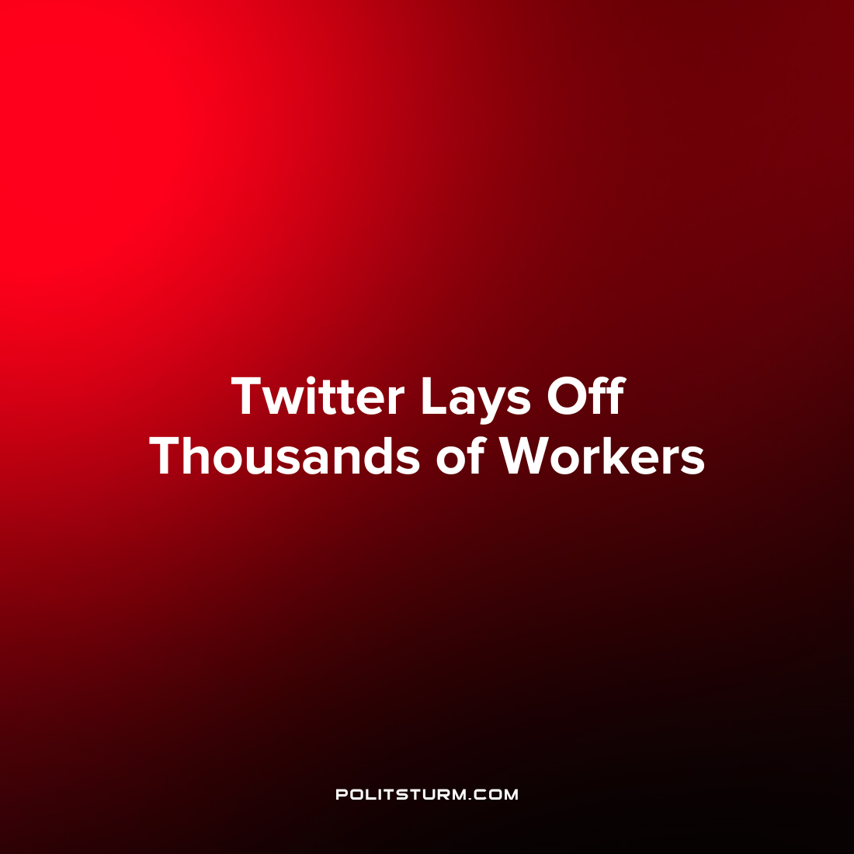

Original article
2022-11-04
1 min read

Nearly half of Twitter’s 7,500 workers are being laid off from their jobs following billionaire Elon Musk’s recent acquisition of the company for $44 billion. Musk rationalized the decision by stating that Twitter has experienced a large decrease in revenue due to “activist groups pressuring advertisers” who are trying to undermine free speech in America. Musk remarked about the situation that “unfortunately there is no choice when the company is losing over $4M/day”. Following the announcement several major advertising sponsors have left the platform citing their concerns about the future of the platform.
The acquisition of Twitter by the billionaire Musk shows the implications of the private ownership of the means of production under capitalism. Firstly, that the structure of capitalist production requires that the livelihood of thousands of workers can be thrown into jeopardy so that a small group of oligarchs can reap private profits. Secondly, while the capitalists such as Musk clamor about “freedom”, one capitalist such as himself can acquire an enterprise and determine the fates of thousands of workers who do not have a say in the matter. Capitalism necessitates the maximization of profits for the capitalist class and they will justify any decision as a means to this end. While the capitalists will always try to present this condition as eternal and natural, capitalism is but one of many class systems throughout history based on the exploitation of man by man.
Sources: 1 2 3 4

Original article

