Turkish Workers in Russia Went On Strike And Succeeded
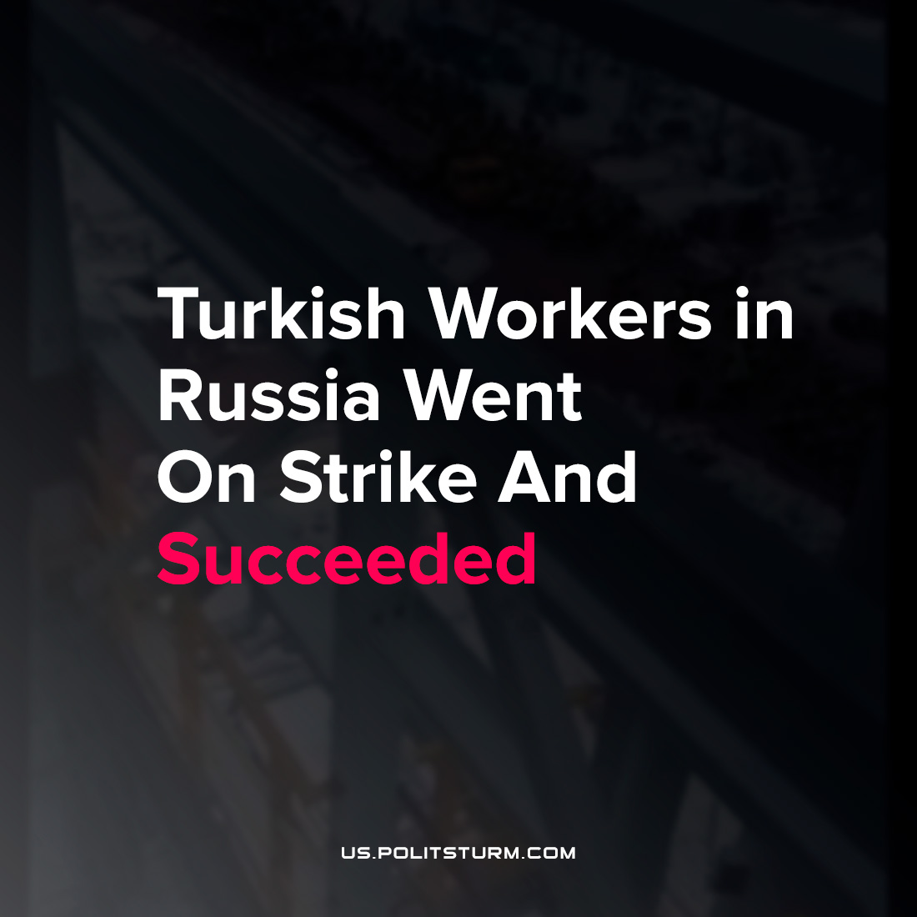

Original article
2022-03-06
2 min read

The current events in Ukraine influenced all spheres of the Russian economy. The ruble keeps dropping. On February, 23, 1 dollar was equal to 80 rubles. By March, 4, this amount went up to 110 rubles, dropping by more than 30%.
This thing could not leave no effect on the working masses. “Gemont Russia” – a subsidiary of the Turkish “Gemont” company. It’s building the EP-600 ethylene complex for “Nizhnekamskneftekhim” (Nizhnekamsk Oil and Chemistry Plant, Republic of Tatarstan). According to the contract, the work should be completed by the end of 2022.
Error loading image
Ruble exchange rate
The new EP-600 will allow processing 1.8 million tons of straight-run gasoline per year to produce 600,000 tons of ethylene and target products: propylene (273,000 tons), benzene (249,000 tons) and butadiene (88,000 tons).More than 6,000 people are employed in construction. As the gas prices keep growing, the importance of this project for the capitalists is clear.
The company has pledged to pay salaries to its employees taking into account the current foreign exchange rate. On March 5, workers from Turkey went on strike because their salaries didn’t include the difference between the old and the new exchange rate. A video of the incident appeared, showing more than 100 workers walking through the production site, whistling and screaming loudly.

Unsupported element: IFRAME
And they succeeded. “Due to the high volatility of exchange rates, a special working group — including representatives of the customer company, contractor and construction personnel — made an agreed decision on the calculation formula for labor contracts, payment for which is tied to the exchange rate of foreign currencies” – says the report of “Gemont Russia”.
The ongoing economic crisis makes the drop in living standards bigger. The example of the Turkish workers shows us, that the working people don’t need to wait for gifts, or to look at their rights and money being taken by the bosses. The only way is to defend their rights. We hope that this example will encourage the Russian workers as well.
Sources: 1, 2.

Original article

