Trumps’s Tax Reform: A Handout to the Oligarchs
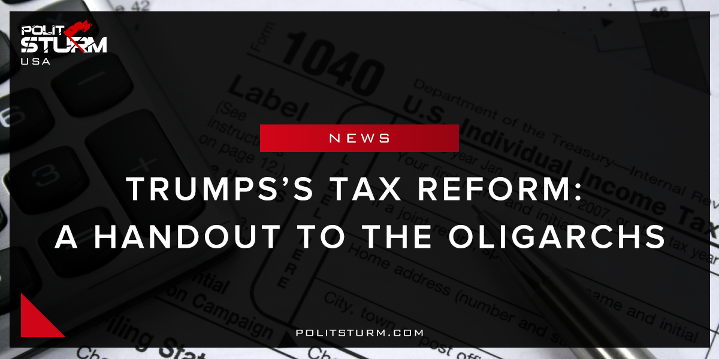

Original article
2017-09-11
1 min read

As details have finally emerged regarding the specifics of the Trump administration’s “tax reform”, it is now easy to see it is a tax cut for the very rich. The highest tax bracket has been reduced from 39.6% to 25%, a nice reduction for the wealthiest in American society. However, this is not all. The dividend and capital gain rates have been brought into parity, the richest Americans will have their ordinary dividend tax reduced from 39.6% to 20%. This will benefit the capitalists who earn money not by working, but by owning stocks, bonds, and investments.
Not only will these tax cuts apply to individuals, but to businesses as well. According to the plan, no business “will pay more than 15% of their business income in taxes”. This means that profits will benefit from a reduction in the corporate profit tax rate.The proverbial cherry on the cake is the elimination of the so called “death tax”, more commonly known as the estate tax. This is the tax individuals pay when they pass down property to their heirs. Under this proposal the capitalist class will be able to pass down their earnings tax free to their descendants. Like the kings and queens of old, the capitalist class has become a self-serving class of parasites, living off blood and sweat of the working people. This “reform” will surely benefit Trump and the oligarchs, but it will be harmful to the most vulnerable and hardest working in American society.
Source

Original article

