Trump’s Family Net Worth Soared by Billions in 2025
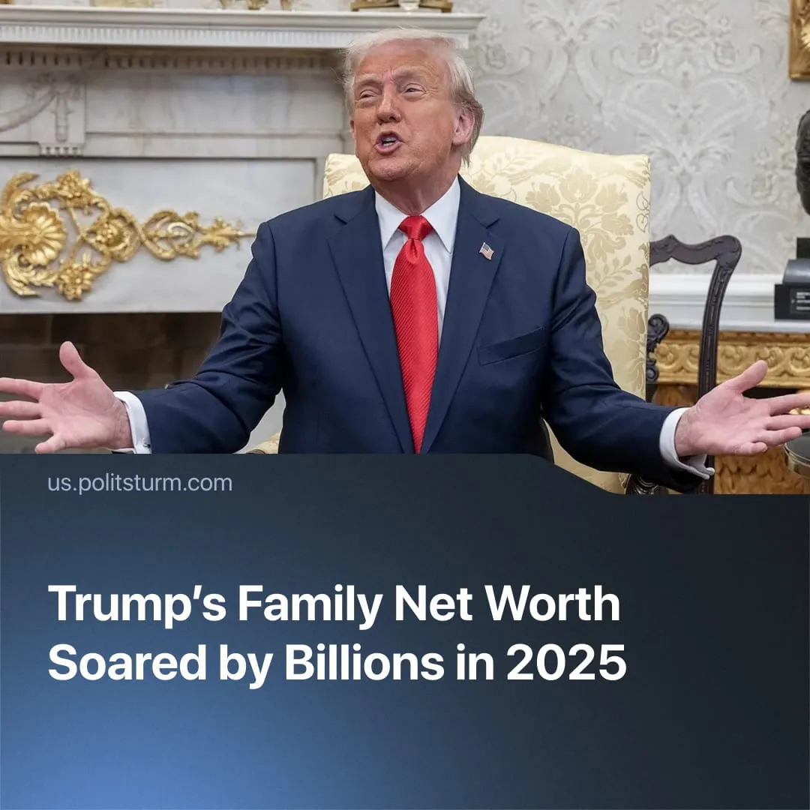

Original article
2026-01-21
2 min read

Trump’s 2025 presidency boosted his family’s wealth by billions, at the expense of workers and in the service of capital.
Details. Following his 2024 election, Donald Trump’s reported total net worth rose sharply, reaching an estimated $7–7.3 billion by late 2025, up roughly 70% from 2024. Bloomberg estimates that specific tracked gains in certain ventures added roughly $282 million during the year.
► Before officially taking office in 2025, Trump earned over $6 million in royalties, advertising MAGA‑themed products, including hats, Bibles, NFTs, and memorabilia sold at rallies and through his media company.
► Despite previously criticising cryptocurrency, Trump accepted donations from crypto firms during his 2024 campaign, reportedly totalling $18 million, and encouraged supporters to contribute via crypto. He also launched his own meme coin, increasing his net worth by $350 million before a “rug pull” scam that cost investors $2 billion collectively.
► Trump Media & Technology Group (TMTG), which went public in March 2024 during Trump’s campaign, has added several billion dollars in market value, boosting Trump’s personal net worth by hundreds of millions. The stock has frequently risen during periods of US military escalation abroad, including the bombing of Iran and the raid on Venezuela.
► Trump signed the One Big Beautiful Bill Act (BBB) in 2025, permanently extending and expanding tax cuts from the 2017 Tax Cuts and Jobs Act. The legislation primarily benefits the capitalist class, including Trump himself.
Context. Alongside the Trump family’s gains, the world’s wealthiest continued to amass extraordinary wealth in 2025. According to the Bloomberg Billionaires Index, the richest 500 individuals added a record $2.2 trillion to their combined net worth, bringing the total to $11.9 trillion
► The administration has pursued executive actions and policy shifts disproportionately benefiting the capitalist class – deregulation, permanent tax cuts under the BBB, and expanded government military and tech spending that funnelled lucrative contracts to large corporations.
► Palantir, Meta, and OpenAI were officially commissioned for US military collaboration before the passing of the BBB, which granted the largest military spending budget in US history. Palantir shares rose 3.4% after the US invasion of Venezuela the following year.
► Meanwhile, living conditions for America’s working class continue to deteriorate. Inflation rose 3% and continues to climb, while secure healthcare, food and shelter remain out of reach for more Americans, exacerbated by cuts to social spending. Job growth is now trending toward zero, threatening millions with unemployment as economic stagnation persists.

Original article

