Trump's Short Absence Prompted Death Theories
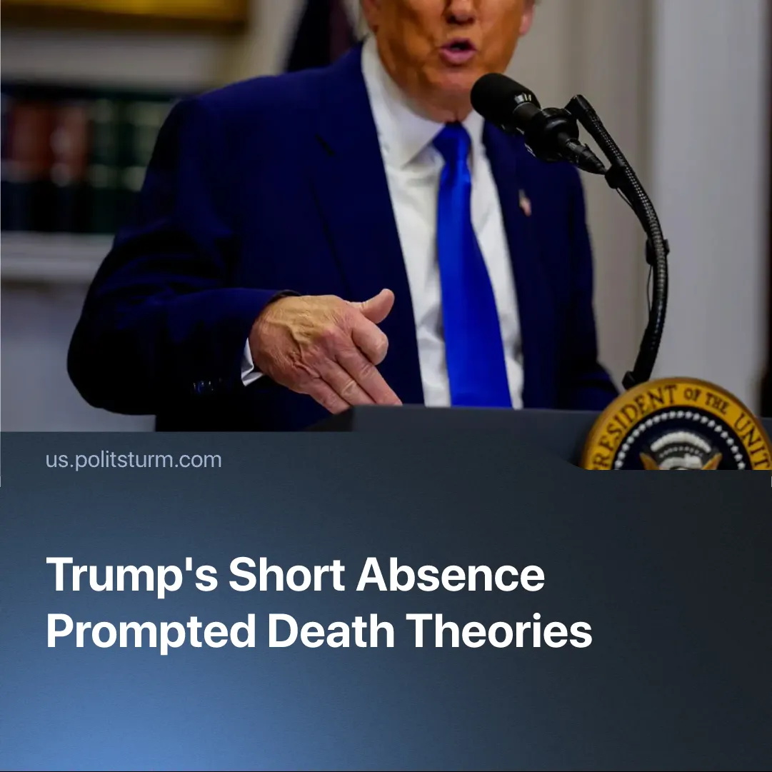

Original article
2025-09-11
1 min read

Trump’s brief absence from the public eye prompted theories about his health or possible death. But would such a death alter anything?
Details. In late August, theories spread online after Trump went six days without a major public appearance, with users speculating that his team was hiding a major health crisis or even his death, following earlier sightings of bruising on his hand.
► On X, hashtags like #TrumpDead and #TrumpBodyDouble trended, generating millions of impressions and tens of thousands of reposts. Many posts celebrated the idea of his death or mocked it with memes, some receiving tens of thousands of likes and reposts.
►US President Donald Trump dismissed the rumours about his health as "fake news" during a press conference at the White House. Trump himself responded by posting an old photo of himself golfing to “prove” he was alive — an action that only further excited the conspiracy theory.
Context. Political and economic tensions in the US are often personalised around Trump. A similar reaction occurred after the 2024 rally assassination attempt, when speculation and memes such as "how do you miss," "they missed," and "one job" trended on X.
► If Trump were to die, Vice President J.D. Vance would immediately assume office under U.S. law. Vance has already said of this possibility: “If, God forbid, there’s a terrible tragedy, I can’t think of better on-the-job training than what I’ve gotten over the last 200 days.” He has shown consistent alignment with Trump’s domestic policies and foreign posture, suggesting that his presidency would continue the same course without interruption.
► This demonstrates a broader principle. The death or change of a single leader rarely changes the course of an entire state. For example, US preparation for conflict in the Indo-Pacific with China has spanned multiple administrations; Iran’s foreign support of imperialist proxies and domestic repression continued after President Raisi’s death; and in France, multiple changes of Prime Ministers under Macron have not altered the persistence of austerity measures.

Original article

