Trump’s Asia Tour Achieved China Concessions
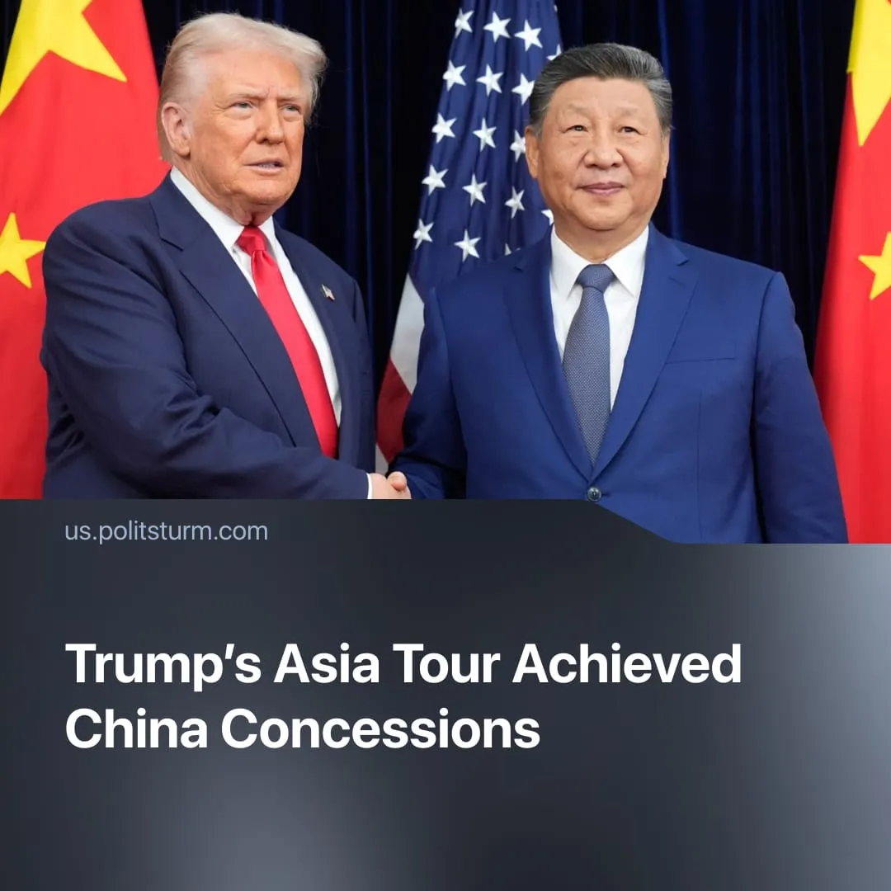

Original article
2025-11-08
2 min read

Trump’s Asia tour strengthened the encirclement of China – while securing trade concessions from Beijing.
Details. In late October, Trump visited several Asian countries with the stated aim of strengthening economic ties and military alliances to continue his campaign as a “peacemaker.”
► The tour began at the ASEAN summit in Kuala Lumpur, where Trump attended the signing of a peace accord between Thailand and Cambodia. Washington quickly followed with new security and infrastructure pledges for Southeast Asia, framed as “investment deals,” and negotiated partial easing of trade restrictions on US exports to key partners such as Malaysia, Thailand, and Vietnam.
► In Tokyo, Trump met Japan’s newly elected Prime Minister Sanae Takaichi, praising her push to expand the country’s military and purchase additional US defense equipment. The two finalized agreements on rare-earth minerals and joint missile-defense cooperation aimed at reducing reliance on Chinese resources.
► In South Korea, Trump met President Lee Jae-myung and approved the construction of a nuclear-powered submarine. Seoul pledged to invest $350 billion in the US and purchase over $600 billion in American oil and gas. In return, Trump reduced tariffs on automobiles from 25% to 15%.
► The tour concluded in South Korea with a meeting between Trump and Xi Jinping. Speaking afterward, Trump confirmed that the two had agreed to pause tariff escalations and had “talked about Ukraine for a long time.” Both sides pledged to expand agricultural and energy trade, with China agreeing to resume large-scale purchases of US soybeans and liquefied natural gas. The deal included a modest reduction in US tariffs on Chinese imports – from roughly 57% to 47% – while existing 15–25% duties on key industrial and technology goods remain in place pending further negotiations. Chinese average tariffs on the US remain at 32%.
Context. The trip occurred amid months of mutual maneuvering, with both the US and China aiming to close strategic vulnerabilities and strengthen their positions.
► Prior to the tour, Washington intensified pressure on major Chinese allies, Russia, Iran, and Venezuela, while taking control of infrastructure projects such as the Zangezur corridor between Armenia and Azerbaijan, weakening Beijing’s overland transport influence.
► At the same time, China recently strengthened control over its client states, hosting the largest-ever SCO summit with members including Russia and India. The summit produced 24 agreements on energy, infrastructure, and technology, including plans for a SCO Development Bank. Separately, China signed an expanded free trade pact with ASEAN countries, further boosting regional economic ties.
► The recent thaw of the US–China trade war, despite both sides calling for “stability,” came after China expanded restrictions on rare-earth mineral exports. In response, Washington planned to add 100% additional tariffs on Chinese imports.
► Despite the deal, both imperialist powers continue to seek to reduce dependence on one another. the US by securing access to rare earth minerals, and China by expanding domestic consumption, developing new export markets, and securing access to critical technology. This structural competition makes renewed confrontation inevitable, as illustrated by the recent thaw.
For a deeper analysis on the US–China confrontation, read our in-depth article on the topic.

Original article

