Trump Moves To Extend Federal Policing To Other US Cities
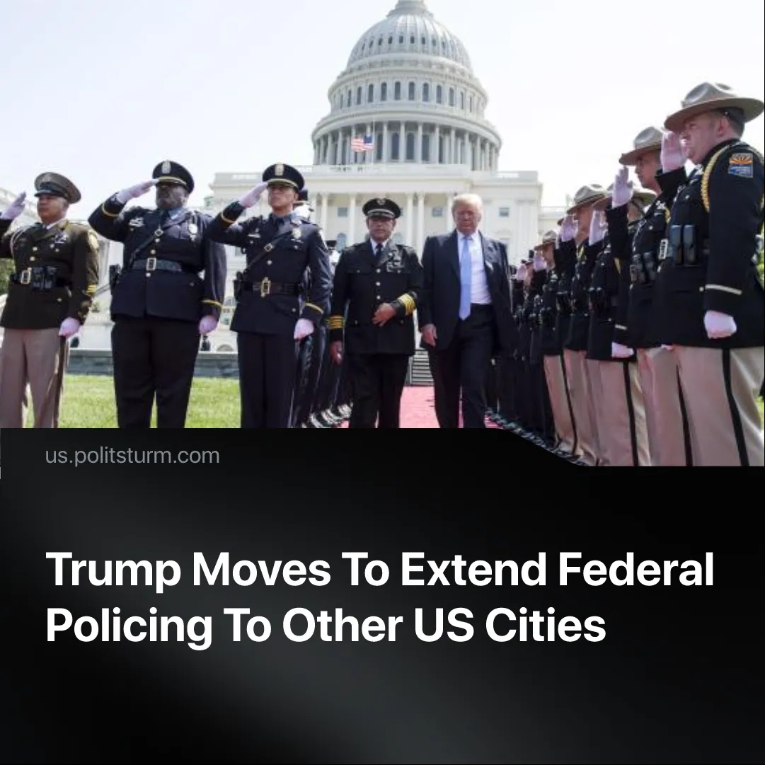

Original article
2025-08-16
2 min read

In a historic first, Trump has invoked emergency powers to federalise the D.C. police and deploy the National Guard after an attack on a DOGE official.
Details. On 3 August, Edward Coristine, senior adviser on government reform initiatives in the Department of Government Efficiency (DOGE), was attacked by a group of juveniles during a carjacking attempt in Washington, D.C.
► Following the incident, Trump announced a historic move to place the district’s police under federal control, invoking emergency powers under Section 740 of the D.C. Home Rule Act. He additionally deployed 800 National Guard troops “to help re-establish law, order and public safety,” of which 100–200 were assigned to support law enforcement.
► Trump justified the move by citing a “public safety emergency” involving rising crime, homelessness, public concerns, and “violent gangs,” emphasising the need to “reclaim” D.C. from “chaos, disorder, and destitution.”
► He also said that “this will go further”, suggesting possible National Guard deployments in other U.S. cities, specifically naming Chicago, New York, Baltimore, Los Angeles, and Oakland.
Context. Trump has previously deployed the National Guard in Los Angeles to suppress protests. In both cases, he relied on federal authority to bypass opposition from Democratic officials — in L.A., from Democratic Governor Gavin Newsom; in D.C., from 11 of the 13 council members, who are all Democrats.
► In Los Angeles, Trump invoked the “Supremacy Clause” — a principle that resolves conflicts between federal and state law in favour of the federal government — to bypass Newsom’s objections. In D.C., he relied on the Home Rule Act, which allows the President to assume direct control of the police in the event of threats to public safety and when local authorities are unable to maintain order.
► However, statistics show that violent crime in 2025 is at or below 2018 levels — depending on the category. D.C.’s murder rate in 2025 is declining and is comparable to rates seen in 2005 or even 1975. Offences such as carjacking and larceny are also decreasing.
Important to Know. Trump’s unprecedented federal takeover of the D.C. police is part of the ongoing fascisation of the U.S. state — the ongoing concentration of repressive powers in the executive, carried out to defend the rule of the capitalist class amid deepening crisis. Such measures are necessary for the bourgeoisie to pre-empt and crush potential working-class resistance.
► The move further normalises the use of emergency powers to bypass local authorities, targeting areas controlled by the Democratic Party — a rival faction of the same capitalist class — while creating legal precedents that either faction could later use to expand executive interventions.

Original article

