Trump To Deploy National Guard in More Cities
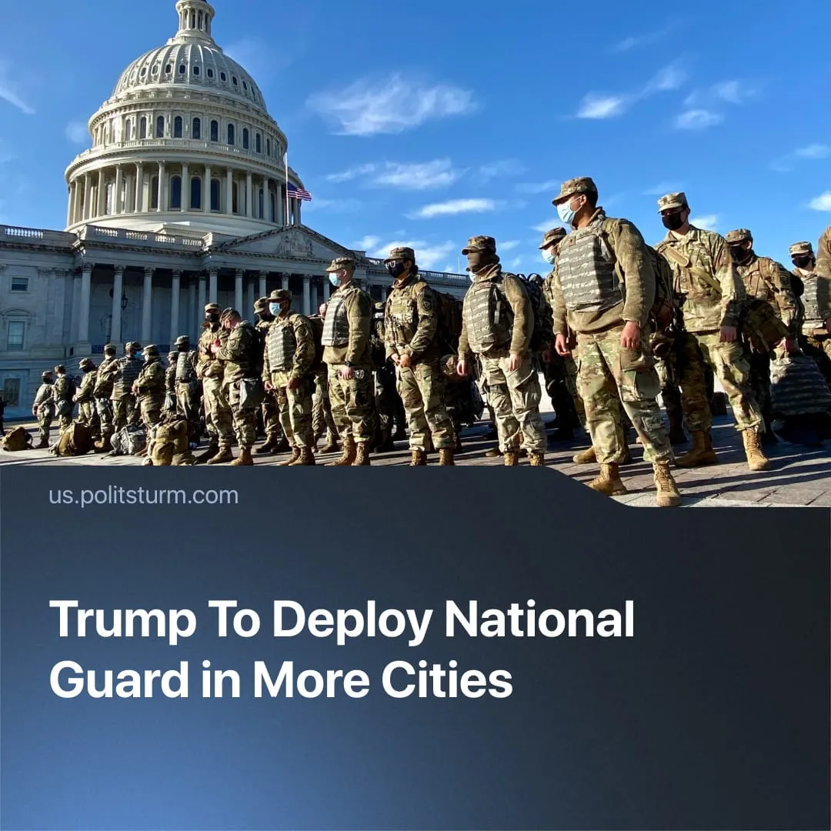

Original article
2025-10-16
1 min read

In under a year, Trump is on track to exceed all National Guard deployments initiated solely by the executive since World War II.
Details. Trump has recently aimed to deploy the National Guard in three cities.
► On September 27, Trump attempted to deploy about 200 Guard members to Portland to protect federal property from "Antifa and other domestic terrorists," calling the city "war-ravaged" and authorizing "full force, if necessary." A Judge blocked the deployment, ruling that local law enforcement could manage the unrest, and attempts to bypass the order were restrained.
► On October 8, 500 Guard members were sent to Chicago to protect federal personnel and property amid protests. US District Judge April Perry froze deployments for 14 days, and Illinois Governor J.B. Pritzker announced plans to sue, stating: "Donald Trump is not a king – and his administration is not above the law."
► On October 10, Separately, 300 Guard members were stationed in Memphis. In Tennessee, Republican Governor Bill Lee endorsed the Memphis deployment, citing the same justification of “rising crime”.
Context. Trump’s Guard deployments mark an unprecedented expansion of executive authority. Since World War II, presidents have federalised the Guard only in exceptional cases: Eisenhower in Little Rock (1957) to enforce desegregation, Kennedy in Mississippi and Alabama (1962–63) during university integration crises, and Johnson in Detroit (1967) amid large-scale riots.
► Earlier this year, Trump also sent federalised Guard units to Los Angeles, and Washington D.C. Each deployment was justified as a response to “rising crime” or “unrest.” In Los Angeles, Governor Newsom sued to stop the deployment, but courts froze the case pending proof of violence against protesters, and the deployment proceeded.
► Despite Trump’s claims, official data show that homicides and shootings in Chicago have fallen sharply, and demonstrations remain limited and largely peaceful. The deployment was met with marches downtown opposing federal involvement. Memphis has recorded its lowest overall crime rate in 25 years, though violent crime there remains above the national average.

Original article

