Trump Threatens Government Shutdown Over Immigration
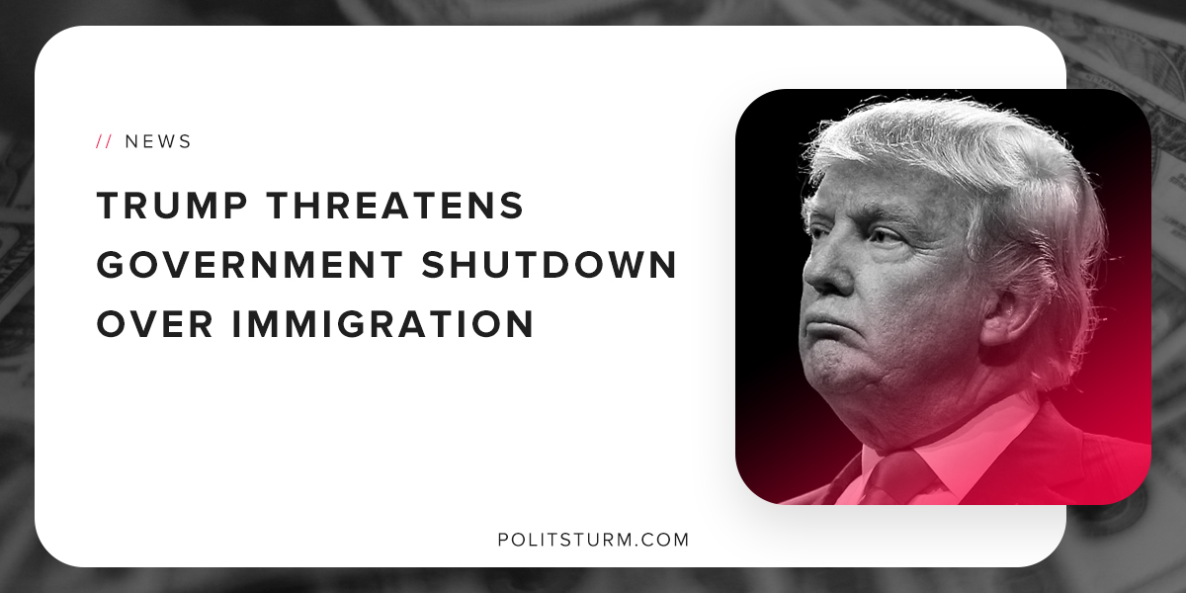

Original article
2018-08-08
1 min read

President Trump tweeted that he would be willing to shutdown the government if the Democrats do not cave to several of his demands surrounding immigration policy. Trump targeted the border wall, the visa lottery, merit-based immigration and several other right-wing immigration talking-points.
Trump stated that the United States has the worst immigration system in the world and it is in desperate need of reform. In actuality, this is nothing more than racist rhetoric aimed at division and confusion of the working class.
Consider the research of the Mercatus Center, the “non-partisan” think tank chaired by billionaire Charles Koch. The think-tank published a report that showed that all of the racist mythology surrounding the issue of immigration is patently false. The United States is not being flooded with immigrants. Immigrants do not bring higher rates of violent crime to the areas in which they live. These myths do not reflect reality, but rather are lies designed to benefit the oligarchs.
While the capitalist class can benefit from the labor of immigrants, they are used as a political tool to maintain the dictatorship of the capitalist class. As industrial production has left the United States to other countries in search of the highest possible profit, many Americans are suffering from unemployment and underemployment.
This has caused great anger and resentment, particularly in the “rust-belt” region that largely elected Trump. The area is accumulating rust because the capitalist class finds it more profitable to produce steel in other countries, particularly China. Capitalism, not immigration, it at the center of this issue. The United States is in a state of deindustrialization and decline and the capitalist class simply needs to deflect the blame onto the immigrant community. This is the crux of the matter.

https://www.mercatus.org/publications/benefits-of-immigration-key-myths
https://www.mercatus.org/charles-koch
https://www.trade.gov/steel/pdfs/07192016global-monitor-report.pdf
https://www.nbcnews.com/politics/donald-trump/trump-again-threatens-government-shutdown-over-immigration-n895586

Original article

