Trump Tariffs Lead America To Another Great Depression
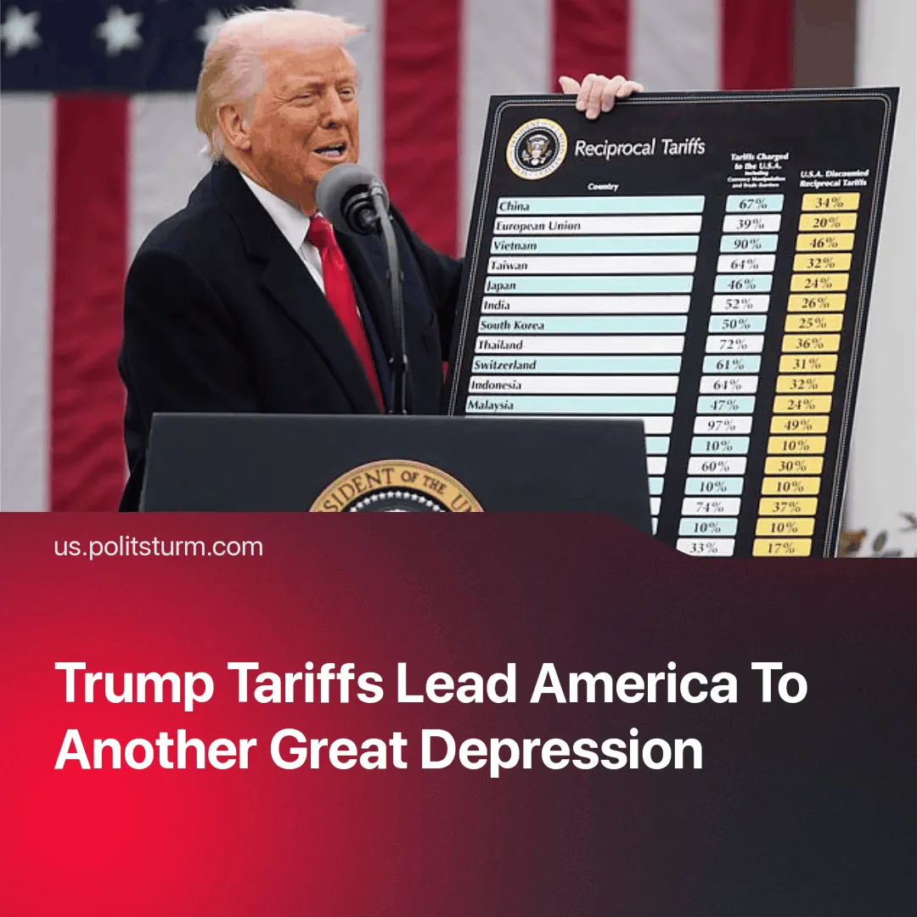

Original article
2025-04-04
3 min read

On 2 April 2025, US President Donald Trump announced sweeping tariffs on nearly every country, escalating the US trade war. He called it “Liberation Day”.
Details. A baseline 10% tariff will be imposed on all goods imported into the US, but some countries face up to 50% in import tariffs. Countries in the EU will face tariffs of up to 20%, and China will face 34% on top of the 20% already in place. Trump also confirmed 25% tariffs on steel, aluminium, and foreign cars
► Trump said the tariffs were a response to years of "unfair trade" — explaining that other countries have always imposed tariffs on US goods. He also said it would "restore American sovereignty, boost the national economy and protect American jobs".
► Countries around the world have promised countermeasures to these tariffs. The EU seeks a better deal but is preparing a proportionate response. China has retaliated with 34% tariffs, as it urges the US to cancel this latest round of tariffs immediately.
Context. This came as the US faced a ballooning trade deficit, which reached an all-time high of $131.4 billion. Imports rose by 10%, while exports grew by only 1.2%.
► Tensions are rising between China and the US as the EU tries to reassert itself as a third power. China's expanding sphere of influence threatens the hegemony that the US has enjoyed since the end of the Cold War.
► Many US national industries have struggled to compete with cheaper, and often state-subsidised, imports. One example is the US auto industry, which has a trade deficit of $93.5 billion and imports 50% of the cars sold in the US.
► Canada and Mexico, which were previously threatened with tariffs, are now exempt from the 10% base tariff. Earlier this year, both countries faced possible 25% tariffs on a range of goods, but these have been delayed or suspended in recent months as negotiations continue.
Important to Know. These tariffs are being used to redirect capital and consolidate markets in preparation for war, similarly to what happened in the early 20th century.
► Coming out of the post-Cold War era, the United States is seeking to reclaim the American market, a process Stalin had outlined before World War I in his book "Marxism and the National Question": "The chief problem for the young bourgeoisie is the problem of the market. Its aim is to sell its goods and to emerge victorious from competition with the bourgeoisie of a different nationality. Hence its desire to secure its "own," its "home" market. The market is the first school in which the bourgeoisie learns its nationalism."
► Trump's actions have a direct analogy with those of the Republican President Hoover from 1920s. Like Trump, Hoover imposed tariffs to "protect domestic producers" and unleashed trade wars. The result of his actions was the Great Depression: a rapid decline in world trade, the ruin of millions of people and a huge increase in unemployment. We are already witnessing a significant fall in the US stock market.
► Countries, most of which are heavily dependent on exports to the US, are either being forced to the negotiating table — such as Mexico, Canada or the UK — or are beginning to consider realigning with other economic powers. As other imperialist powers begin to respond in kind, we see the heating up of a global trade war that could escalate into armed conflict.
Conclusion. Behind the rhetoric of "Liberation Day" lies the reality of inter-imperialist competition. The United States is attempting to redivide global markets and reassert control over trade routes and resources at the expense of rival imperialist powers. These contradictions are the inevitable consequence of the capitalist system’s crisis of overproduction and stagnation.
The burden will fall on the working class — first through job losses, inflation, and austerity, and then through conscription and death, as history has already shown.

Original article

