Trump Targets Left Under “Antifa” Label
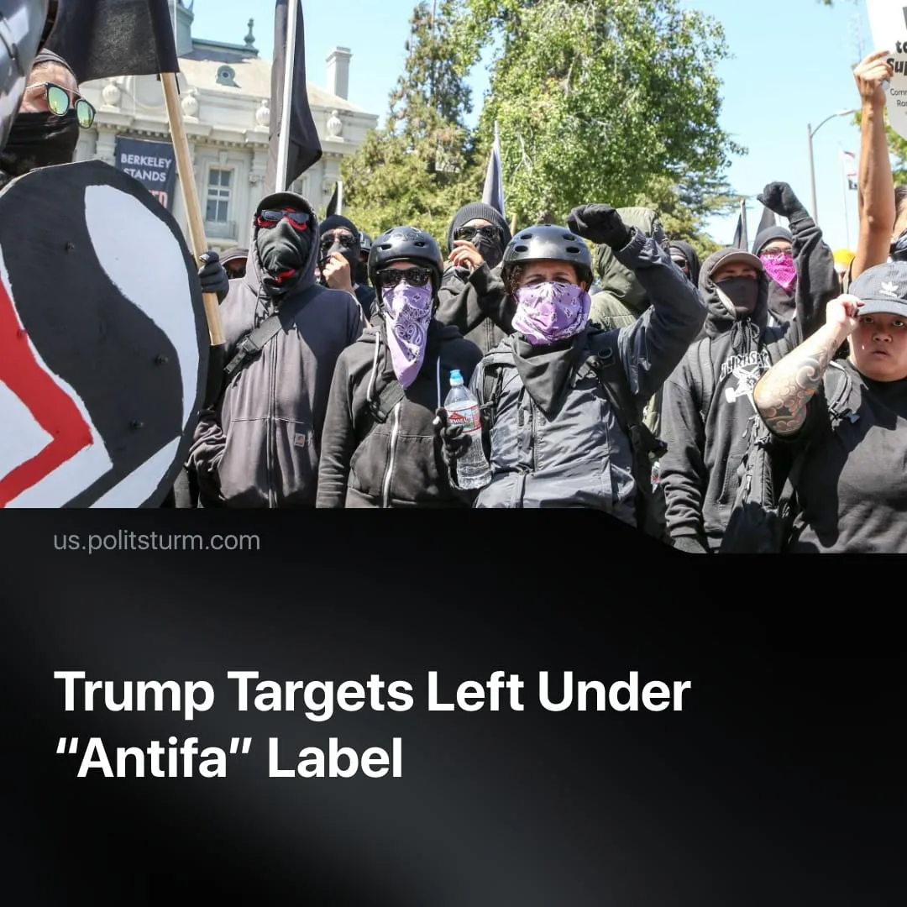

Original article
2025-09-24
1 min read

Trump has declared “Antifa” as a domestic terrorist organisation. This threatens communists and left-wing activists in general.
Details. On September 22, 2025, Trump signed an executive order designating Antifa — short for “anti-fascism” — as a domestic terrorist organisation. He described Antifa as “a sick, dangerous, radical left disaster” and called for an investigation into its source of funding.
►The legal implications remain uncertain. US law currently only allows foreign organisations to be designated as terrorist groups, but there is no equivalent framework for domestic entities. Trump’s executive order nonetheless opens the door to surveillance, prosecutions, and financial penalties against anyone accused of “funding” or “associating with” Antifa.
► Antifa is not a real, centralised organisation. The term is mostly used by loosely organised anarchists who adopted it after the dissolution of the socialist bloc. Right-wing commentators have broadened the term to encompass a wide spectrum of leftists.
Context. Charlie Kirk’s assassination has immediately been used as a martyr to justify increasing repressive measures and to increase persecution of any leftists. This move also serves to divert attention away from other issues of Trump’s presidency, such as his involvement in the Epstein case, the struggling economy and difficulties in negotiating peace between Ukraine and Russia.
► After the socialist bloc’s collapse, anarchist and ultra-left groups — harmless to capitalism — adopted the term for loosely organised anti-fascist activism. Labelling “Antifa” a terrorist organisation now sets a precedent to target communists, who have historically been the only force capable of effectively challenging capitalist power and played the decisive role in the fight against fascism.

Original article

