Trump Sets 50-Day Ultimatum for Russia Over Ukraine Peace Deal
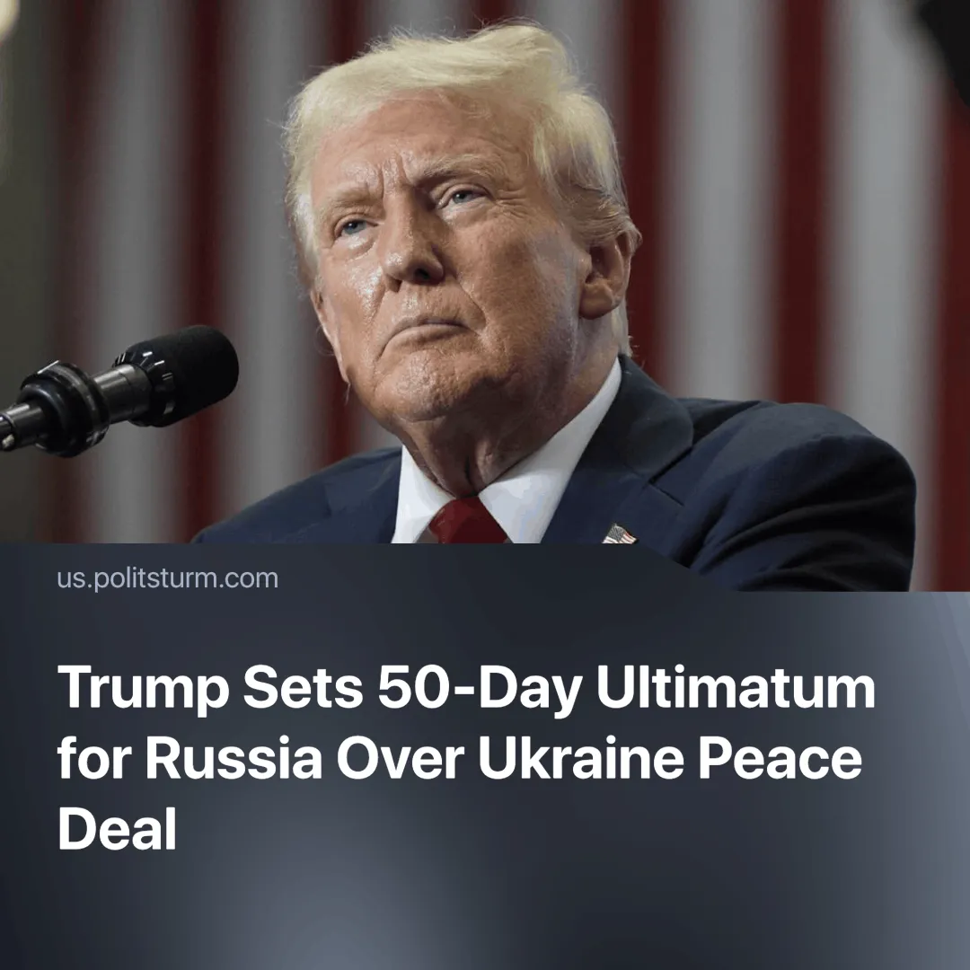

Original article
2025-07-23
1 min read

Faced with a 50-day deadline and the threat of sweeping tariffs, Russia may escalate its military campaign in Ukraine to gain leverage before talks.
Details. Trump’s ultimatum was announced during a meeting with NATO Secretary-General Mark Rutte on July 14.
► Trump stated that “100% secondary tariffs” would be imposed on Russian goods and any country continuing to trade with Russia if no deal is reached within 50 days.
► The Kremlin dismissed the 50-day deadline as “election posturing,” but Russian media outlets warned that US economic escalation could prompt retaliatory trade measures and a renewed military push in Ukraine.
► Zelensky reportedly asked Trump to approve a US-backed strike on Moscow, but Trump refused, calling it “reckless” and claiming it would “drag America into World War III.”
Context. Although Russian exports to the US account for only 3–5% of its total trade, secondary sanctions could impact major partners like China, which recently reached a tariff reduction deal with the US. This creates pressure for Beijing to influence Moscow’s decisions.
► Trump’s threat comes as NATO announces new weapons shipments to Ukraine, including air defence systems and long-range artillery.
► The 50-day deadline may push Russia to escalate offensives in Ukraine to improve its leverage. Reports suggest North Korean reinforcements are already arriving to support these efforts.

Original article

