Trump Renames Department of Defense
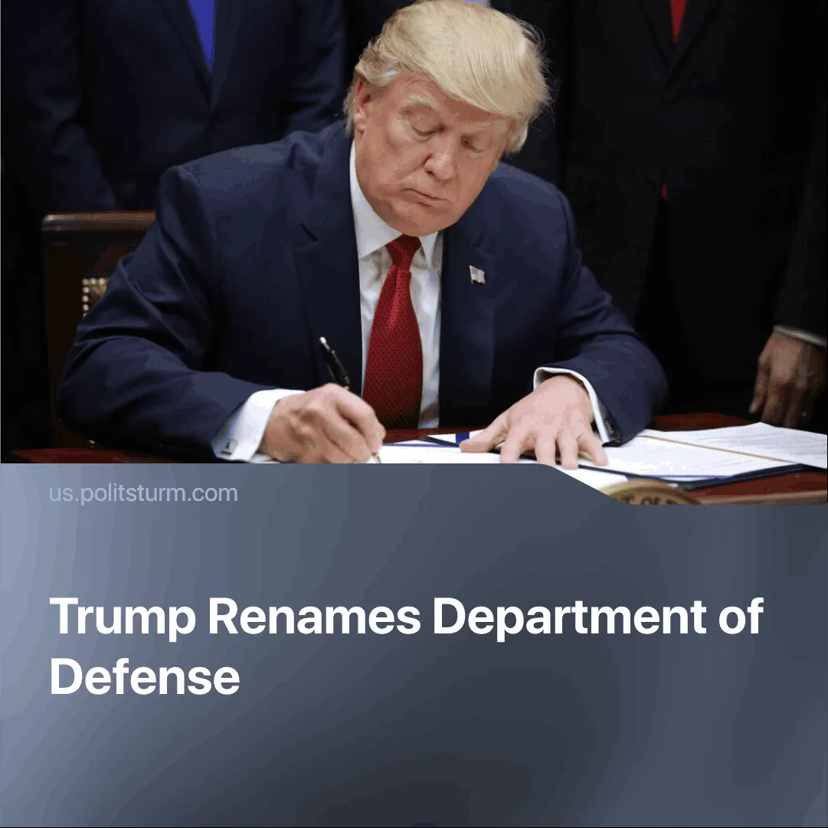

Original article
2025-09-10
1 min read

By evoking its image as the “victor” of the World Wars, the US seeks to stoke chauvinism and prepare workers for war.
Details. On September 5, 2025, Trump announced an executive order that allows the Department of Defense officials to use “Department of War” as a secondary title, such as “Secretary of War”. The Pentagon has changed its domain from defense.gov to war.gov, stationary and official signs will be updated accordingly.
► Trump stated that renaming the Pentagon carried “a message of victory”, stressing that it was “really about winning” and recalling the US as a “winner” in both World Wars. He and his Republican allies noted that it was officially the “Department of War” until 1949, with Pete Hegseth arguing that the US “hasn’t won a major war” since.
Context. In 1949, Congress renamed the unified military structure previously called “National Military Establishment” to “Department of Defense” amid the upcoming Cold War, aiming to present US interventions as “defensive” in contrast to the USSR and its support for anti-imperialist movements.
► Trump’s reversal of this name shows recognition that imperialist powers are again heading toward a major armed confrontation, with US military spending projected to reach $1.01 trillion in 2026 — a 13% increase from 2025.
► By invoking the language of “war”, Washington seeks both to normalise militarism among the US population and to fuel chauvinism, while simultaneously signalling to rivals — above all China — that it is preparing for direct military conflict.
For a deeper analysis of the China–US rivalry, see our in-depth article on this subject.

Original article

