Trump Promised Peace but Continues to Escalate Militarism
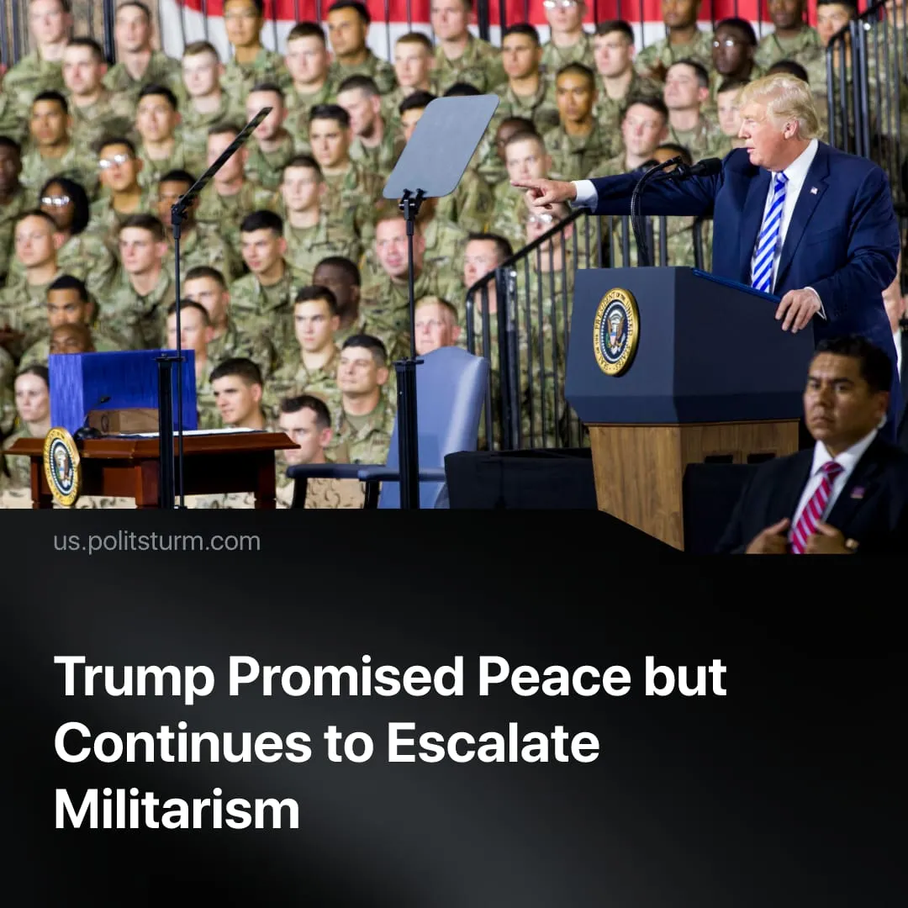

Original article
2025-12-17
2 min read

Trump promised peace at the beginning of 2025. As a result, the US adopted the largest military budget in history, bombed Iran, and threatened to strike Venezuela.
Details. Throughout 2025, the Trump administration has demonstrated an escalation in US militarism.
► On September 5th, the Department of Defence was renamed the “Department of War,” invoking a WWII-era title in an attempt to bolster the US’s image as a “war winner,” while also normalising militaristic language.
► Trump’s “Big Beautiful Bill” grants the largest US military budget in history, increasing military spending by $100 billion, funded through cuts to social spending programs such as healthcare and food assistance.
► The number of strikes on foreign countries during Trump’s first year has already exceeded that of the entire Biden administration. This includes attacks such as “Operation Rough Rider,” US military action against the Houthis in Yemen, and the 12-day war between Israel and Iran, during which the US bombed three Iranian nuclear research facilities.
► As of late 2025, the US has deployed over 15,000 troops, an aircraft carrier strike group, submarines, and advanced aircraft near Venezuela. Operations include the destruction of civilian vessels under the pretext of alleged drug trafficking, the seizure of a Venezuelan oil tanker, potential CIA activity, and possible cyberattacks on Venezuela’s state-owned oil company, alongside ongoing aerial patrols.
Context. Trump led a campaign on conflict reduction, stating in his inaugural address that he would be remembered as a “peacemaker.” He has repeatedly expressed a desire to be awarded a Nobel Peace Prize for his brokering of ceasefires in Africa, the Middle East, and South Asia. Recently, he was awarded the “FIFA Peace Prize,” an award created only one month beforehand, essentially designed as an appeasement gift.
► Many so-called “successful” peace deals merely freeze conflicts, allowing the US to shift focus to its main inter-imperialist rivalry, China. In Rwanda and the DRC, the ceasefire quickly collapsed as Rwandan-backed militias resumed seizures of Congolese land, while the US secured mineral access through the agreement.
► A ceasefire brokered by Trump between Thailand and Cambodia has also recently proved ineffective, with clashes resuming as both sides claim to act in “self-defence.”
► The major economic powers of the world, such as Europe, China, and the US, are preparing for a large-scale redivision of territory. Globally, armed conflict already reached a 75-year high in 2024, whilst the capitalist-led UN has proven incapable of de-escalation in the face of inter-imperialist contradictions.

Original article

