Trump Prioritises War Spending Over Healthcare
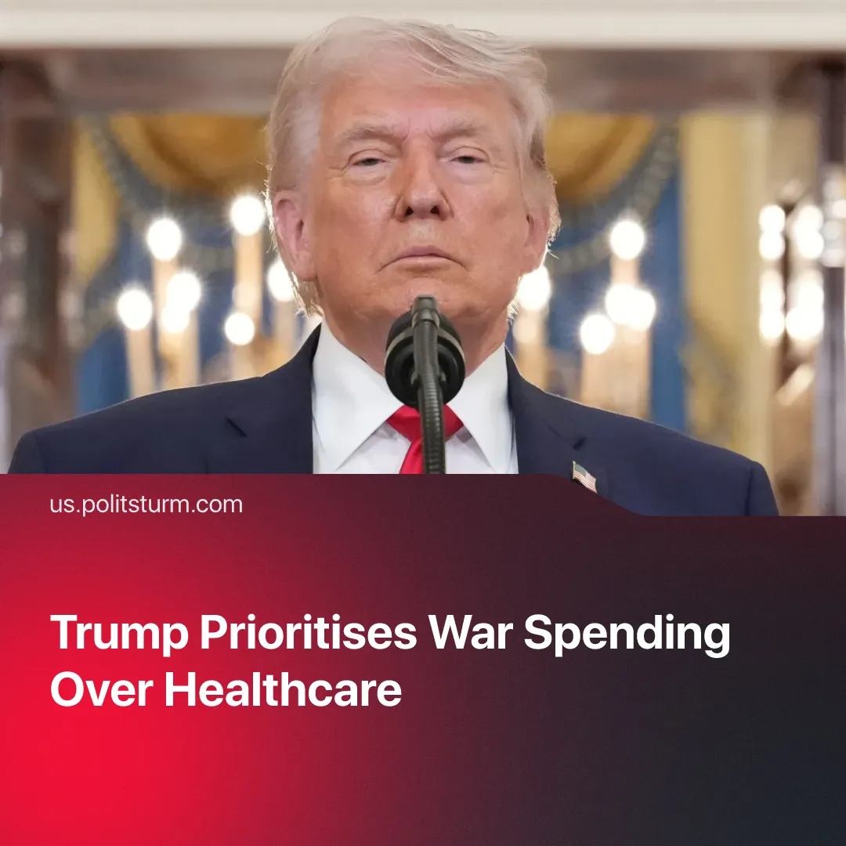

Original article
2026-04-08
2 min read

Trump says the US cannot afford kindergartens or healthcare. Meanwhile, around $20 billion has been spent on bombing Iran.
Details. On April 1, during a White House Easter event, President Donald Trump said “it’s not possible” for the US to fund daycare and Medicare programs because “we’re fighting wars” and “we have to take care of one thing: military protection.” In 2025, US federal healthcare spending is projected to reach approximately $1.8 trillion, including roughly $900 billion for Medicare and $691 billion for Medicaid.
► For 2026, the US Congress approved a baseline defence budget of roughly $840 billion. On March 19, 2026, the US military requested an additional $200 billion in funding for the Iran war. This request has not yet been approved and is facing significant resistance in Congress. At the same time, the Pentagon is proposing a record-breaking $1.5 trillion military budget for 2027.
Context. In his second-term inauguration speech, Trump told Americans: “We will measure our success not only by the battles we win but also by the wars that we end — and perhaps most importantly, the wars we never get into.” A year earlier, he also claimed: “I will stop the chaos in the Middle East, and I will prevent World War III.”
► As previously shown, the war in Iran is rapidly increasing military expenditure, driven in part by the use of extremely costly equipment. By April 1, the offensive is estimated to have cost the US $16.2-23.4 billion.
► Military spending is currently near half of total healthcare spending, and is expected to rise further. Although the US spends more on healthcare than any other country, the system continues to deteriorate in quality and remains inaccessible to millions due to high costs. Meanwhile, the largest health insurers have amassed around $54 billion in profits, while major pharmaceutical companies (such as Pfizer and Johnson & Johnson) continue to generate exceptionally high profits.
► In contrast, despite allocating only about 6% of government spending to healthcare by 1939, the USSR maintained a system of universal, free care for its entire population from 1934.
For a deeper analysis of the US-Iran conflict, see the Marxist position on this subject: The Middle East: Architecture of War.

Original article

