Trump Orders Delay of Immigration Raids
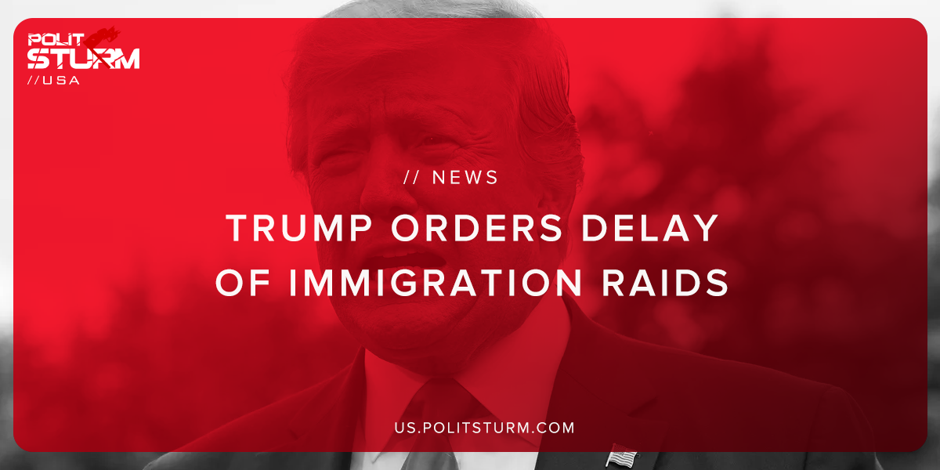

Original article
2019-06-23
1 min read

President Trump announced that he would be delaying the planned deportations that were planned to occur this weekend across 10 major US cities. The raids are intended to forcibly remove 2,000 families who have received orders to turn themselves in to immigration enforcement officials.
The acting director for Immigration and Customs Enforcement (ICE) Mark Morgan said that the purpose of the planned raids was to maintain the “rule of law”.
The capitalist class in the United States benefits doubly from illegal immigration. First, employers are able to exploit the hard-working immigrant population who lack even the basic legal protections afforded to citizens and permanent residents.
Secondly, the capitalist class is able to redirect criticisms related to the economic de-industrialization of the United States, the lack of jobs, and the lack basic healthcare and educational services, onto immigrants.
The “rule of law” in the United States in actuality is the dictatorship of the bourgeoisie. The rule of law protects the class of exploiters, the capitalists, and their ability to extract profit from the international working class. For workers to target immigrants and support the enforcement of the “rule of law” is only to be deceived into supporting the interests of the oligarchical class of billionaires.

Sources: 1, 2, 3

Original article

