Trump Launches “Anti-Communism Week”
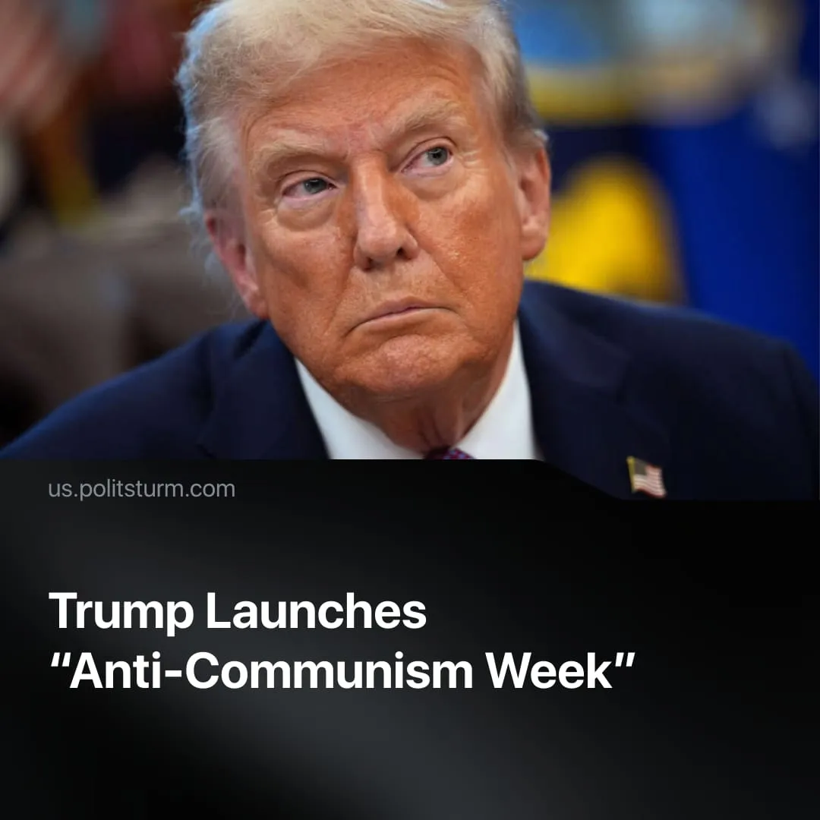

Original article
2025-11-20
2 min read

Trump's "Anti-Communism Week" was timed to coincide with the anniversary of the October Revolution. In the wake of Mamdani's election and the Epstein files, it went unnoticed.
Details. On the anniversary of the Great October Socialist Revolution, President Trump announced that November 2–8 would be “Anti-Communism Week” in the USA.
► The proclamation reiterated Cold War propaganda myths – communists killed “100 million,” communists want to “suppress freedom” and “destroy prosperity.” These claims were contrasted with supposed American virtues such as “liberty” and “human worth.” Trump vowed to continue fighting communism, even when it “appears” under names like “social justice” or “democratic socialism.”
► The proclamation received little attention from mainstream media, except the liberal outlet “The Nation”, which merely reversed the Trump administration’s accusations of communism “back in their face.”
Context. Democratic Party candidate Zohran Mamdani, a self-described “socialist,” recently won the New York City mayoral election over a Trump-endorsed opponent. Trump used this outcome to escalate anti-communist rhetoric for factional advantage within the capitalist class. Both factions routinely label each other “Marxist” and “communist,” despite representing the same class interests.
► Trump’s proclamation extends the federal government’s recent repression of “Antifa” and, by extension, communists. As we previously covered, the Charlie Kirk and ICE shootings were instrumentalised to spread fascist slogans and justify counter-terrorism measures against the broad left.
► Coming into 2026, there are no concrete plans for further protests against Trump’s regime. The “No Kings” protests have fizzled out for now, lacking clear leaders and a program, although communists were blamed for instigating the demonstrations.
► Renewed Cold War rhetoric functions as propaganda in the inter-imperialist rivalry with the Chinese capital bloc, legitimising intensified repression and preparing the population ideologically for war.
Important to Know. This campaign is effectively fascism week, as anti-communism is the ideological core of fascism. Reactionary and chauvinist positions are now openly proclaimed at the federal level, accelerating the fascisation of the US. Trump’s base – major capitalists, MAGA nationalists, small business owners, declassed and marginalised layers – is being mobilised accordingly.
► MAGA attacks on communism are fused with attacks on the moderate wing of capital – the Democratic Party, which they label “woke,” “radical left” or “socialist.” This tactic aims to weaken the electoral opposition while reviving Cold War tropes of communist infiltration. Crucially, repressive laws like the 1954 Communist Control Act – which suspends the civil rights of suspected communists – remain on the books. Trump allies are now threatening to wield these tools against figures of the moderate wing of capital, such as Zohran Mamdani.
► This escalation of political rhetoric reflects capital’s response to its growing crisis with deepening internal contradictions and an intensifying drive toward imperialist war with the Chinese capital bloc. American workers face impoverishment, tariff-driven inflation, rising unemployment, and welfare cuts, all while a record-high $1 trillion military budget was passed. Trump’s “America First” policies have failed to convince the population; most Americans no longer view capitalism positively.
► Even 35 years after the USSR’s collapse, communism remains a central preoccupation for the ruling class. The US President is making proclamations as if it were 1970, in the midst of the Cold War. This demonstrates how deeply the bourgeoisie remains haunted by the spectre of communism – how dangerous it is to their class rule, and why even mild hints of it are immediately strangled.

Original article

