Trump Begins 2026 by Invading Venezuela After Promising World Peace
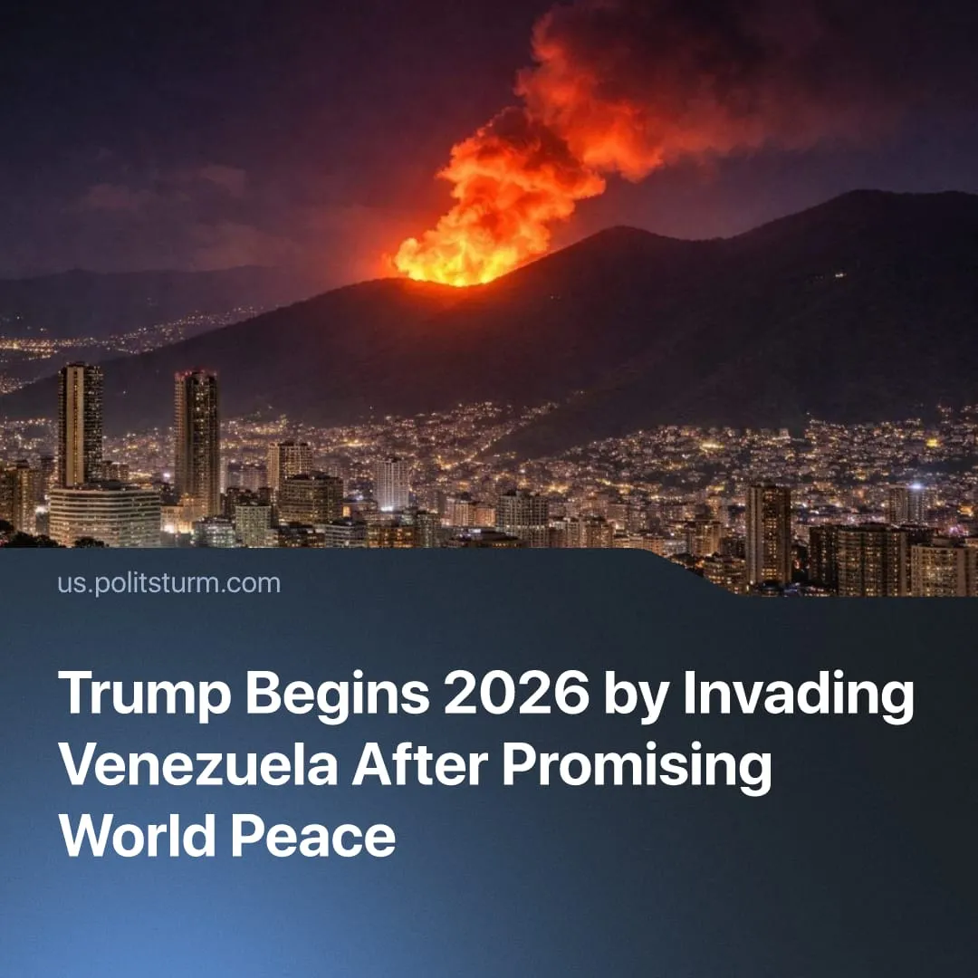

Original article
2026-01-05
1 min read

Trump started the new year by invading Venezuela. Less than a week ago, he spoke of approaching world peace.
Details. On January 3, the United States carried out a violent coup to remove Venezuela’s existing bourgeois government and replace it with a US-controlled alternative.
► US military forces intervened directly, using air and ground operations against Venezuelan state infrastructure. The operation resulted in the capture and removal of President Nicolás Maduro, and Trump subsequently announced he was working with the vice president, Delcy Rodríguez.
► Washington framed the invasion as a law-enforcement action, claiming it was “executing an arrest warrant,” rather than an act of war.
► Trump also openly linked the regime change to oil interests, stating: “We're going to have our very large United States oil companies, the biggest anywhere in the world, go in, spend billions of dollars, fix the badly broken infrastructure, and start making money for the country.”
► Following the coup, Trump also issued indirect threats toward other South American governments, warning Colombian President Gustavo Petro that “he does have to watch his ass,” and stating that “Cuba is going to be something we’ll end up talking about, because Cuba is a failing nation right now … we want to help the people in Cuba.”
Context. During the 2024 election campaign, Trump repeatedly promised to quickly end wars abroad, presenting himself as a “peacemaker” and stating he would reduce global conflicts. He emphasised his intention to negotiate ceasefires and portrayed himself as uniquely capable of achieving stability and peace in contrast to a weak Biden administration.
► Trump continued to present himself as a peace-maker – brokering ceasefires and freezing conflicts in Ukraine, the Middle East, South Asia, and Africa, while pushing for a Nobel Peace Prize. These agreements were largely fragile and strategic, securing US access to resources, consolidating influence, and allowing focus on the main inter-imperialist rivalry with China.
► On January 1, 2026, Trump declared “peace on Earth” as his guiding objective for the year, framing world peace as imminent – less than forty-eight hours before ordering a new US military intervention in Latin America.

Original article

