Trump impeachment trial begins
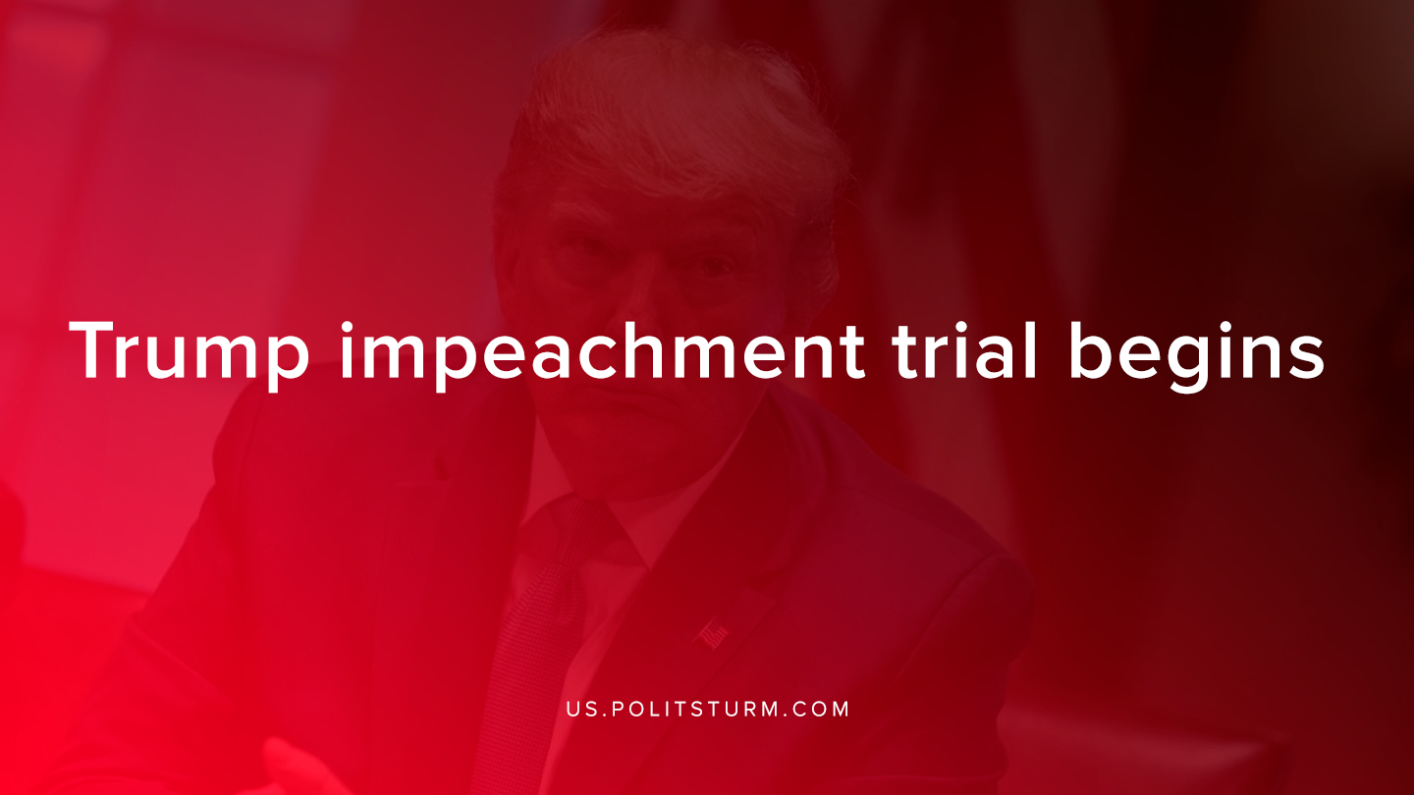

Original article
2020-01-25
1 min read

The Republican majority Senate voted to adopt a resolution that lays out the rules for the impeachment trial of Donald Trump. Trump is on trial for the withholding of military aid unless Ukrainian President Zelensky investigated the activity of Hunter Biden, the son of Democratic candidate for president Joseph Biden.
Hunter Biden was on the board of directors for a Ukrainian natural gas company called Burisma Holdings. According to allegations from the Democrats, Trump pressured the Ukrainian president to investigate potential corruption of his political rivals and withheld military spending in the process.
The formal articles of impeachment say that Trump abused his power and should be removed from power for the failure to: preserve “protect and defend the Constitution of the United States”. The second charge alleges that Trump obstructed justice in hampering attempts to investigate this conduct.
The Trump administration has referred to the impeachment process as a “brazen political vendetta” against Trump.
The two major bourgeois political parties are in conflict over the Trump impeachment. The Democrats allege that Trump put his personal political interests above the imperial interests of the United States. The Republicans allege that no laws were broken and that the impeachment has no factual basis.
The bourgeois political spectacle of the Trump impeachment trial is merely a dispute between different bourgeois political parties within the United States.
Both the Democrats and the Republicans protect the interests of the propertied class, the capitalists and landlords. Under the capitalist system, the political system merely redirects the systemic discontent of the economic system. Both political parties are neither able nor willing to resolve the problems of capitalism because they uphold the dictatorship of a class, namely the bourgeoisie.
Only under the dictatorship of the proletariat and the political rule of the proletariat class will it be possible to remedy the systemic crises brought forth by capitalism. Under these conditions the political theatre of the bourgeois representatives will be a relic of the past.
Sources:
1, 2, 3

Original article

