Donald Trump Cracks Down on Illegal Migration
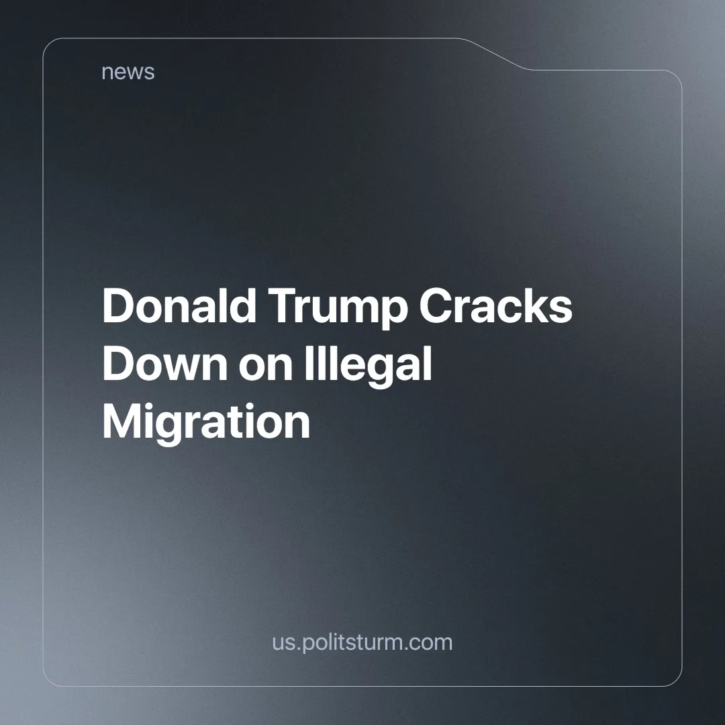

Original article
2025-02-12
7 min read

During his presidential campaign, Donald Trump promised to deport “at least 15 million - and as many as 20 million” [1] undocumented migrants. Basic arithmetic gives us a range of about 13,900 deportations per day, with 7,600 at the low end over a four-year presidency. In the first 10 days, as of January 29, U.S. Immigration and Customs Enforcement reportedly arrested 1,016 illegal migrants [2].
Far short of the promise but still loathsome as the migrants themselves are blamed for the problems, born out of the inherent contradictions of capitalism. Illegal migrants have journeyed to find a better life to escape desperate poverty or war. In view of the fact that countries higher in the hierarchy of imperialist relations have generally enjoyed more stability and higher standards of living than the dependent nations. In other words, migrants come to the U.S. in no small part because the U.S. ruling class has an interest in keeping their countries exploited at a higher rate. Videos of Gestapo-like raids, and migrants chained aboard military planes, show the erosion of the U.S. social fabric resulting from the deepening contradictions of capitalism in the U.S. and its imperialist grip over the globe.
There is no shortage of footage of the raids, as it is painted in nationalistic rhetoric by bourgeois news networks. From a Colorado raid, whose enforcers asked residents to “snitch on their neighbors” [3], to teachers turning against their students [4] [5]. In Huston, where ICE “was taking people in chains” [6] an eyewitness reported. On the other hand, in New Jersey a case was highlighted as ICE “stormed a place of business without a legal warrant” [7] detaining in the process a U.S. military veteran. Furthermore, in California, even State Senator Nancy Skinner stated in 2018 that ICE was using “great intimidation tactics” [8] to the point even schools were preparing to protect their students from them. Yet this is happening again, as the U.S. Department of Homeland Security issued a directive to arrest undocumented migrants even in churches and schools, reducing at some places attendance to as much as half [9].
This has already had an economic impact, as seen in East Boston, where there has been less commercial engagement in local businesses. We must reject the chauvinist framing that pits locals against immigrant workers. The real minority siphoning off the wealth of the nation is not the illegal immigrant struggling to survive under harsh working conditions, but the exploiting class, that thrives on the exploitation of all workers, being themselves native or otherwise.
Elon Musk is a perfect example of this capitalist minority siphoning off wealth and their hypocrisy; as one of the richest men on earth, he exploits the labor from both American workers and undocumented migrants alike, while not born in America himself, and yet still expounding American chauvinism. In New York City, restaurants and street vendors are fearful, and the latter have generally stopped popping up as raids target wholesale and food markets [10]. In Los Angeles, ICE continues with indiscriminate arrests of people even as they are "going to work" [11].
Meanwhile, ABC News reported that in California, "the breadbasket of America", at least half of the workers were undocumented [12]. As Trump’s rhetoric ramps up the hate towards undocumented migrants, they endure some of the harshest conditions under modern wage slavery, to feed the American people. Being undocumented sets them up for ‘A lot of abuse for little pay’ [13], as an aptly named news report by The Guardian about a human smuggling and labor trafficking operation outlines, “The Georgia workers were threatened with deportation or violence if they did not comply with the conspirators”. The indictment includes allegations of “raping, kidnapping and threatening or attempting to kill some of the workers or their families, and in many cases sold or traded the workers to other conspirators”. At least two workers died as a result of the living and working conditions and another was repeatedly raped, the indictment said. We have previously written about the treatment of illegal migrants in the US.
The possibility of death is not uncommon as reported by the BBC, tragically Jose Arturo Gonzalez Mendoza “died within his first few weeks on the farm in September 2023” leaving “wife and children in Mexico” in pursuit of a better life for them and him [14].
The reign of terror has had the desired effect, as undocumented workers are now afraid to leave their homes [15]. And this fear is not unfounded, as migrants are now even being placed in Guantanamo [16][17]. The infamous black site, located outside the U.S. used for torture [18]. This has sparked international anger as Indian [19] [20], and Colombian [21] among other migrants have been reported to be flown in chains [30].
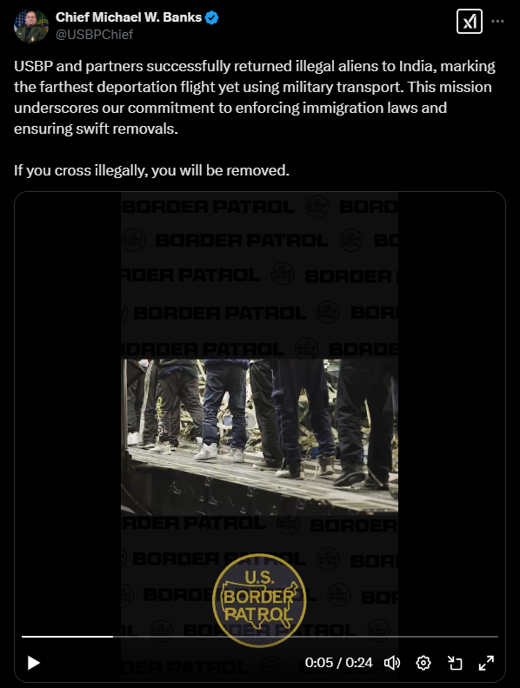
Immigration has served as a smokescreen to mask the inherent contradictions of capitalism, since it is not unique to the U.S. It has been used to explain the decline in the purchasing power of the working class (the fall in real wages), the rising cost of home ownership, and so on, which are all trends, felt by a greater or lesser degree by the whole world. This is quite evident when we see the media spectacle made out of deportations, starting from January 20, 2025, from the Twitter account of U.S. Immigration and Customs Enforcement [22].

The U.S. has long cultivated the myth of the American Dream. Defined by the Oxford Dictionary the American Dream is “​the belief that America offers the opportunity to everyone for a good and successful life achieved through hard work” [23]. This myth constitutes nothing more than an ideological weapon. As Jose Arturo Gonzalez Mendoza died too in the pursuit of it, deceived as the “American dream is a powerful attraction for destitute and desperate people across the globe, and where there is need, there is greed from those who will attempt to exploit” [14]. But as stated before, the perpetuation of this myth is in the interests of the capitalist class that exploits such desperate people. While the official policy towards undocumented migration under Reagan in 1982, was one of “Our nation is a nation of immigrants” [24]. Today the very same U.S. government cast immigration, particularly undocumented, as the root of all evil threatening the country, after gleefully enriching themselves from their harsh exploitation for so many years.
The escalation of repression against undocumented migrants is a direct response to the deepening contradictions of capitalism; the accumulation of wealth for the few, while the living standards of the working class plummet. The lowering of acquisitive power – through higher prices without increases in wages – nearly unpayable higher education [25] and housing [26], needs to be explained away with scapegoats. Obscuring the reality that the root cause lies in capitalist development and its inherent contradictions. As capitalists reap record profits [27] and the richest men alive align themselves with Trump [28]. The real enemy is not the migrant worker struggling to survive; it is the very system that exploits and dispossesses all workers, driving up the price of necessities, regardless of nationality.
Yet again these are not ideological U-turns, but tactical adjustments to maintain their class hegemony, by replacing the contradictions of labor and capital, with foreigners and nationals. Rehashing the conciliatory idea that, no longer are employers and employees separated by class, but united under nationality. History shows us that in times of increased contradictions between labor and capital, when the hardships of the working class become more and more unbearable, the state has turned to chauvinism to distract the workers from the real sources of their suffering as is happening today in the U.S. The American people have to endure “a little pain” [29] as Trump said, so to allow their capitalists to carve a bigger part of the world from the Chinese and European imperialist powers.
The solution lies in the abolition of the system that enriches the few on the backs of the many. By replacing the exploitative capitalists’ economic relations with socialism. And the only way to achieve such a goal is by the formation of a communist party, that represents the common interests of the proletariat across all borders. Our response is the organization of one such party, as a concrete path towards socialism. Join us in the fight for a world where no human is disposable, where no one is criminalized for seeking a livelihood, join us in the fight for socialism.
[1] The Guardian — “Trump confirms he will utilize US military to conduct mass deportations” — 18/11/2024
[2] U.S. Immigration and Customs Enforcement — “Trump confirms he will utilize US military to conduct mass deportations” — 29/01/2025
[3] ABC 7 Chicago — “Video shows ICE agents carry out Colorado raids” — 6/02/2025
[4] New York Post — “Texas teacher invites ICE to raid his Fort Worth school” — 26/01/2025
[5] The Washington Post — “Pennsylvania school bus operator posted ‘No speaking Spanish’ sign - ” — 5/02/2025
[6] FOX 26 Houston — “ICE raids Houston business on the north side, sources say” — 27/01/2025
[7] PIX11 News — “ICE agents raid NJ seafood store, detaining U.S. military veteran” — 23/01/2025
[8] KPIX | CBS NEWS BAY AREA — “Bay Area Cities Brace For Workplace ICE Raids” — 23/01/2018
[9] WTVC NewsChannel 9 — “Concerns grow over ICE raids in public schools” — 2/02/2025
[10] NewsNation — “ICE raids heighten fear among NYC street vendors | Morning in America” — 5/02/2025
[11] FOX 11 Los Angeles — “ICE raids, immigration arrests expand across Los Angeles” — 29/01/2025
[12] NewsNation— “Migrant farm workers on high alert amid immigration raids” — 03/02/2025
[13] The Guardian — “‘A lot of abuse for little pay’: how US farming profits from exploitation and brutality” — 25/12/2021
[14] BBC — “‘Migrant farm worker deaths show cost of the 'American Dream'” — 01/09/2024
[15] Eyewitness News ABC7NY— “Undocumented immigrants afraid to leave their houses amid immigration raids.” — 04/02/2025
[16] The Times and The Sunday Times — “First migrants land at Guantanamo Bay after mass deportation” — 07/02/2025
[17] CNN — “Migrant flight lands in Guantanamo Bay as legal questions swirl around Trump plans” — 04/02/2025
[18] UN OHCHR — “Guantanamo Bay: “Ugly chapter of unrelenting human rights violations” – UN experts” — 10/01/2022
[19] CBS News — “Fury in India over U.S. allegedly flying deportees halfway around the world in handcuffs and leg chains” — 06/02/2025
[20] NDTV — “"You Will Be Removed": US Border Patrol Shares Video Of Indians In Chains” — 06/02/2025
[21] Reuters — “US, Colombia reach deal on deportations; tariff, sanctions put on hold” — 27 /01/2025
[22] U.S. Immigration and Customs Enforcement Twitter — “Trumps Inauguration” — 20 /01/2025
[23] Oxford Dictionary — “the American dream noun - Definition, pictures, pronunciation and usage notes ” — 10 /02/2025
[24] Ronald Reagan — “Statement on United States Immigration and Refugee Policy” — 30 /07/1981
[25] Education Data Initiative — “Average Cost of College [2024]: Yearly Tuition + Expenses” — 26/12/2024
[26] CNN — “Homelessness hit a record high in the US this year” — 27/12/2024
[27] Statista — “Corporate profits by quarter U.S. 2024” — 27 /08/2024
[28] Reuters — “Who's at the inauguration of Donald Trump - January 21, 2025 | ” — 21 /01/2025
[29] HuffPost — “Trump's Big 'Pain' Confession Leaves Critics Horrified” — 3 /02/2025
[30] Chief Michael W. Banks Twitter— “If you cross illegally, you will be removed. ” — 4 /02/2025

Original article

