Trump Fails to Condemn Proud Boys
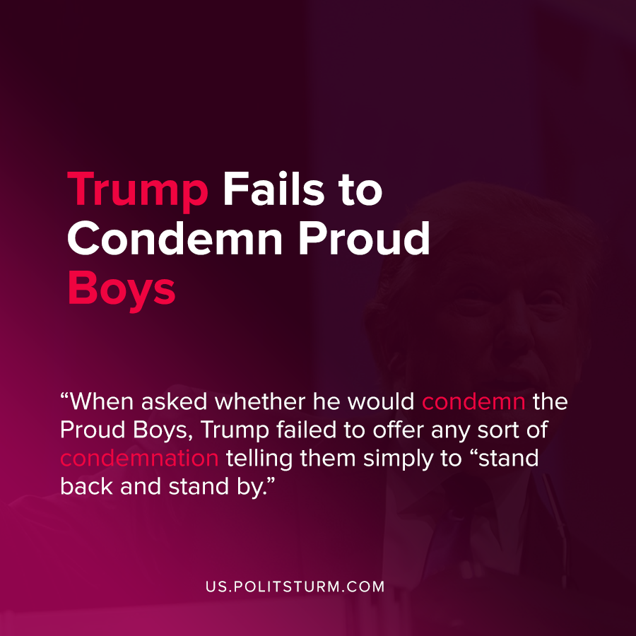

Original article
2020-10-01
1 min read

In a debate between President Donald Trump and democratic party candidate Joe Biden, the topic of white supremacy groups such as the Proud Boys were discussed. When asked whether he would condemn the Proud Boys, Trump failed to offer any condemnation telling them simply to “stand back and stand by”.
Trump then went on to claim that the right-wing and white supremacist groups are not primarily responsible for violence at protests, rather blaming Antifa and the left-wing in general.
“I would say almost everything I see is from the left wing not from the right wing”, said Trump.
The Proud Boys reacted to the national recognition on social media, and were emboldened by the President’s statements.
The statements by Trump express the support of far-right militia groups who promote openly reactionary nationalism, chauvinism and bigotry. Nationalist groups such as the Proud Boys are useful to the capitalist class, as they serve to divide workers and inhibit resistance to the exploitative force of capitalism.
Trump will not condemn white supremacist and nationalist groups because they are part of his political base and support. Trump has taken multiple actions in office to appease their nationalist sentiments from building a border wall on the Mexican border, limiting immigration and visas, among countless other appeasements. The tacit refusal to condemn white supremacist organizations is a continuing trend of fascization in the wake of the failure of bourgeois democracy and parliamentarism.
Source: 1

Original article

