Trump Executive Order to Prevent Immigration
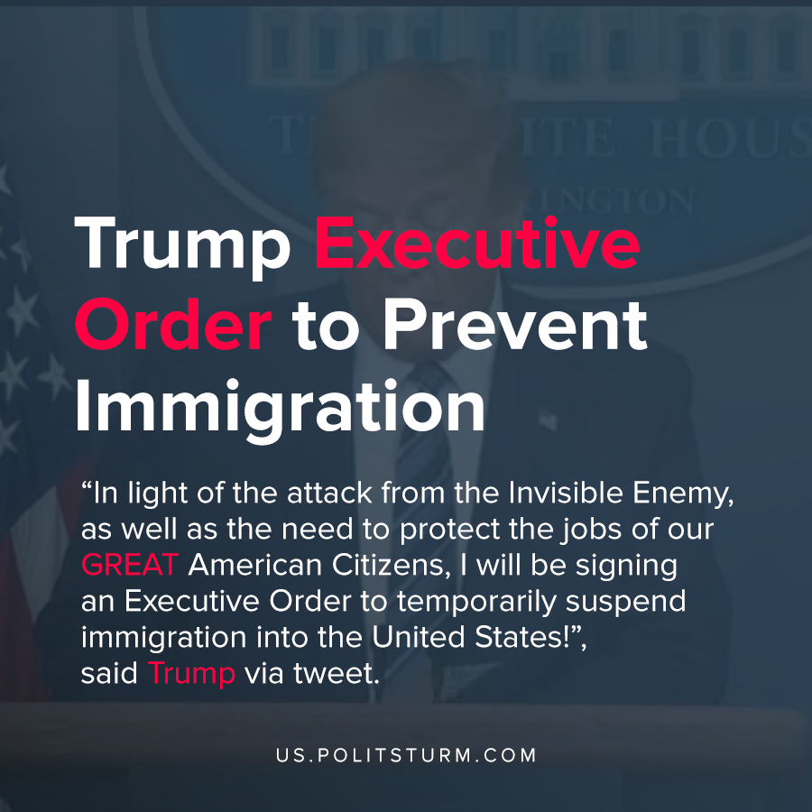

Original article
2020-04-24
1 min read

President Trump announced that he would be signing an executive order that would restrict immigration into the United States for the next 60 days. Trump stated that the intent of restricting immigration was to protect jobs for American workers, as millions of Americans are now unemployed.
“In light of the attack from the Invisible Enemy, as well as the need to protect the jobs of our GREAT American Citizens, I will be signing an Executive Order to temporarily suspend immigration into the United States!”, said Trump via tweet.
The executive order would affect those seeking permanent residency within the United States, and would not affect those entering on a temporary basis. After the 60 day period has elapsed, Trump said that he will consider adding “additional immigration related measures” in order to protect American workers.
As the capitalist economic system is in a state of crisis, the leaders of capitalist states utilize nationalism as a tool to deflect the root causes of capitalist dysfunction onto others.
Due to the uneven development of capitalism in combination with the recurrent crises of overproduction, workers are needlessly unemployed or underemployed. The cause of this unemployment is not immigrants, but rather the anarchic, profit-driven capitalist system. Only under a planned, socialist economic system would it be possible to eliminate unemployment and the nationalistic scapegoating that accompanies it.

https://twitter.com/realDonaldTrump/status/1252418369170501639
https://www.c-span.org/video/?471380-1/president-trump-sec-mnuchin-discuss-senate-passing-480-billion-coronavirus-relief-package&start=1015

Original article

