Trump Executive Order Targets Foreign Workers
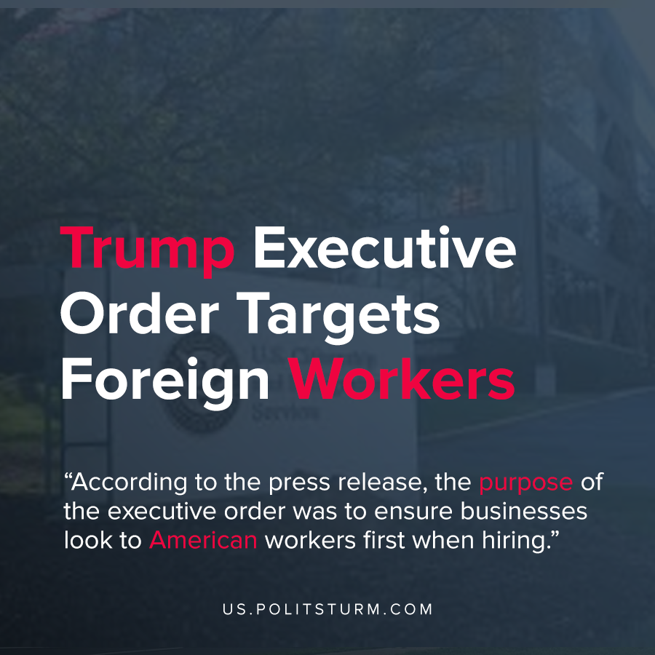

Original article
2020-06-23
1 min read

The Trump administration issued a new executive order regarding immigration that would “expand the suspension” of certain visas. The order extends the suspension of visas through the end of the year.
In addition to immigrant visas, non-immigrant visas would also be impacted, including the H-1B, H-2B, and certain H-4, L, and J visas. These visas allow foreign workers to enter and work in the U.S.
According to the press release, the purpose of the executive order was to “ensure businesses look to American workers first when hiring”.
In an effort to justify the move, the executive also cited liberals who support the exclusion of foreign labor from entering the United States, such as former Democratic Presidential candidate Bernie Sanders, and liberal economist Paul Krugman.
With millions of Americans facing unemployment, the Trump administration is using nationalist rhetoric and reasoning to target workers who come into the United States from foreign countries. The Trump administration is opportunistically using the crisis to appeal to their political base by attacking foreign workers, and using this act to falsely portray itself as being supportive to the American workers.
The reason for the decline of opportunities for the American working class is not the inclusion of foreign workers into the economy, but the decaying capitalist system. The American working class should not fall victim to the false rhetoric of the Trump faction of the bourgeois class, as Trump himself represents the racist, imperialist capitalist class that plunders the global working class.
Source: 1

Original article

