Trump Escalates US Conflict With International Institutions
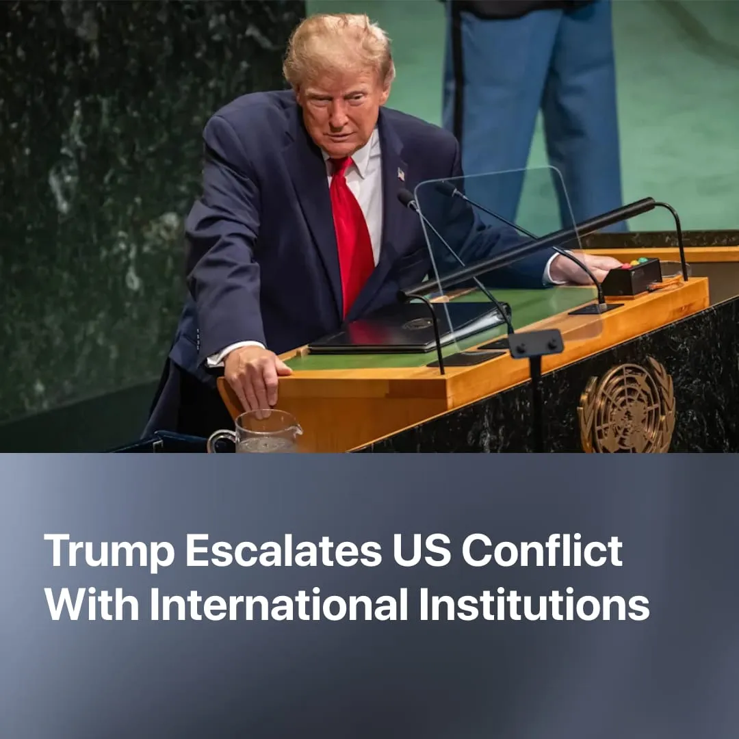

Original article
2026-10-07
2 min read

At the UN’s General Assembly, Trump gloated about defunding the “far-left” UN and denounced the “anti-American” International Criminal Court. In the lead-up to WWII, fascist powers left international institutions that attempted to restrict their actions.
Details. Speaking at the 81st UN General Assembly, Trump gloated about the first cuts to the UN budget, claiming that his administration had reduced it by 15% and eliminated over 4,000 positions, although the final cut was approved at 7%. The White House claimed that over $1 billion had been cut in six months.
► Trump criticised the UN as being run by unelected “globalist bureaucrats” imposing a “far-left agenda”, citing the international carbon tax on shipping as an example of policies he opposes. Negotiated through the UN, the tax was ultimately scrapped with US pressure.
► Trump then attacked the International Criminal Court, calling it an “anti-American tribunal” and a “rogue institution”, and called on other countries to leave it. He restated that the ICC has no jurisdiction over the US.
Context. International organisations such as the UN facilitate relations between capitalist states and provide a framework through which the major imperialist powers pursue their interests.
► The US helped establish the post-Cold War international order and has long used these institutions to advance its own interests. As they increasingly obstruct US actions or provide a platform for criticising them, Washington has become more willing to withdraw from or undermine them, including recently leaving 66 international organisations.
► The UN has criticised US actions in Iran, stating that there are grounds for investigating potential war crimes, and condemned US sanctions against Cuba. Relations with the ICC deteriorated after it issued arrest warrants for Benjamin Netanyahu, prompting the US to impose sanctions on the court.
► At the same time, the UN faces a serious financial crisis, as not all 193 member states are paying their dues. The US, in particular, owes billions. If this issue is not resolved, there is a significant risk that the UN will be unable to sustain itself financially and will cease to exist.
Important to Know. Parallels can be drawn with the collapse of the League of Nations during the rise of fascism. The major imperialist powers were unwilling to confront fascist expansion, hoping for them to invade the Soviet Union, contributing to the League’s inaction. Fascist powers withdrew when the League obstructed their initial military expansion and territorial ambitions, helping to undermine its authority.
► Japan withdrew after the League condemned its invasion of Manchuria. Germany withdrew from the League and Disarmament Conference as the Nazi government pursued rearmament, while Italy withdrew after the League condemned its invasion of Ethiopia and imposed sanctions.
► Like the League, the UN and ICC can issue condemnations, resolutions and calls for action without possessing an independent means of enforcing them. The UN commission’s finding that Israel had committed genocide in Gaza, for example, did not result in sanctions or other measures against Israel through the UN itself.
► These institutions cannot resolve the contradictions between competing imperialist powers. When international rules conflict with a major power's interests, that power can simply disregard them, withdraw from them, or try to weaken them.

Original article

