Trump Deploys Troops Without State Approval to Crush ICE Protesters
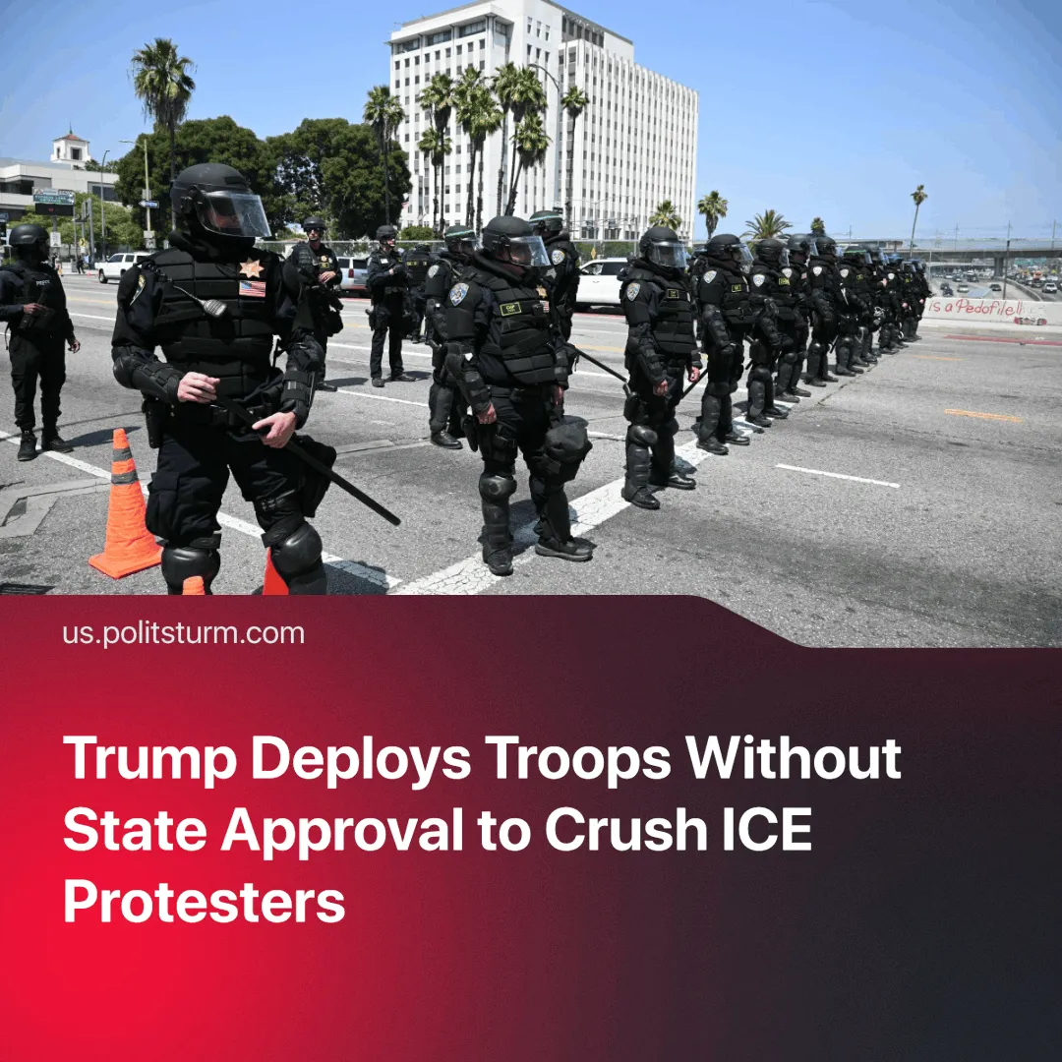

Original article
2025-06-12
1 min read

For the first time in over 60 years, the US president has bypassed state authority to deploy National Guard troops. He has done this in order to crush anti-ICE protests.
Details. President Trump deployed 4,000 National Guard troops to California to suppress unrest. Days later, 700 troops were mobilised to reinforce federal positions around key Immigration and Customs Enforcement (ICE) facilities. He justified the deployment by claiming the protests could “form a rebellion.”
► Protests began Friday in downtown Los Angeles after ICE deportation arrests. Demonstrators attempted to block Border Patrol vehicles by throwing rocks and chunks of concrete. Agents in riot gear responded with tear gas, flash-bangs, and pepper balls.
► Over the weekend, National Guard troops and police used tear gas and non-lethal rounds to disperse crowds. The unrest soon spread to other cities, including San Francisco, where over 150 people were arrested during clashes with local authorities.
► California Governor, Newsom, denounced the entire operation as unconstitutional, called it a "step toward authoritarianism," and filed a lawsuit against the federal intervention.
Context. The National Guard has been mobilised in past unrest, such as in the 1992 Los Angeles riots following the Rodney King verdict and the 2020 George Floyd protests. However, in both cases, deployment occurred with the consent of state governors.
► Both spontaneous protests resulted in only symbolic gains.
► The last time the executive power bypassed a governor to deploy the National Guard was in 1965, when they were deployed to protect civil rights protesters against the local police force in segregationist Alabama.

Original article

