Trump Declares Antifa Terrorist Organization
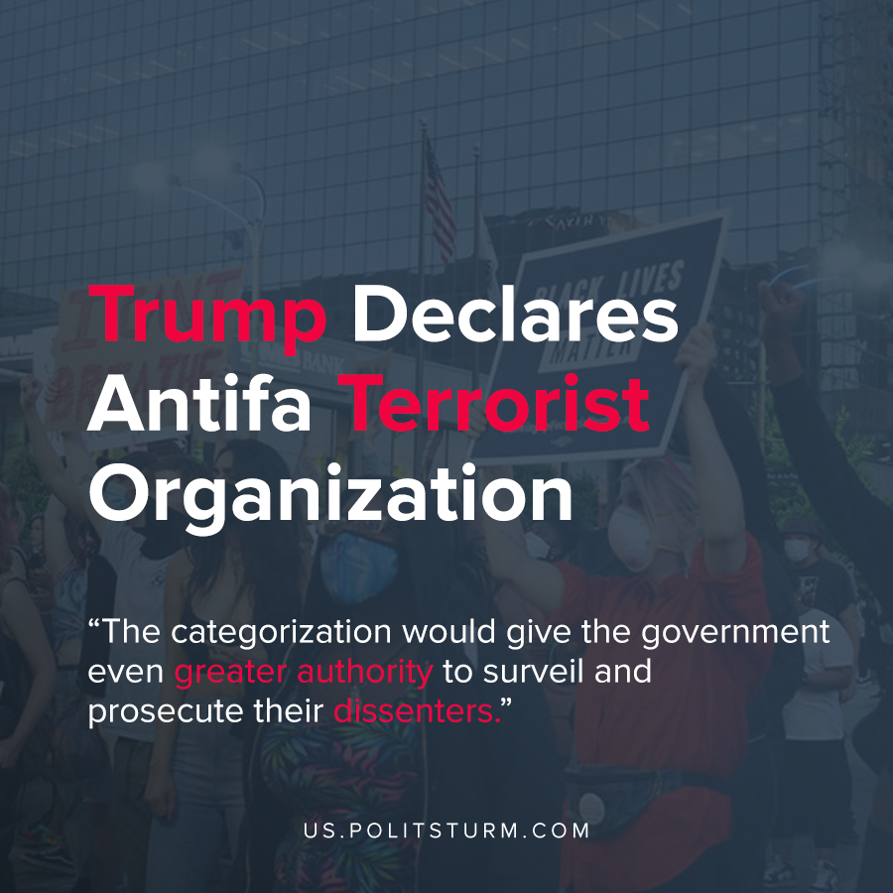

Original article
2020-06-01
1 min read

Protests have erupted across the United States in response to the killing of George Floyd. The last moments of George Floyd’s life were captured on video as a Minneapolis police officer pressed his knee on Floyd’s neck.
Despite his pleas and repeated indications that he could not breathe, the officer kept his knee pinned on Floyd’s neck for 8 minutes and 46 seconds.
One of the police officers involved in George Floyd’s death, Derek Chauvin, has been charged with 3rd degree murder and 2nd degree manslaughter in Hennepin County Court.
Floyd’s death sparked protests across the United States from New York to Los Angeles as protesters decry repeated unjust killings and racial injustice. In response to the protests and the associated property damage, bourgeois politicians have expressed eagerness to suppress the protests.
Trump tweeted “ …Any difficulty and we will assume control but, when the looting starts, the shooting starts”. Trump also stated that he will be declaring Antifa as a domestic terrorist organization on Sunday. The categorization would give the government even greater authority to surveil and prosecute their dissenters.
In response to the tragic death of George Floyd, the Trump administration is giving greater authority to law enforcement to suppress dissent. The ruling class of oligarchs use the state as a tool by which they exploit the masses and maintain their dictatorship. The protests demonstrate that under any conditions of resistance to their class domination, the facade of liberal democracy is erased to reveal the true face of bourgeois dictatorship.
Sources: 1 , 2 , 3 , 4 , 5

Original article

