Trump Claims Coronavirus Will Just Disappear
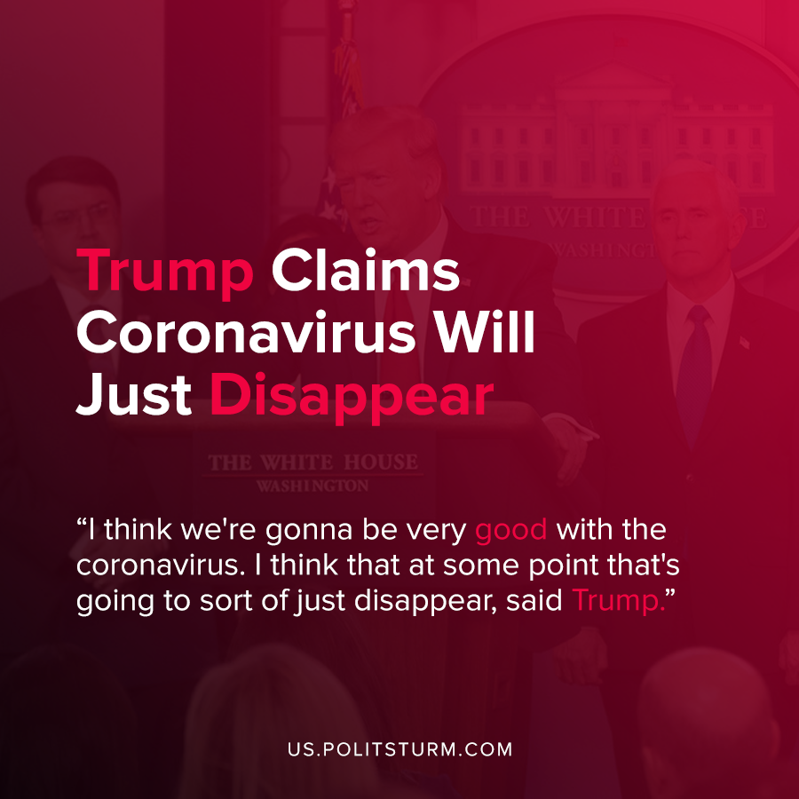

Original article
2020-07-21
1 min read

In a recent interview with Fox News, President Trump discussed the coronavirus, which has already claimed over 140,000 American lives. When discussing the topic of the President’s failures to contain the virus, Trump made a comment about how he thinks the coronavirus pandemic will end.
“I think we’re gonna be very good with the coronavirus. I think that at some point that’s going to sort of just disappear. I hope…I’ll be right eventually. I will be right eventually. You know I said, It’s going to disappear”, said Trump.
Despite the rise of cases in hot spots such as Florida, Texas, and California, Trump is convinced that the coronavirus will just disappear through some unexplained process. According to the President, when this unexplained process has completed, he will have been vindicated and correct despite the current objective indications to the contrary.
Trump’s statements reflect either childish idealism, or a wanton callousness to the suffering of the American people who have died or been infected with the virus. Despite the objective data, Trump continues to publicly state that the virus will just “go away”, and has at every moment pushed for re-opening enterprises and schools and criticized both experts and those who suggest action is needed to prevent further spread of the coronavirus.
The Trump administration does not want to impose any sort of restrictions on capitalist enterprises that would limit their ability to exploit workers, even during a pandemic. In this instance, shortsightedness of capitalists and those who demagogically support them has led to poor objective results in containing the spread of the coronavirus, despite what Trump may think, believe, or say.
Sources: 1 , 2 , 3

Original article

