Trump Bans “Woke” AI
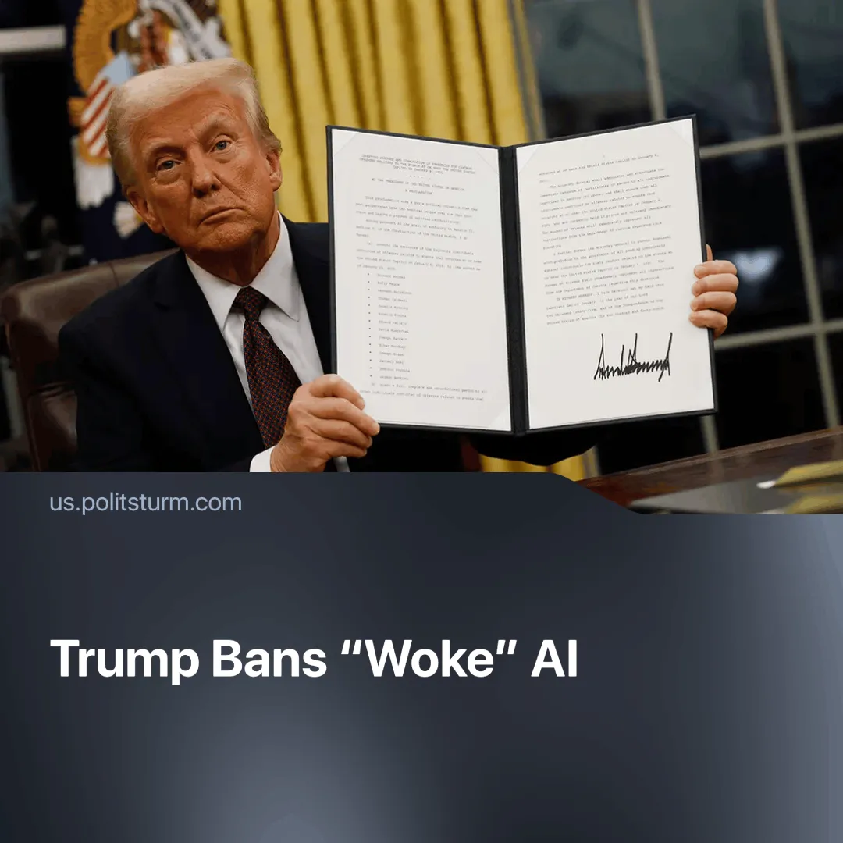

Original article
2025-07-31
1 min read

Trump has signed an executive order banning “woke AI” in federal agencies. Earlier, Elon Musk attempted to steer his Grok chatbot towards right‑wing views.
Details. The executive order, Preventing Woke AI in the Federal Government, signed on 23 July, requires any AI company working with the US government to maintain large language models (LLMs) that comply with “unbiased AI principles” of “truth-seeking” and “ideological neutrality”.
► LLMs must therefore be ‘neutral’ and ‘non-partisan’ tools that do not manipulate responses in favour of ideological “dogmas” such as diversity, equity and inclusion (DEI).
► The order requires all federal agencies to procure only AI models adhering to these principles. It effectively regulates the entire AI industry, which is increasingly seeking government contracts and integration within the state.
Context. The ability of AI to produce personalised messages on a large scale is a powerful tool for shaping public opinion. The order itself admits that “AI will play a critical role in how Americans consume information and navigate their daily lives.”
► Elon Musk previously attempted to make xAI more “right-wing”, while OpenAI’s LLM has been criticised for “leaning left”. These were individual attempts by capitalists to steer AI politically.
Important to know. The US state has now established explicit guidelines to ensure LLMs influence how people consume information in line with the collective interests of monopoly capital.
► These guidelines are presented under the pretence of "truthfulness," but all "truth" is ultimately filtered through the lens of class interests. The call for "ideological neutrality" is not neutral; it aims to enshrine bourgeois ideology as the default with AI.

Original article

