Trump Attacks “Political Correctness” in Military
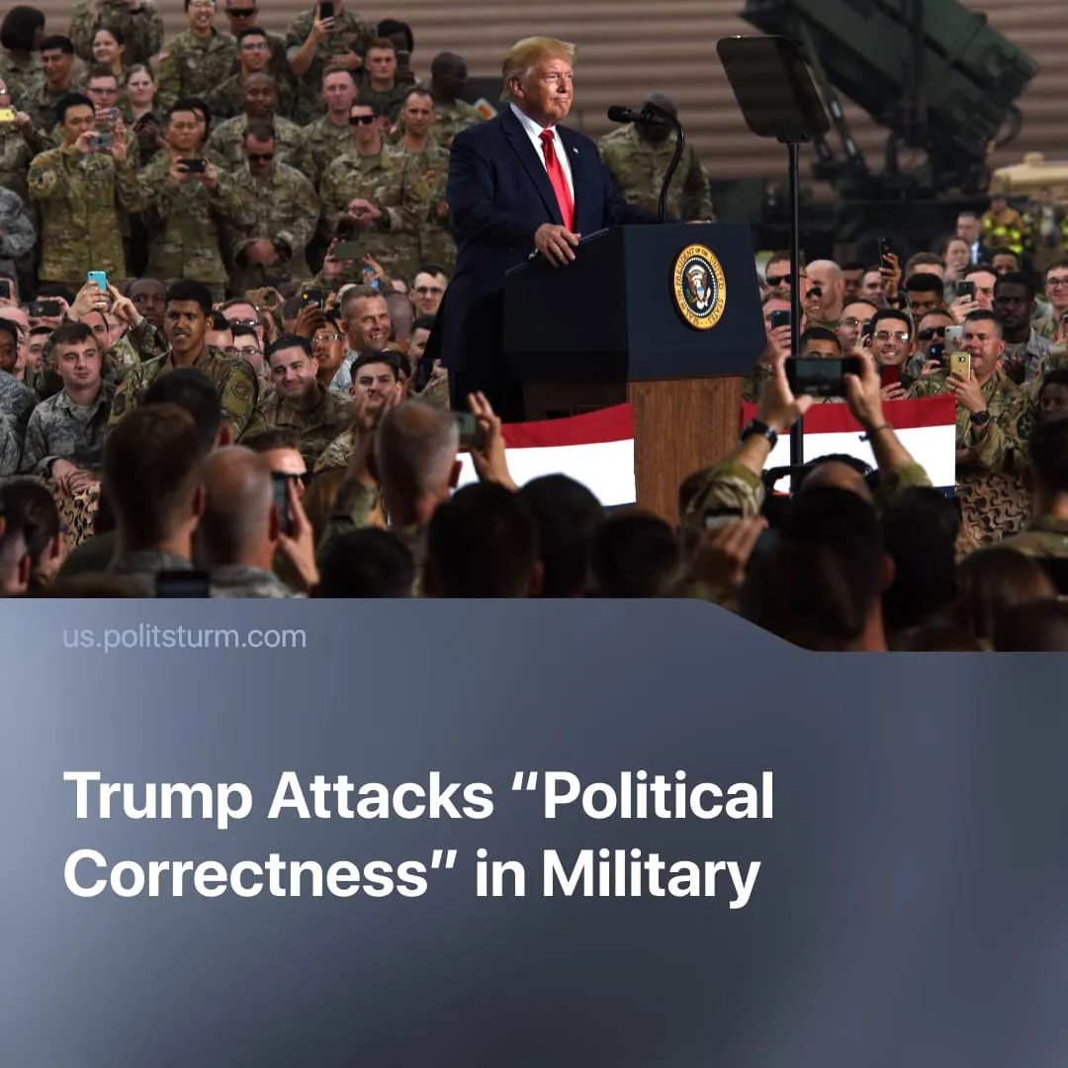

Original article
2025-11-03
1 min read

Trump vows the US will reject “political correctness” in address to troops in Japan. Has the US military ever been "politically correct"?
During his visit to Japan, in a speech to US soldiers stationed there, Donald Trump said that under his leadership, the United States would abandon “political correctness” in the military.
Quote: “Unlike past administrations, we will not be politically correct. You don't mind that, do you? When it comes to defending the United States,” adding that “if we're in a war, we're going to win the war.”
Context. This is not the first time Trump has raised this topic. In 2017, he recalled senior US military officials to the White House to discuss “political correctness.” Again in 2025, he summoned hundreds of top military officials to a speech denouncing “wokeness,” diversity, and inclusion in the military – claiming such values weakened America’s “fighting spirit.”
In reality, the US military has never been “politically correct.” From nuclear bombings to countless foreign invasions, it has consistently acted as a violent instrument of imperialism and domestic repression, not as a restrained or moral force.
► Since 1945, the United States has carried out military operations or interventions in more than 90 countries, according to Congressional records. These actions – from full-scale wars to covert coups – have killed millions, displaced tens of millions, and left large parts of the globe destabilised and under US political and economic influence. Just after 9/11 alone, US operations in the Middle East are estimated to have killed 432,000 civilians.
► The US remains the only country to have used nuclear weapons, dropping atomic bombs on Hiroshima and Nagasaki – killing an estimated 200,000 civilians – even as its own generals said Japan was already defeated.
► Domestically, the U.S. armed apparatus has long suppressed workers and protest movements – for example, during the Ludlow Massacre (1914), when the Colorado National Guard killed 25 striking miners and their families including 11 children, and at Kent State University (1970), when the Ohio National Guard opened fire on anti-Vietnam War protesters, killing four students and wounding nine.

Original article

