Trump Attacks "Free Speech" Despite Campaign Promises
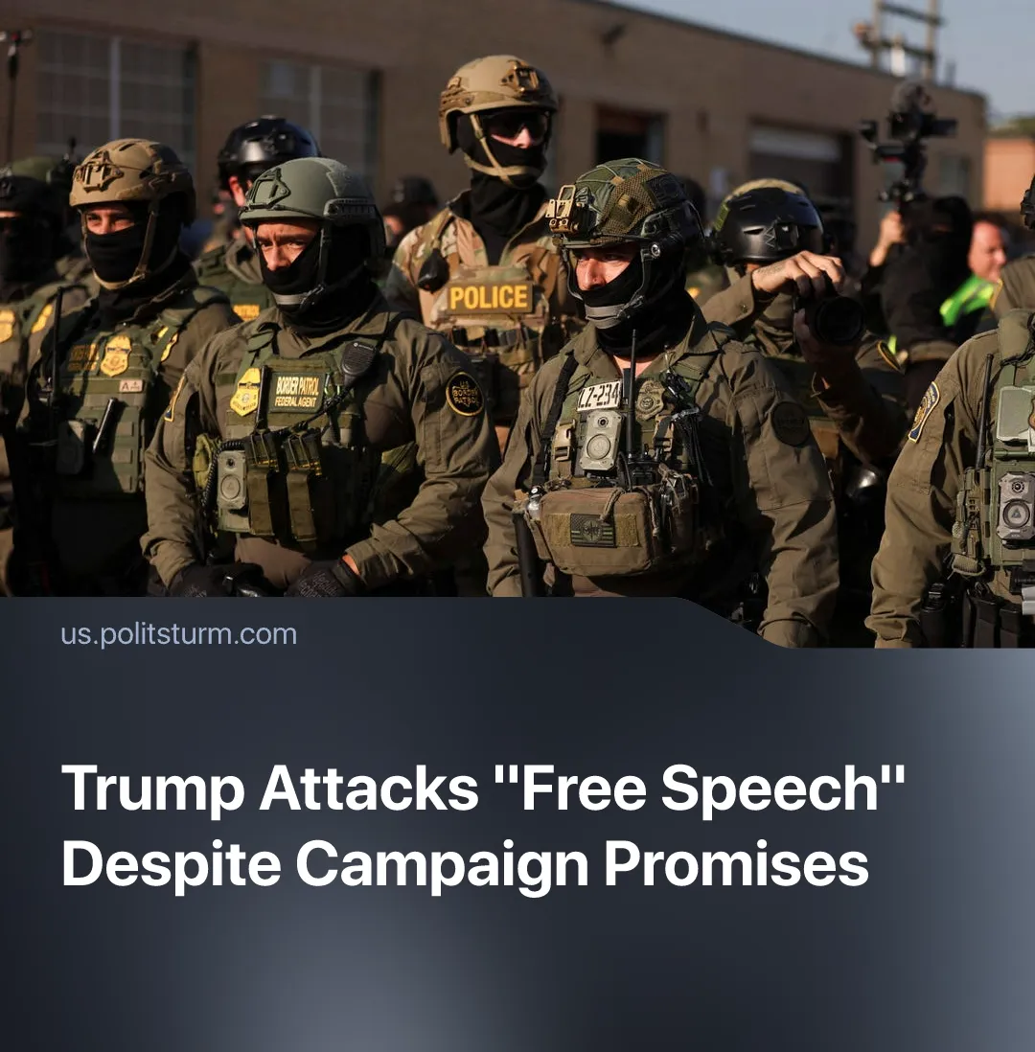

Original article
2026-08-12
1 min read

Trump promised “free speech”. Judges have ruled that he has stifled it 75 times.
Details. Since returning to the White House, the Trump administration has faced 93 lawsuits alleging breach of the First Amendment, which protects freedom of speech, religion, the press, assembly and petition in the US Constitution. Federal judges ruled against the administration in 75 cases, while appeals courts later stayed or overturned 15. By comparison, Biden faced 27 such cases over four years, losing 13.
► Some examples of Trump violating the First Amendment included the detention and attempted deportation of foreign students and activists involved in pro-Palestinian protests, alongside attempts to withhold university funding over their handling of such protests. Harvard faced a $2.3 billion funding freeze, while Columbia had $400 million withheld. Courts subsequently blocked several of these measures.
► The administration also attacked federal workers' collective bargaining rights. In February, the federal appeals court covering the western United States overturned a ruling protecting hundreds of thousands of federal employees' ability to bargain through unions, although the court did not accept the administration's position in every related case.
► Schools, universities, legal organisations and medical groups have likewise faced pressure when the policies or activities of these organisations conflicted with the administration. Courts blocked attempts to cancel grants to schools and medical organisations, while federal agencies used ideological keywords to cancel nearly $2 billion in University of California research grants.
Context. Trump's election campaign presented him as an opponent of government censorship. Within hours of his second inauguration, he signed an executive order titled “Restoring Freedom of Speech and Ending Federal Censorship”. However, even during his first term, Trump repeatedly threatened critics and labeled the press "the enemy of the people".
► This forms part of the broader fascisation of the US state, through militarisation, increased repression, the concentration of executive power and the growing anti-communist campaign. Trump has repeatedly labelled Democrats "Marxists" and "communists" (these accusations and general anti-communism are also used by Democrats), and has charged people using the antifa terrorist label, which is frequently associated with communists.

Original article

