Trump Arms and Begins Training National Guard
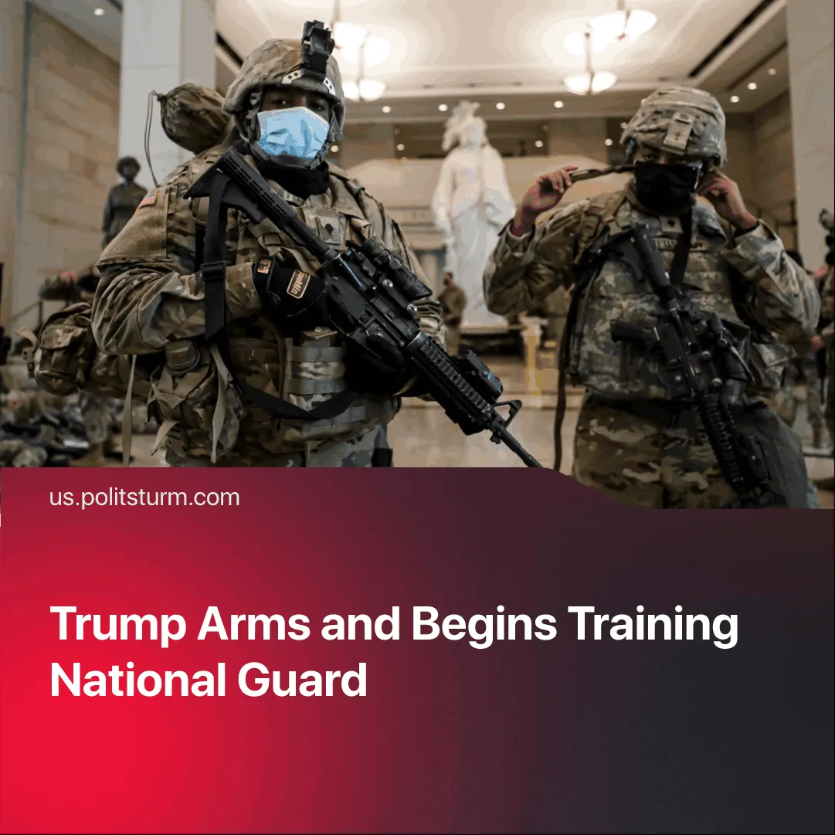

Original article
2025-08-29
1 min read

The Trump administration has armed the DC National Guard, ordered additional training, and signalled they may remain in DC past the legal deadline.
Details. As further developments of what we previously covered, the number of National Guard troops deployed by Trump to D.C. has grown to 2,200, and they are now carrying firearms. Almost 60% of the troops in D.C. are from Republican states outside the district.
► Trump said he is considering declaring a national emergency after the 30-day deployment deadline passes. This would allow him to keep a military presence in Washington, D.C., and to deploy additional troops to Democratic-controlled cities he has continued to threaten, including Chicago, New York, and Baltimore.
► While 76% of Republicans have supported the deployment, only 38% of Americans support it. It has resulted in protests led by a broad coalition of “liberals, leftists and intellectuals” called “Refuse Fascism”.
► One poll found that 80% of D.C. residents oppose the deployment. “It’s gotten to the point where people are scared to be out and about,” said a D.C. resident. Immigrant residents, particularly parents and caregivers, are too scared to live their daily lives because Immigration and Customs Enforcement (ICE) agents, now reinforced by the National Guard, roam around and even show up at schools.
► Trump has since signed an order establishing specialised National Guard units "specifically trained and equipped to deal with public order issues." The Defence Ministry will designate some of these units to serve as a "quick reaction force" ready for rapid nationwide deployment.
Context. The expansion of executive authority over lower courts, the tighter integration of monopoly capital with the state, the repeated federalisation of the National Guard and record levels of funding for the military and domestic policing lay the groundwork for further fascization.

Original article

