Trump Appoints Capitalists to Science Advisory Council
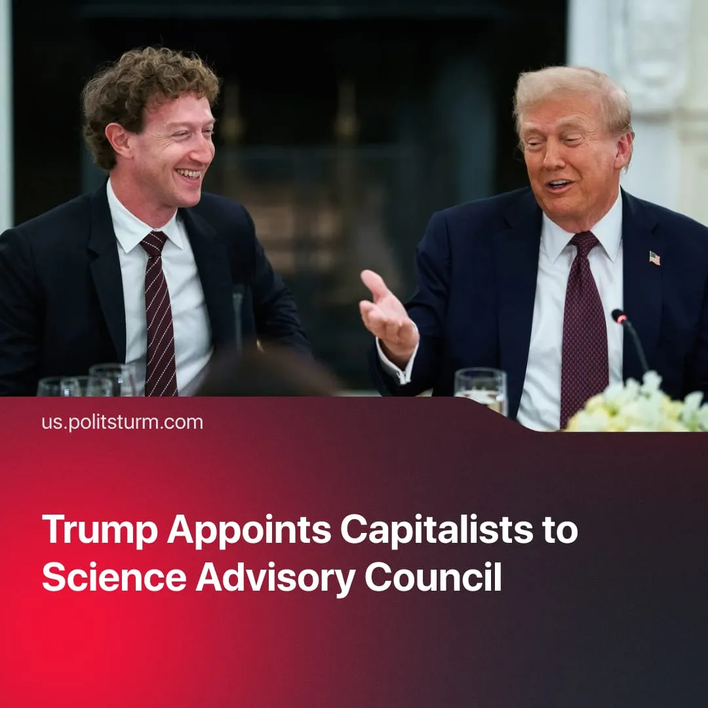

Original article
2026-04-04
1 min read

After a year vacant, Donald Trump has filled his science advisory council with top capitalists – deepening the direct integration of monopolies and the state.
Details. Trump has announced the first members of his administration’s President’s Council of Advisors on Science and Technology (PCAST), which advises the White House on technological policy, innovation, and the integration of science into state strategy.
► The council is formally tasked with shaping policy on AI, defence technology, industrial development, and scientific research, giving it a direct role in aligning technological development with state priorities and long-term geopolitical strategy.
► The composition of the council reflects a clear class character, as 12 of its 13 new members are major capitalists and top corporate executives, including figures such as Mark Zuckerberg, Michael Dell and Jensen Huang, who lead major technology firms – Meta, Dell and Nvidia, respectively.
Context. Throughout 2025, tech executives were increasingly integrated into state structures, including involvement in military planning and formal roles within defence institutions. At the same time, the US government has sought massive investment from financial capital into military infrastructure.
► This aligns with earlier anti-science actions by the Trump administration, including the public condemnation of established medicines, funding cuts, dismissals of scientists, suppression of research, and direct political interference in federal scientific institutions.
► As Karl Marx explained in Capital vol 1, “it is not because he is a leader of industry that a man is a capitalist; on the contrary, he is a leader of industry because he is a capitalist. The leadership of industry is an attribute of capital, just as in feudal times the functions of general and judge were attributes of landed property.”

Original article

