Trump Appointee Sacks Editors of State Sponsored Media
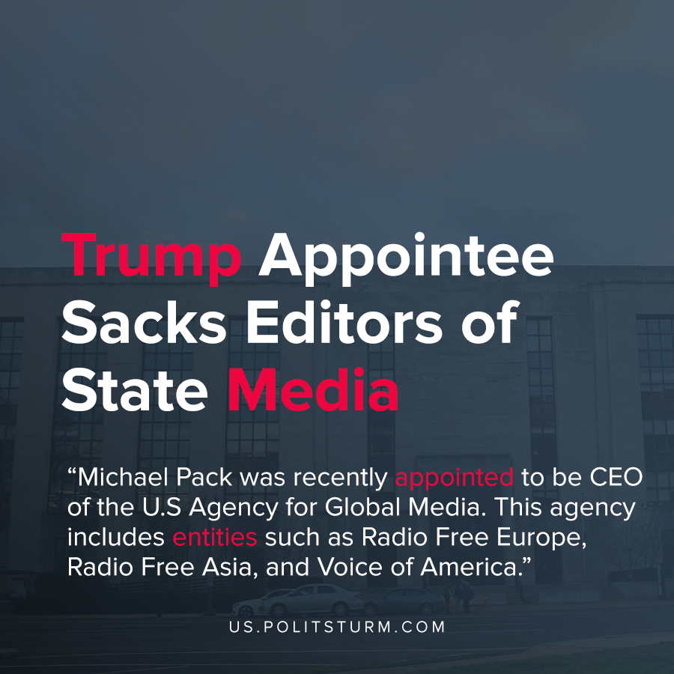

Original article
2020-06-22
1 min read

Michael Pack was recently appointed to be CEO of the U.S Agency for Global Media. This agency includes entities such as Radio Free Europe, Radio Free Asia, and Voice of America. The stated purpose of these organizations is to “inform, engage, and connect people around the world in support of freedom and democracy”.
The newly appointed chief of US federal media sacked three senior officials, in turn provoking fear from the Trump opposition as the monopoly of information grows stronger in favor of pro-Trump capitalists.
Michael Pack, as a representative of the Republican Party, had further allowed for the monopolization of information. Such will grant the US to use the media to push narratives that would uncritically follow one camp of capitalism while opposing the other.
This paints a similar picture to Operation Mockingbird, however, now that there is no longer socialist opposition the divided camps swiftly lose their unity and now stand against each other. This depicts another powder keg thrown into the pile of contradictions that capitalism poses.
Should the working class let these contradictions continue further emerging we will risk war, and hence the working class must organize, or else we will fall with capitalism. Propaganda is necessary for the proletariat, and with it the proletariat could spread class consciousness. Only if the media machine is in the hands of the proletariat we will gain free press, absent of private interest.
Sources: 1 , 2 , 3

Original article

