Trump Announces New Wave of Tariffs
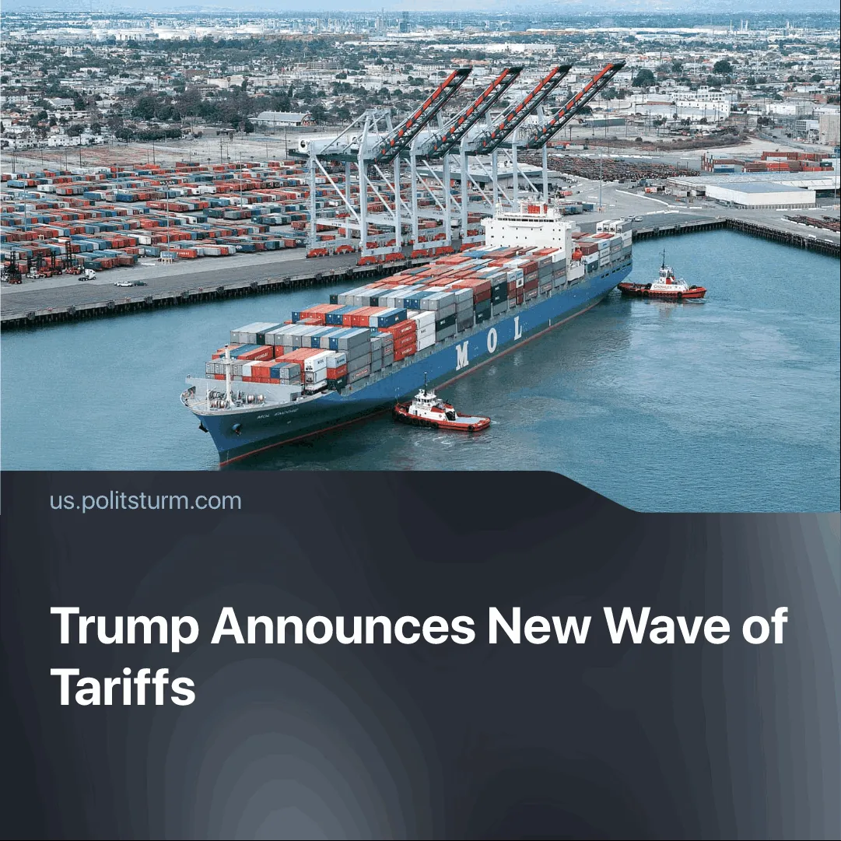

Original article
2025-08-09
2 min read

Trump has reignited the tariff trade war after extracting concessions from major economies.
Details. On July 31, Donald Trump announced a new baseline tariff of 15% on imports from approximately 40 countries with which the US has a trade deficit. In addition, tariffs above 15% were imposed on goods from 26 countries with significant trade surpluses with the US. These measures came into effect on August 7.
► Mexico and Canada face higher tariffs for goods that are not exempt under the US-Mexico-Canada (USMCA) free-trade agreement. Mexico agreed to extend the current 25% tariff rate for 90 days. Meanwhile, non-exempt Canadian goods like steel, aluminium, and finished motor vehicles, among others, are subject to a 35% tariff.
► The new wave of tariffs caught Switzerland off guard, as a trade agreement had appeared imminent. The country has the highest tariffs in Europe at 39%.
► Brazil faces the highest rate, with 50% tariffs on its exports to the US. Trump imposed tariffs to protect Bolsonaro. However, Brazil's Economic Reciprocity Law includes counter-tariffs, the suspension of intellectual property rights and the suspension of trade agreement obligations, all of which would greatly affect the US, which has a trade surplus with Brazil. As a result, the US removed nearly 700 products from the tariff list.
► Currently, Indian goods are subject to a tariff rate of 25%. Trump has since threatened an additional 25% tariff on India, along with an “unspecified penalty” if they continue to purchase Russian oil, which is set to take effect on 27 August.
Context. The new tariff campaign continued the successful strategy of imposing steep tariffs that would seriously impact profits, followed by delays or exemptions for certain goods. This approach has enabled the revision of trade terms and the extraction of concessions while commodity flows continued. Trump had boasted that he would secure "90 deals in 90 days."
► The tariff strategy resulted in favourable deals with major economies, such as Japan and the EU. For instance, Japan agreed to a baseline 15% tariff on its goods and to invest $550 billion in the US. Meanwhile, on Wednesday, Japan’s second-biggest carmaker reported a 50% year-over-year profit decline due to US auto tariffs.
► In June, Trump signed a temporary trade framework with China. The US reduced its tariffs to 30%, while China lowered its tariffs to 10%, with the truce set to expire on August 12.► Similarly, the EU agreed to a 15% tariff on its exports and to purchase large quantities of US military equipment and energy products over the next three years. Additionally, EU companies promised to invest at least $600 billion in the US economy. Trump further threatened to impose 'Canada-style' tariffs of 35% if the investment pledge remains unfulfilled.
► The tariffs have already increased consumer prices and led to an abrupt decline in employment in America’s manufacturing and transportation sectors.
► Internationally, they have pushed other imperialist blocs to pursue separate trade arrangements, such as the March 22 meeting of the foreign ministers of Japan, China, and South Korea, and the China–EU exchange of letters pledging to deepen cooperation.

Original article

