Trump Ally Claims Billionaires Create Jobs
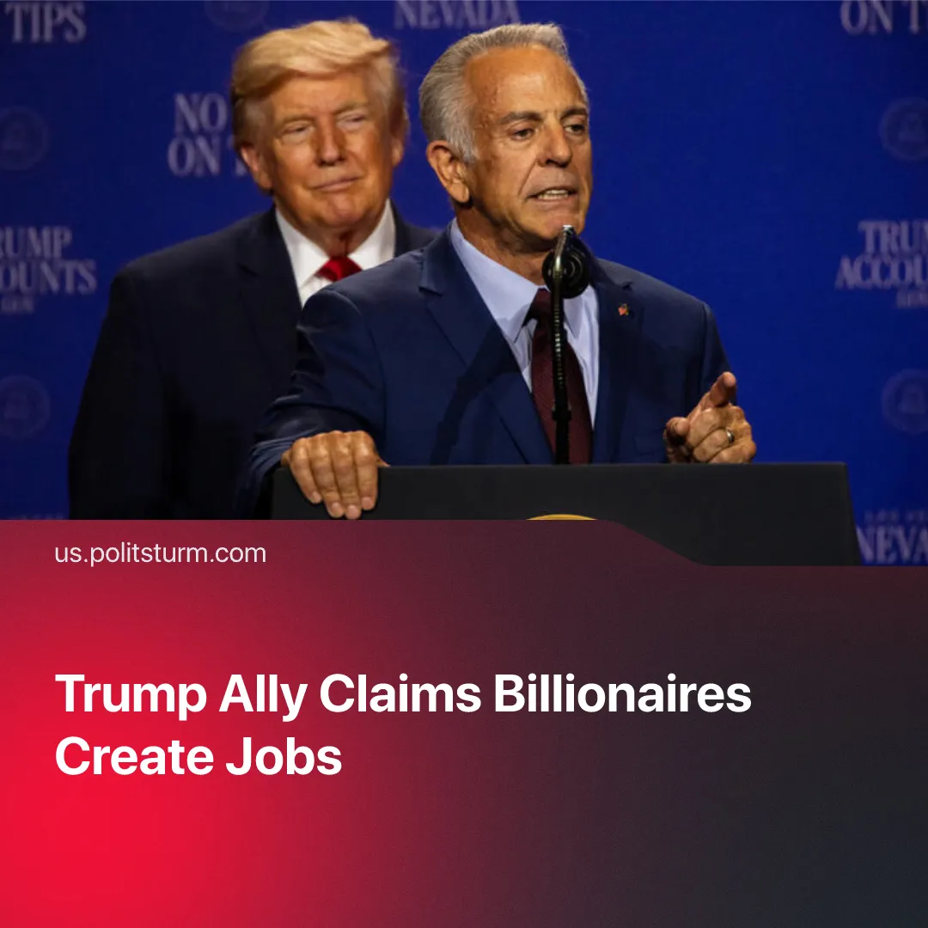

Original article
2026-08-13
2 min read

Trump takes care of billionaires so that they can continue to “provide jobs”, claims Nevada Governor, as unemployment continues to rise.
On August 5, 2026, Nevada Governor Joe Lombardo (Republican), who is running for re-election, argued that Trump’s billionaire-friendly policies benefit the working class. He made the statement alongside President Trump at a campaign rally in Las Vegas.
Quote: "Quite often when the press and the media run him down, they think about, you know, he's taking care of his billionaire friends. Those billionaire friends provide jobs. Unless you take care of them [capitalists], those jobs are absent."
Context. President Trump is unashamed about his closeness to the big capitalists. His second inauguration was attended by prominent billionaires – including Musk, Zuckerberg and Bezos – whom he has since put in charge of US industrial policy and imperialist negotiations with China. Under his administration, the US Army has commissioned big tech executives from Palantir, Meta, and OpenAI as reserve officers.
► President Trump has repeatedly manipulated the markets in favour of himself and his close oligarch friends. For example, in July of 2026 he urged Americans to "go out and buy a Dell computer". Consequently, the company’s stocks rose by 7.8% in just one day. His close friend, Michael Dell, saw his net worth increase by $34 billion.
► News agencies like The Washington Post, Associated Press and The Wall Street Journal have accused Donald Trump of cosying up to his “billionaire friends”, arguing that the president provides oligarchs with preferential treatment by ensuring that they hold key positions in his government. President Biden’s similarly pro-capitalist policies did not suffer the same scrutiny – Democrat politicians are now opportunistically presented as “pro-worker”.
In reality, unemployment has continued to rise under Trump's second term. In total, 7.1 million Americans are now unemployed and seeking work, an increase of 2.2% since the start of his second term. Trump fired 300,000 federal workers, and his Iran war caused major job cuts this summer.
► To boost their profits, big capitalists have laid off tens of thousands of workers to replace them with AI. The billionaires argue that AI will help reduce the workload for employees, but incorporating AI actually intensifies exploitation. In some cases, workers reported experiencing brain fog linked to the overuse of AI.
► Alongside unemployment, US workers face skyrocketing living costs. In the past year, energy expenses have risen 15% and food expenses are up 3%. Since 2021, average rent prices have risen 40%. Given these costs, 9 out of 10 Americans reported that the country was in a cost-of-living crisis, which most expect to worsen. This stands in stark contrast with the increasing wealth of billionaires, who have seen their wealth increase by an average of 80% since 2020.
► Unemployment is a necessary feature of capitalism, providing replacements to keep workers’s wages low and make workplace organizing risky. As Comrade Stalin explained: “no capitalist would ever agree to the complete abolition of unemployment, to the abolition of the reserve army of unemployed, the purpose of which is to bring pressure on the labour market, to ensure a supply of cheap labour”.

Original article

