Trump administration wants to cut medical programs and education
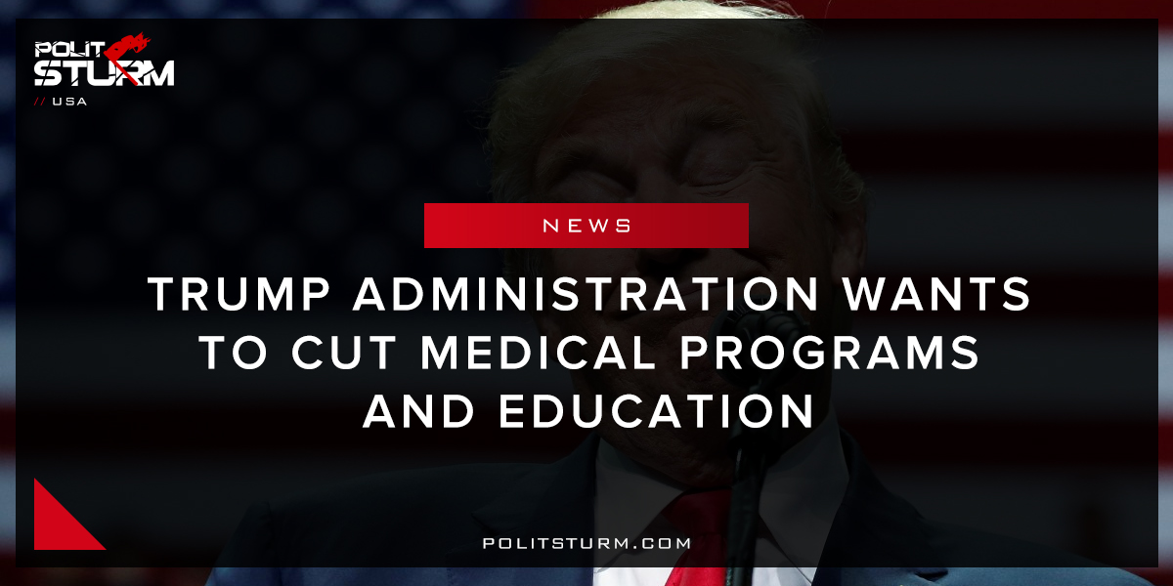

Original article
2018-03-11
1 min read

«The President has placed America on a new course, one that promises an era of a prouder, stronger, and more prosperous Nation. This new course has unleashed liberty and opportunity. It also makes the tough choices to produce a more efficient, effective, and accountable Government. The engines of America are indeed running again.» In his inaugural address, the President envisioned a Nation where “prosperity and strength” would return again. He laid out, in his first words as President, a simple but familiar American strategy: “winning again, winning like never before.” Most importantly, the President insisted on a simple, but forgotten principle— America First. The President’s first Budget was built on the principle that Government is a steward of taxpayer dollars, not an owner. That means fiscal responsibility and prioritizing the most effective programs.
«Politsturm»: The release of the 2019 budget shows to what extent the Trump administration is “prioritizing” certain programs over others. For example, The Department of Health and Human Services which oversees programs related to health-related programs will have a 21% decrease in funding from 2017. Likewise, the Department of Education will see a 10.5% decrease in its budget from the 2017 level. Alternatively, the Department of Defense which provides funding for military forces will see a 13% increase in its budget.
This budget expresses the will of the oligarchs in the US to scale back the public services that are provided to the mass of people. The departments which benefit the working class the most including education, housing and development, and health services are being cut. This budget is nothing more than an attempt to scale back these programs while selling it to the American people as a more “efficient, effective, and accountable” budget. This budget is efficient and effective from the perspective of the bourgeoisie parasites who are able to reduce their tax burden. This bill shows the government is only “accountable” to the bourgeois class, not the working mass of people.
Source

Original article

