Trump Administration Targets Federal Unions
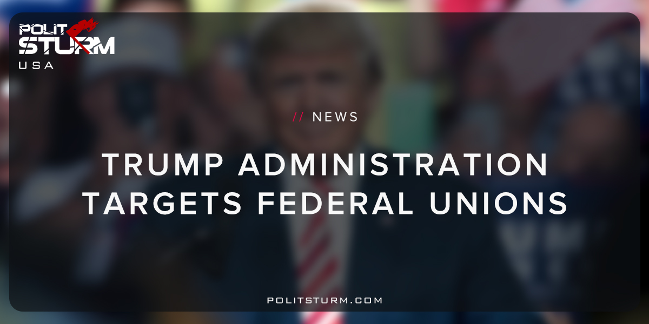

Original article
2018-06-23
1 min read

An executive order signed by President Trump is attacking federal unions, specifically by making a change to section 7101 (b) of the Federal Service Labor- Management Relations Statute.
The statute is being reinterpreted in a way that will harm unions under the guise of making them more “efficient”. From the perspective of the oligarchs this amounts to reducing their tax burden while simultaneously reducing federal employment and benefits.
Collective Bargaining agreements will now be required to be “effective and efficient”. The executive order claims that current arrangements do not reward high performing employees, do not hold low performing employees accountable, and are wasteful to the taxpayer.
The new executive orders will make collective bargaining more difficult from the perspective of workers. Any directive designed to reduce costs and which is targeted specifically towards federal employees is intended to weaken federal unions and reduce federal employment and benefits.
The current administration, and every preceding administration, has served the interests of the idle class, the oligarchs. Public sector unionization is much higher than private sector unionization in the United States and the oligarchs will continue their struggle to reduce unionization even further. (34.4% vs. 6.5%, respectively) Overall unionization has been on a long-term decline in the United States for decades.
By signing this executive order, the Trump administration has made it clear that the oligarchs are continuing the offensive against organized labor. This trend was certainly not specific to the Trump administration, but it has recently intensified under Trump. The executive, legislative, and judicial branches of government serve the material interests of the oligarchs, not the working class. Only a government of the working people could possibly improve the long-term well-being of the working class.
https://www.federalregister.gov/documents/2018/06/01/2018-11913/developing-efficient-effective-and-cost–reducing-approaches-to-federal-sector-collective-bargaining
https://www.flra.gov/resources-training/resources/statute-and-regulations/statute/statute-subchapter-i-general-0
https://www.bls.gov/spotlight/2016/union-membership-in-the-united-states/pdf/union-membership-in-the-united-states.pdf

Original article

