Trump administration roll back environmental protections
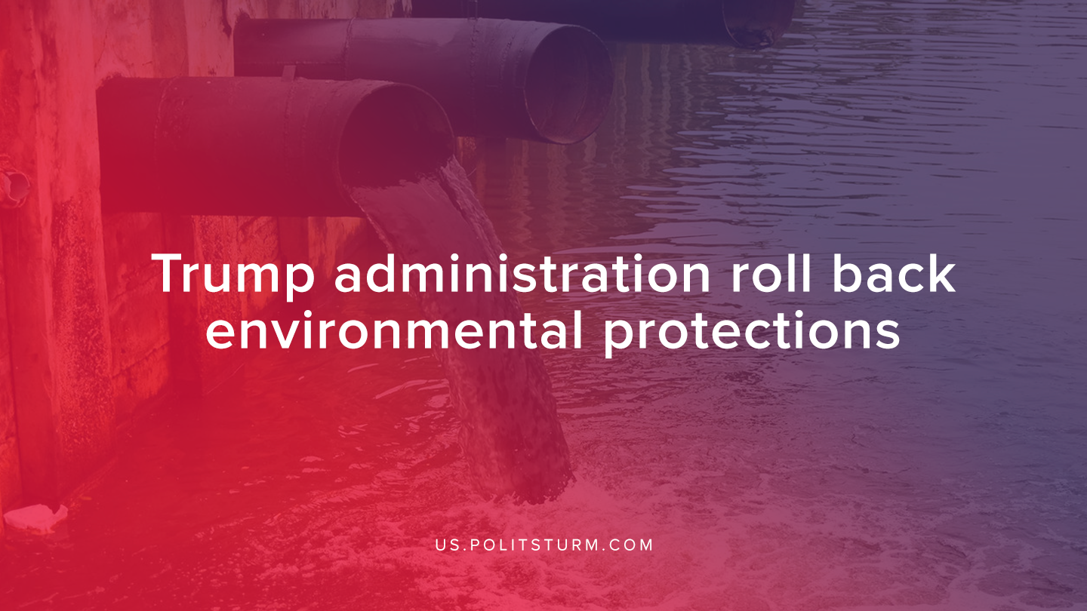

Original article
2020-01-29
1 min read

The Environmental Protection Agency announced that it will be revoking a regulation that protected U.S wetlands and streams. The administration defended the revocation of the Obama-era regulation to adopt a new definition of national waters “that protects the nation’s navigable waters from pollution and will result in economic growth across the country”.
The Clean Water Act required landowners to obtain permits before they could develop these areas and pollute waterways. Also, the new definitions of waters of the United States would define groundwater, ditches, converted cropland, farm and stock watering ponds and waste treatment systems as not being subject to federal control.
The ruling will roll back environmental regulations to allow developers and farmers to pollute the environment more freely. Developers, drillers and miners will also be able to pollute small streams and wetlands that were previously protected by government regulation.
The Trump administration’s continued assault on environmental regulations reveals the inherent futility of environmental regulations under the political rule of the bourgeoisie. One party, the Democrats, favor basic regulations while simultaneously supporting the capitalist organization of production that destroys the environment. They are theatrically opposed to the Republicans which support the same capitalist system and vigorously undermine any meaningful reform. This keeps pollution and degradation of the environment within limits acceptable to the capitalists.
Sources: 1, 2

Original article

